FINAL QUALIFYING EXAMINATION FOR -GENERAL
NURSES - NOVEMBER 2010
MARKING SCHEME PAPER I

1a. Description of the Pathophysiology of Hepatitis B virus (HBV) infection
- Hepatitis B virus infection is the inflammation of the liver cells by hepatitis B virus.
- Hepatitis B virus can be transmitted into the host through the following means-blood and other body fluids e.g. semen, saliva, urine.
- Following successful entry into the systemic circulation the virus gets into the liver.
- In the liver, the virus takes about 6 weeks to 6 months to replicate with resultant inflammation due to antigen - antibody reaction.
- This process may lead to damage (necrosis) to the liver cells.
- Following necrosis there is proliferation and enlargement of the kupffer cells, if there is weak anti — viral immune response by the host.
- If the immune response by the host is strong enough to combact the infection the patient becomes asymptomatic but tests positive because of the presence of antibody- for hepatitis B.
- The damage done to the liver cells will lead to the following: prevention of normal secretion and excretion of bile causing jaundice.
- Metabolic dysfunction of functional cell causing reduced conversion of glycogen to glucose and oxidation of fatty acids leading to weight loss and fatigue.
- In severe cases, the liver is unable to convert ammonia to urea for excretion and this interferes with brain function leading to lethargy, personality change and subsequent hepatic coma.
½ mk each for any correct 10 points
Total 5 mks

b. Clinical Features of Hepatitis B virus Infection
The clinical features arc as follows:
- General body malaise
- Loss of appetite
- Nausea and vomiting
- Right upper abdominal pain, joint pain, rashes.
- Jaundice, dark urine, clay-coloured stool, mild fever.
- Liver tenderness. Hepatomegaly
- Heart burn, flatulence
- Splemomegaly
- Enlarged posterior cervical lymph nodes.
½ mk each for any correct 6 points
Total = 3 mks
[
c. Medical and Nursing Management of Mrs. Darling
Medical Management
- Alpha interferon 5 million units daily or 10 million units thrice weekly for 4 —6 months.
- Anti —viral agents e.g. Lamivudine and Adefovir are useful to reduce progression of hepatitis B infections.
- Antacids e.g. Gelucil, magnesium trisilicate help to relief heart burn.
- Anti-emetics e.g. promethazine etc. to control vomiting.
- Intravenous infusion with Dextrose in water 5% 8 hourly for 24 hours or more depending on medical prescription.
- Anti-inflammatory drugs e.g. Prednisolone.
- Vitamins e.g. Essential forte, litrison, Redundyn, hepabiont.

½ mk each for any correct 6 points
Total 3 inks
Nursing Management
Admission
- Admit the patient in a well - ventilated environment.
Observation
- Regular observation of vital signs should he maintained.
- The patient’s skin, urine and stool should be observed, recorded and reported.
- Patient should also be observed for signs of mental involvement e.g. delirium, confusion, disorientaion etc.
Isolation
- The patient is barrier — nursed.
- There should be proper hand washing and use of gloves, aseptic technique in handling syringes and needles.
Rest and Sleep
- Rest reduces damage to the liver and hasten convalescence.
- Total nursing care should he given, to avoid disturbance.
- Active exercises arc introduced gradually only when the condition has improved.
Diet/Fluids
- A light diet supplemented by fruit drinks and glucose can be given during the acute stage of the disease.
- A high caloric diet principally of protein and carbohydrate should be given as Soon as the patient’s nausea and vomiting arc controlled however if the patient slows signs of hepatic coma the protein should be reduced.
- Fat intake should be restricted while there is jaundice and increased as tolerated.
- Adequate fluid intake of about 3000ml per day is necessary because of the fever and to promote urinary elimination of the serum bilirubin. Intake and output recording should be maintained.
Skin Care
- King frequent bathing and change of linen during d period of lever.
- Avoid the use of soap, emollients may be added to bath water to relieve the itching associated with jaundice.
- Calamine lotion may also be applied to the skin after bath to relieve itching.
- The finger nails should he trimmed and kept clean.
Health Education
- Health educates both patient and family on personal hygiene (proper hand washing before and after eating) and environmental hygiene.
- Health educates them on report of contacts to the health sector and immunization.
- Sex education is also given especially on use of condom for the married until tested sero-negative.
Psychotherapy
Patient and relations arc constantly reassured.
Advice on Discharge
- Advise the patient and relations to maintain good personal and environmental hygiene.
- Use condom for sex until tests sero-negative
- Avoid use of unprescribed drugs.
- Avoid use of alcohol and smoking.
- Have enough rest.
- Come for check up in the hospital.
1 mk for each identified and discussed
1 mk each for may correct 6 points= Total =6 mks

d. Universal Precautions against the spread of Hepatitis B virus infection

- Health education of susceptible individuals and groups.
- Barrier nursing of patients suffering from hepatitis B virus infection.
- Routine screening of all the patients in the ward to identify who do not have the infection and immunize them with HAV and HBV vaccines.
- Carriers in the ward need to be identified and given proper treatment to prevent cross Infection in the ward.
- Nurses, doctors and other health care providers should always wash hands before and after each procedure on patients.
- Patient’s discharges like vomitus, urine, saliva, body fluids, blood and blood products should be properly disinfected and properly disposed.
- Strict aseptic techniques must observed by nurses during procedures like blood transfusion, injection, wound dressing etc.
- Use disposable equipment for procedures involving penetration of the skin.
- Use sharp safety by placing directly into sharps container, never recapped, do not overfill container and close securely before disposal.
- Protective gadgets e.g. gloves, gowns, spectacles, masks etc. are worn against direct contact with body fluid and mucous membrane.
- Disinfect spills of blood with hypochlorite and clear up using gloves and a plastic apron.
- Kissing by mouth to mouth should be avoided prevent saliva being infected by body fluids infected by HBV.
- Mother to child transmission of HBV should be avoided through strict intra-natal and post-natal care.
- Safer sex practices should be encouraged
- Tattooing or acupuncture should as much be avoided as frequent re-use of needles can predispose to infection with HAV and HBV.
- Proper personal and environmental hygiene protects against infection with HBV, HEV.
- Proper sterilization of ward’s instruments.
- Strict surveillance will minimize the spread of infection
- Encourage strict adherence to rules of chemotherapy.
- Promote patient’s nutrition to improve his immunity.
- Production of albumin solutions, gammaglobin fractions should involve pasteurization of blood and blood products.
¼ mk each for any correct 12 points Total = 3 mks

2a. DIABETES MELLITUS (1mark)
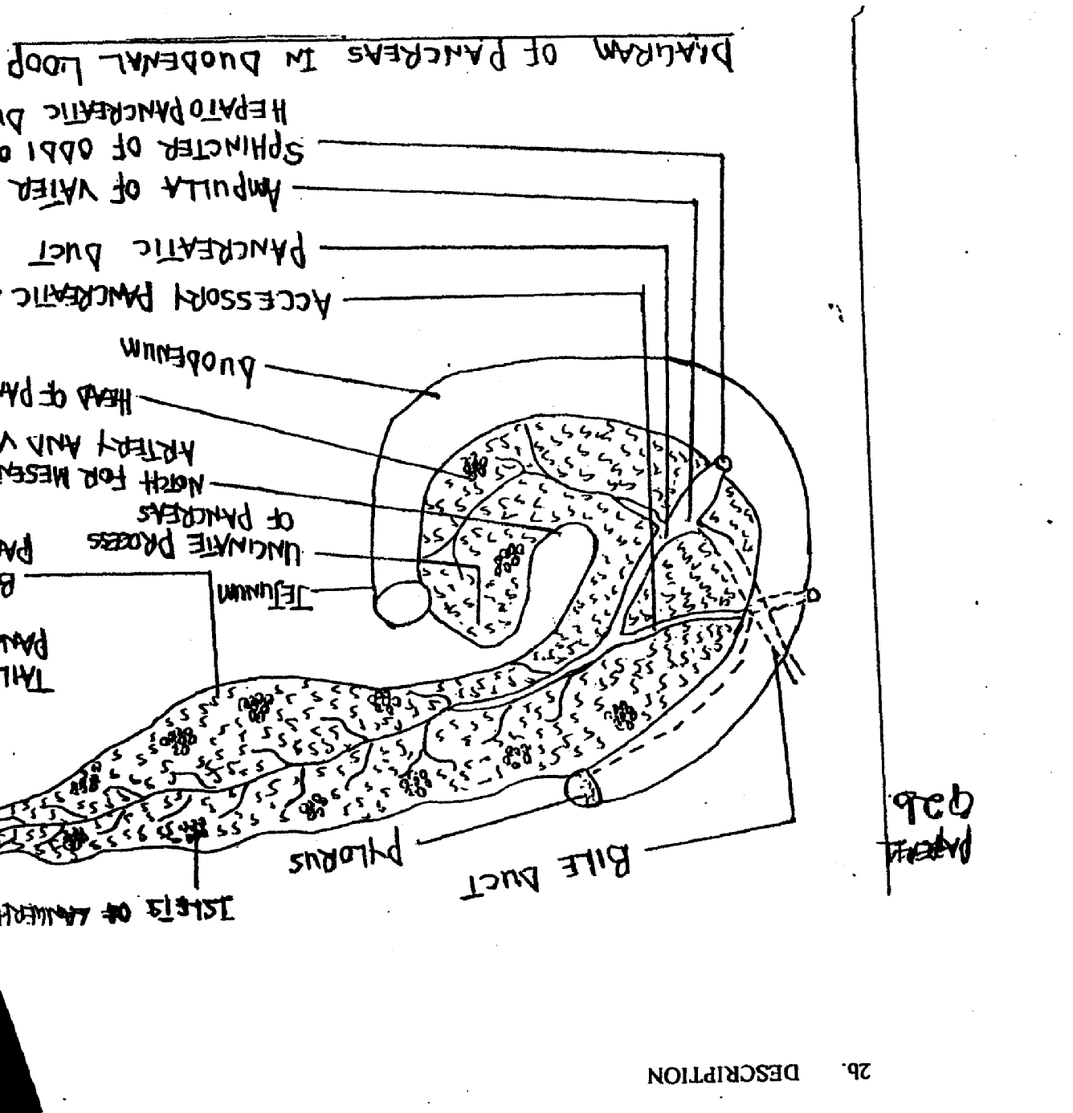
2b. DESCRIPTION

Description: - The pancreases is both exocini 8 enlorine glad
Colour - Pale Grey Gland
Weight/Length - Weighs 6Ogrm, 12 to 15cm long
Location - Situated in the epigastric and left hypochondriac region of the abdominal cavity.
Structure - It consists of a broad head, body and a narrow tail.
Anatomical Relationship- Head lies in the curve of duodenum and the tail extends to the spleen to make an impression.
Secretions- As an exocrine gland it secretes pancreatic juice containing digestive enzymes into the small intestine through its duct. As an endocrine gland the pancreas consists of clusters of cells called Islets of Langerhan which are of three distinct types: Alpha, Beta and Delta cells secreting glucagon, insulin and somastatin hormones respectively. These hormones diffuse directly into the blood.

BLOOD SUPPLY/VENOUS RETURN
Arterial - Superior mesenteric artery
Venous - Corresponding vein
Nerve Supply - Autonomic nervous supply (parasyinphathetic/symphathetic).
¼ marks each for any correct 8 points = total 2 marks

2c. i. FASTING PLASMA GLUCOSE (FASTING BLOOD SUGAR) - No caloric
Intake for at least 8 — 10 hours or patient is starved overnight, Plasma glucose is measure to detect if it is greater than or equal to 126mg/dl (7. 0mm/L).
ii. TWO HOURS POST PRADIAL GLUCOSE - Patient may be given 50g of glucose or allowed to eat normal caloric food. Blood sample is obtained 2 hours later for plasma glucose. Value of 200mg/dI (11. 1mmol/L) or more confirms the diagnosis.
iii. GLYCOSYLATED HAEMOGLOB1N - Blood cells haemoglobin is assessed for glucose content, value higher than 6% confirms high blood glucose level of over 2-3 months duration.
iv. TESTING FOR KETONES IN URINE - Positive result indicate the presence of end products of fat breakdown which the body results to for energy generation in the absence of glucose.
1 mark each for any correct 2 points = total 2 marks

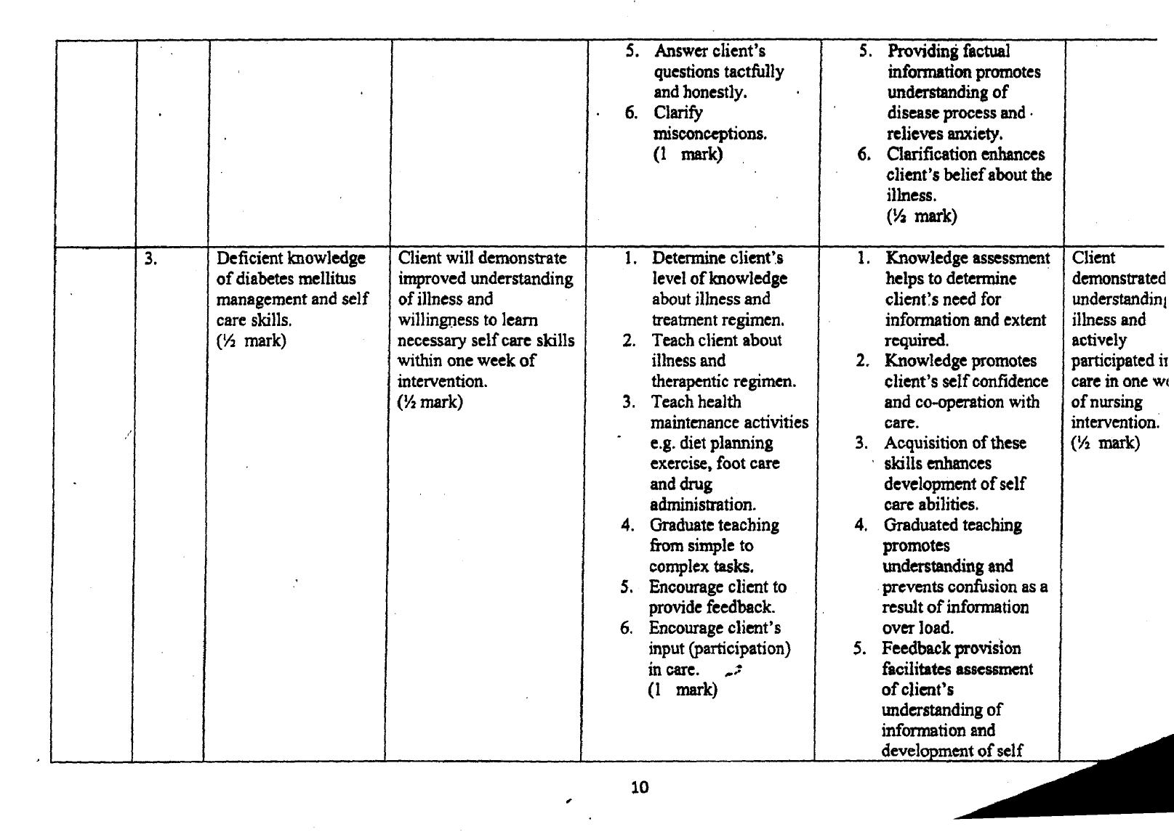
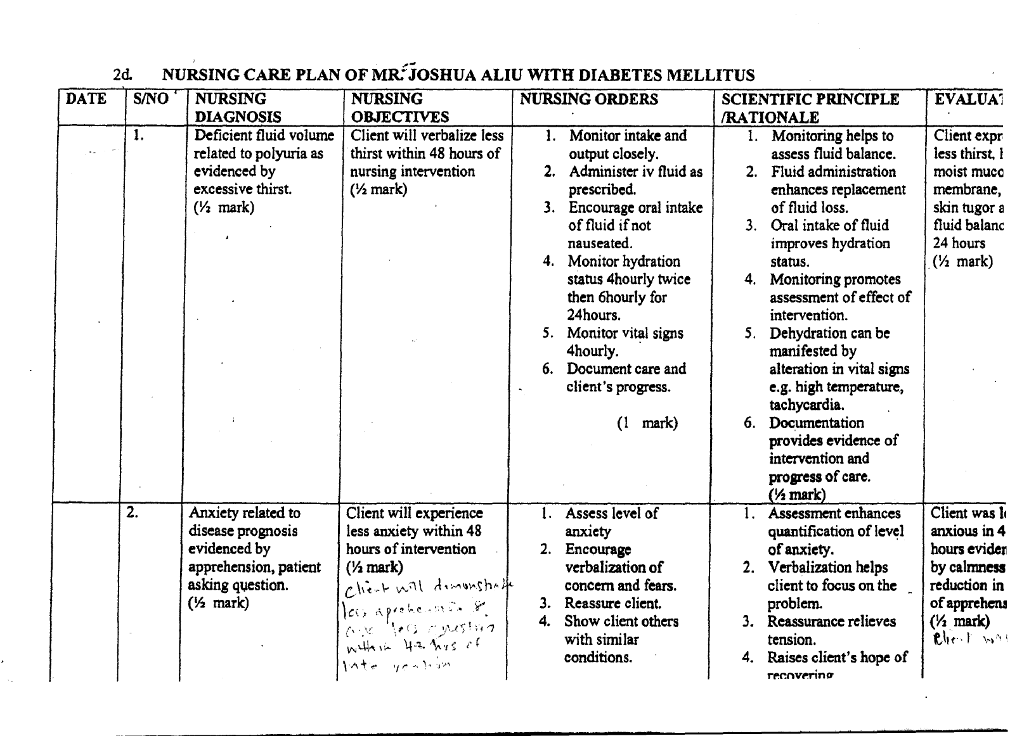
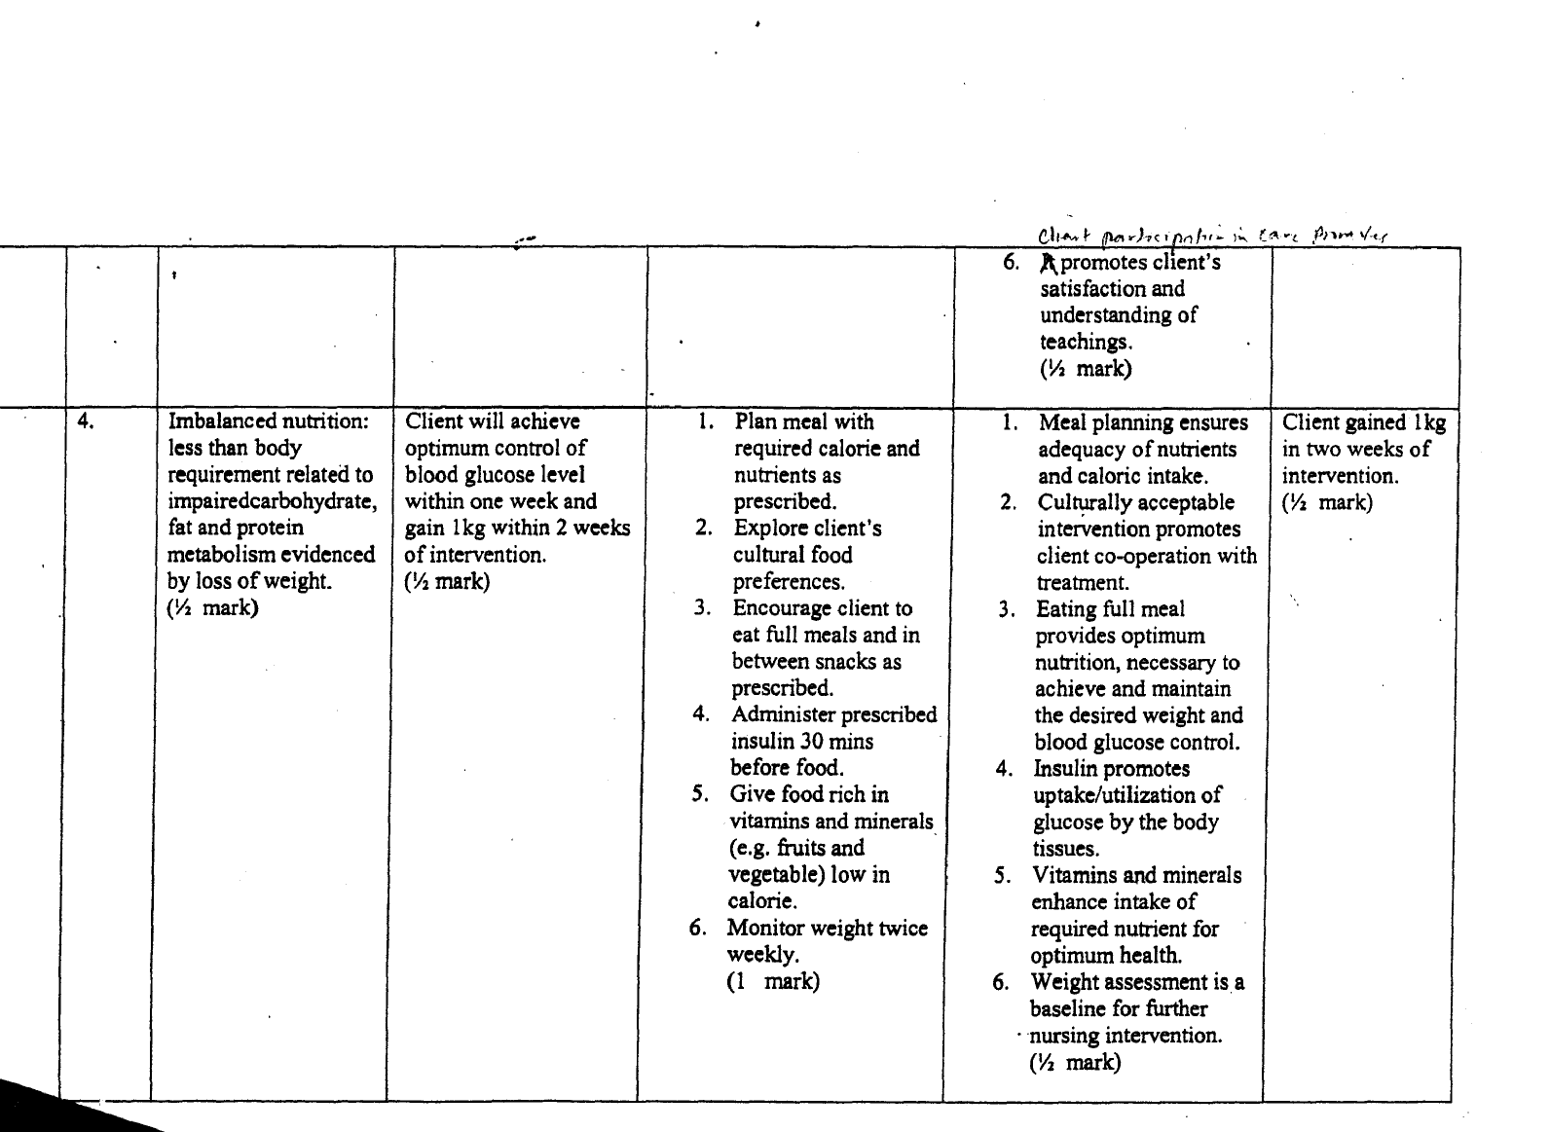
Note/Key
- Nursing Diagnosis with Related factor - ½ mark
- Nursing Objective - ½ mark
- Nursing Order with 4 points - ½ mark
- Scientific Principle/Rationale - ½ mark
- Evaluation - ½ mark
3 marks for any correct 3 points of Nursing care total 9 marks

2c. i. Stress the importance of exercise in weight and glucose control.
ii. Patient should adhere to dietary prescription.
iii. Encourage compliance with treatments
iv. Teach foot care and prevention of injury.
v. Teach about prevention of hypoglycaemia and its management.
vi. Teach self monitoring of blood glucose.
vii. Teach necessary skills to self medicate and observe for desired effects and side effects.
viii. Educate patients on the relevance of carrying diabetic identification label.
ix. Teach the importance of follow-up.
½ mark each for any correct 6 points = total 3 marks
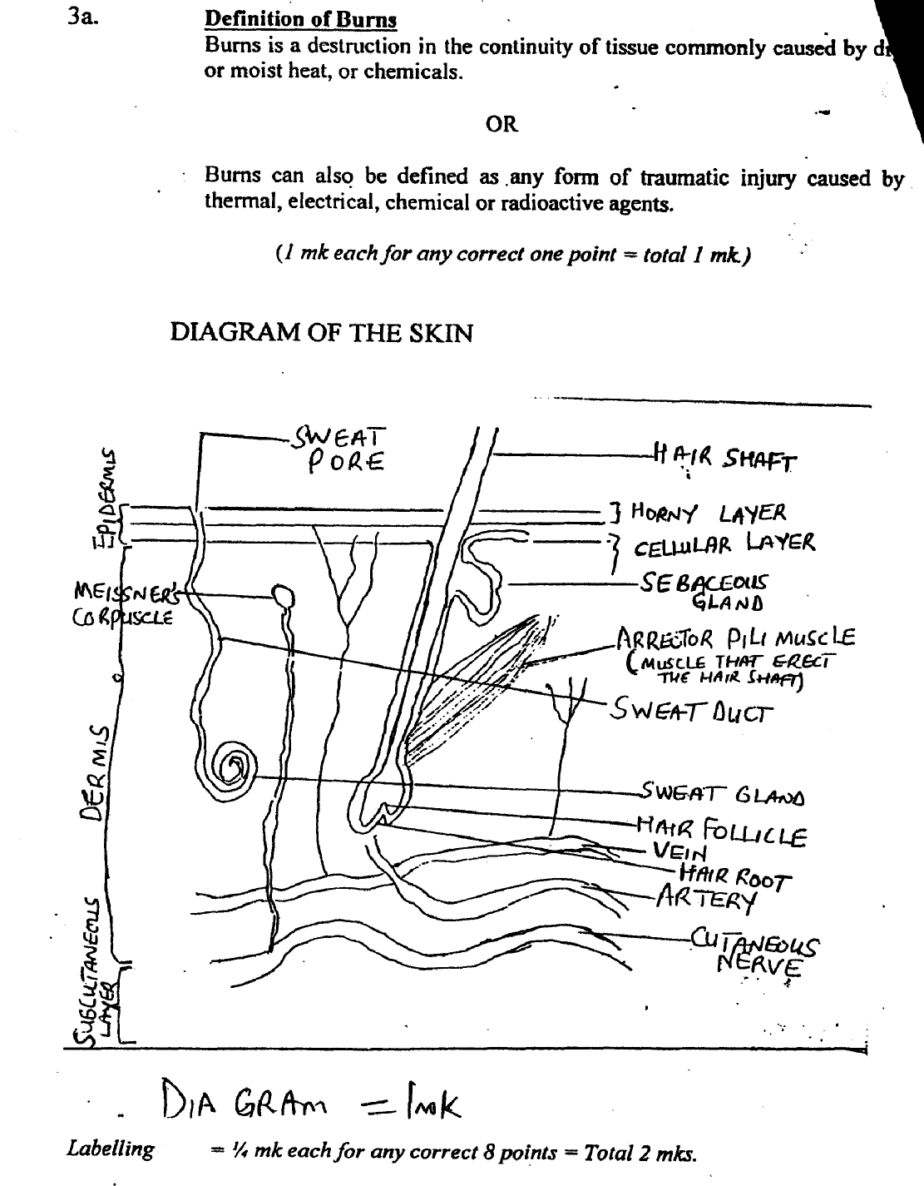

b.

b. DESCRIPTION OF THE SKIN
The skin is the largest organ in the body and has two main layers:
- The Epidermis
- The Dermis
THE EPIDERMIS
- Most superficial layer composed of keratinized stratified squamous epithelium of varying thickness, thickest in the palms of the hand and soles of the feet.
- Contains no blood vessels and nerve endings but the deeper layers are bathed in interstitial fluid from the dermis, which provides nourishment
- The Epidermis is also made up of strata of cells
(i) The superficial stratum corneum (Horny layer)
(ii) The surface is ridged by projections of cells in the dermis called
papillae.
(¼ mk each for any correct 2 points = Total ½ mk)
THE DERMIS
- The deeper layer which is tough and elastic, consist of fibrous tissue interlaced with yellow elastic fibres.
- The structures in the dermis include the following:
(i) Blood vessels — A fine network of arterioles supplying the structures in the dermis
(ii) Lymph vessels — Forms a network throughout the dermis
(iii) Sensory nerves — Specialized sensory receptors, sensitive to touch,
temperature, pressure and pain are widely distributed in the dermis
(iv) Sweat glands — Distributed throughout the skin. Most numerous in the palms of the hand and sole of the feet
(v) Hairs — Hair follicles at the base of which is a bulb. The part above the skin is the shaft.
(vi) Sebaceous glands — They secrete sebum into the hair follicle.
(¼ mk each for any correct 6points = Total 1½ mk).

C. FUNCTION5OF THE SKINS
1. Protection
2. Regulation of body temperature
3. Formation of vitamin D which is essential in the formation and maintenance of bone.
4. It helps in cutaneous sensation — touch, pressure, temperature and pain
5. Excretion
6. Absorption
7. Fluid balance
8. Immune Response.
(½ mk each for any correct 4 points Total 2mk).

d. CLASSIFICATION OF BURNS ACCORDING TO WALACE’S RULE OF NINE
Rule of nine is a quick way to estimate the extent of burns. The system assigns percent in multiples of nine to major body surfaces.
WALACE’S RULE OF NINE
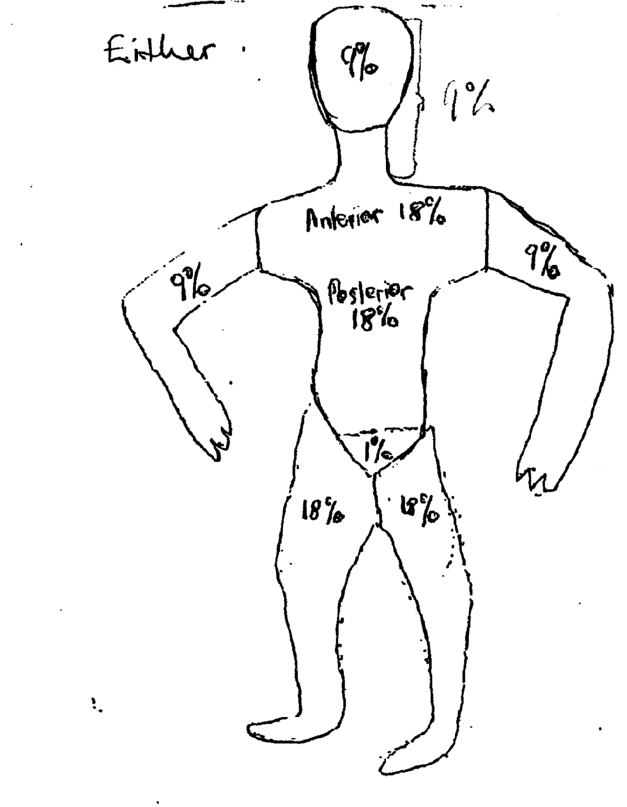

OR
The body is divided into segments each representing 9%, the total equals 100%. The division is as follows:
- The head and neck = 9%
- The whole of the upper limb = 18% (9% each)
- The anterior trunk = 18%
- The posterior trunk = 18%
- The thigh = 18% (9%each)
- The lower limb = 18% (9% each)
- The perineum = 1%.
(½ mk for any correct 8 points 4mks).

e. MEDICAL AND NURSING MANAGEMENT OF Y1NKA
A. MEDICAL MANAGEMENT
1. Fluid Replacement therapy:- This is based on anticipated rate, volume and composition of fluid losses. The type and rate of administration of fluid therapy are influenced by the extent and depth of the burns and patient’s weight, age and general physical status.
According to Artz C4P, et al (1976), the formulaê that are used as quide for fluid resuscitation are based on the patients’ body weight multiplied by the total percentage of burned surface area (i.e. in 2 and 3 degree bums).
Several formula abound but the commonest three are Evans, Brooke’s and Parkland formulars. Rigid adherence to a particular formula is ‘impossible.
Adjustments are determined by the surgeon according to urinary out put. But there is a consensus formula.
Consensus formula
- Salt and water are essential in the first 24 — 48 hours post burns period.
(ii) Colloid may or may not he necessary
(iii) Salt solution in the first 24 hours.
- 2— 4m1/kg body weight x % burns area.
- Half of the calculated total is given in the first 8 hours post burns and other half is given over the next 16 hours.
(iv) I.V. Fluids 5— 10% Dextrose in water is given to replace insensitive losses.
2. Wound Care
Several methods of local and systemic treatment are employed to prevent infection in severe burns.
Four methods usually employed in local treatment include:
i. Open or exposed method: Here, the wounds are treated open
ii. Closed or occlusive method: Wounds are covered with many sterile layers of gauze with antimicrobial agent.
iii. Wound debridement is done by the surgeon under local or general anaesthesia.
iv. Skin grafting may also be performed by the surgeon.
[
3. Antibiotics: Systemic antibiotics are given to prevent infections e.g. IV Ciprofloxacin and I.V metronidazole.
4. Pain Management: Analgesics are given for pain control, e.g. I.M paracetamol or LM pentazocine may be given. However, analgesics with respiratory depressant effects should be given with caution.
5. I.M Tetanus toxoid and Antitetanus Serum: These are given to prevent or treat likely tetanus infection.
6. Rehabilitation: Rehabilitation should be commenced early to reduce or prevent contractures.
(½ mk each for any correct 4 points = Total 2mks).
[
B. NURSING MANAGEMENT
1. Assessment: - A quick evaluation of the surface area burned and the depth is made. The skin tugour is noted to assess the fluid and electrolyte status. Vital signs should be checked.
2. Airways: - If respiratory status assessment indicates respiratory impairment, humidified oxygen is administered. Suctioning may be carried out to clear the airways of secretions.
Endotracheal intubations will be of benefit if respiratory embarrassment increases.
3. Patient should be given high calorie food. Fruits should be encouraged to aid wound healing.
4. Wound dressing should be done with appropriate anti-septic solution
5. Patient should be assessed for pain and analgesic should be given to relieve pain as prescribed.
6. Physical care: - Patient should be assisted to meet activities of daily living. Bed bath and oral toileting should be done by the nurse.
7. Report decreased urine output or increased blood urea nitrogen (BUN) and creatinine values to head nurse or physician.
8. Maintain nasogastric tube on low intermittent suction until bowel sound resume.
9. Administer histamine blockers and antacids as prescribed as such medications reduce gastric acidity and risk of ulcerations.
(½ mk each for any correct 8 points = Total 4 mk).
[
[
f. PREVENTION OF BURNS
1. She should ensure that all gas cylinders are closed where there is an open flame e.g. cigarette smoke.
2. Fire extinguisher should always be placed in the kitchen or hotel corridor and everybody should know how to use it.
3. All gas cylinders should be painted with their appropriate colour in order to be able to identify those that are highly inflammable.
4. Proper storage of inflammable substances or gas cylinders.
5. Advise the patient to avoid storing flammable liquids near a fire source or taking flammable liquid, especially petrol, to the kitchen.
6. Caution against throwing flammable liquids onto an already burning fire.
7. Advise the patient to develop and practice a home exit fire drill with all hotel staff.
8. Advise patient to install and maintain smoke detectors on every level of the hotel.
9. Turn off all electrical appliances when not in use.
(½mk each for any correct 4 points Total 2 mk).

4a. Description of Nephrotic Syndrome
Nephrotic syndrome is’ a collection of signs and symptoms of renal disorder characterized by:
- Generalized/Massive oedema
- Hyperalbuminaemia
- Marked proteinuria
- Hyperlipidaemia

It is most often seen in children but can occur at any age.
Definition -1 mk
Characteristics — ¼ mk each for any correct 4 points
Total=2mks

b. Causes of Nephrotic Syndrome
- Chrnnic glomerulonephritis
- Systemic lupus erythematosus
- Diabetes mellitus
- Sickle cell disease
- Amyloidosis
- Bacterial infections (e.g. streptococcal, syphilis)
- Viral (Herpes Zoster, HIVAIDS. Hepatitis)
- Hodgkins disease
- Multiple myeloma
- Lung cancer
- Colon cancer
- Gastric cancer
- Breast cancer
- Leukaemia
- Bee sting allergy. Pollen
- Drugs (penicillamme, NSAIDS, Heroin)
- Snake venom
- Heredity.
- Mercury poisoning
- Severe congestive heart failure
- Renal vein thrombosis.
½ mk for any correct 6 points = 3 mk
[
C. Pathophysiology of Ncphrotic Syndrome
- The pathogenesis of nephrotic syndrome is not well understood. There may the metabolic, biochemical or physiochemical disturbance in the basement membrane of the glomeruli.
- Regardless of the cause, there is a derangement in the glomerular capillary and this leads to an increase in its permeability to plasma proteins, especially albumin.
- Consequently, there is loss of protein in urine (protcinuria).
- Protein loss leads to decrease plasma albumin level (hypoalbuninaemia).
- Hypoalbuminaemia results in a decrease in plasma oncotic pressure.
- Fall in plasma oncotic pressure causes fluid to shift from the intravascular space into the interstitial space (ocdema).
- F1uid shift also results in reduction in intravascular fluid volume, which leads to a decrease in renal perfusion pressure.
- Decreased renal perfusion pressure activates the renin-angiotensin mechanism.
- Renin-angiotensin mechanism leads to retention of sodium and water, which worsens the ocdema.
- Also, hypoalbuminaemia leads to increased hepatic synthesis of lipoproteins (hyperlidacmia).
- There is increased susceptibility to infections due to loss of immunoglobulins.
½ mk each for any 10 points = 5mk
[
[[
d. Management of Musa with Nephrotic Syndrome.
Medical Management
The medical management involves:
- Administrative diuretics e.g. Chlorothiw.idc. Furosemide to help relieve oedcma. Potassium supplements may be given to replace potassium lost due to the effects of diuretics.
- Administration of corticosteriods e.g. prednisone to induce remission.
- IV administration of human albumin to replace lost protein.
- Immunosuppresant therapy (e.g. cyclosphosphamide, Azathioprine) may be used to reduce symptoms and prevent further relapses in children who do not respond adequately to certicosteroids.
- Paracentesis abdominis and thoracentesis may be performed to remove accumulated fluid in the abdomen and thorax respectively.
- Where all the above measures fail, a kidney transplant may be performed.
½ mk each for any 4 points 2 mks
Nursing Management
Admission: Acute phases of the condition usually require hospitalization. Typically, the patient is admitted into the paediatric ward and away from patients with infectous diseases.
Positioning: Place the client in any position that he feels comfortable in, but turn him frequently (at least every 2 hours to prevent skin breakdown and respiratory infections).
Observations:
- Monitor and record the vital signs, especially the body temperature. Elevated temperature may indicate the presence of an infection.
- Weigh the patient daily and measure his abdominal girth to ascertain the extent of fluid retention.
- Observe the eyes, ankles and other dependent parts for swelling. Note the degree of pitting.
- Monitor fluid in take and out put strictly.
- Carry out daily urine testing to determine the amount of protein lost in urine.

Psychological Care
- Encourage Musa’s parents to freely verbalize their feelings about his condition and its impact on them.
- Involve them in all decision-making regarding Musa’s care.
- Inform them that relapses usually become less frequent as the child gets older.

Diet
- Serve small quantities of food in an attractive manner e.g. using brightly coloured dishes.
- Sit with client during feeding and allow him to feed himself if he is able.
- Consult the child and family to learn which foods are appealing to him.
- Diet should be balanced and high in protein to help replace lost protein.
- Diet should be low in sodium to reduce fluid retention.
- Carbohydrate and fat content of the diet should be high enough to prevent Protein from being used for energy.
Skin/Physical Care
- Inspect all skin surfaces regularly for breakdown
- Bath skin daily and whenever necessary.
- 1-landle the client gently to prevent injury to the skin.
- Scrotal support increases patients comfort, especially during ambulation. Use cotton wool to separate skin surfaces in order to prevent the formation of a rash.
- Protect skin surfaces from pressure by means of pillows and padding.
[
Rest/Exercise
- After the acute phase, allow Musa to participate in normal age-appropriate activities.
- Balance activity with rest periods and encourage the child to rest when fatigued.
[Elimination
- Provide a urinal or bed pan as often as required.
- During the acute phase, a diaper may be used.

Preventing Infection
- Protect the child from anyone with an infection.
- Practice hand washing.
- Maintain medical asepsis.
1 mk each for any correct 6 points = 6 mks

e. Heath Education on discharge
- Teach parents how to test urine and measure weight and abdominal girth.
- Instruct his parents to keep a record of the child’s weight and urinary proteins.
- Instruct Musa’s parents to maintain dietary restrictions e.g. low sodium diet.
- Instruct his parents to report promptly any signs of increased protein in urine, infection or abnormal weight gain.
- Instruct the parents to allow the child to play with other children when in remission. This will enhance the child’s development. He should be made to rest when fatigued.
- Instruct the parents to adhere to follow-up appointments.
½ mk each for any correct 4 points = 2 mks

5a i. Types of cells in blood
- Erythrocyte (Red blood cells)
- Leucocytes (White blood cells)
- Thrombocytes (platelets)
1 mk each 3 marks

ii. Two diseases or abnormal features
A ERYTHROCYTES
- Anaemia
- A-plastic
- Megaloblastic
- Microcytic
- Haemolytic
- Iron deficiency
- Sickle cell disease (abnormal shape of the red blood cell or sickled shape cell)
- Thalassaemia (deficient cellular synthesis of RBC)
- Methemoglobinemia (abdominal amount of heamoglobin build up in the blood) Polycythaemia (an excessive number or increase in RBC)
- GIucose-6-phosphate dehydrogenese deficiency
- FLaemoglobinopathies (red blood cells which contain inherited abnormality of hacmoglobin).
(½ mk each for any correct 2 point = Total =I mk

B. LEUCOCYTES (white blood cells)
- Leucocytosis (increase in the number of leucocytes
- Leukaemia (malignant disorder of WBC or cancer of the white blood cells)
- Leucopenia (reduction in the number of leucytes)
- Neutropenia (decrease number of neutrophils)
- Agranulocytosis
- Gaucer’s disease — (deficiency in the enzyme — glueocerebiosidase which accumulate in WBC)
½ mk each for any correct 2 points = Total 1 mk
[
C. THROMBOCYTES (PLATELETS)
- Thrombocytopenia (decreased number of circulating thrombocytes)
- Thrombocytosis (increase number of thrombocytes)
- Von Wile brand’s disease (deficiency of VWF factor in blood)
- Thrombasthemia (defective functioning of platelets)
- Diseminated intravascular coagulation (an inappropriatate exaggerated stimulation of clotting mechanism which begins with platelet aggregation).
- Wiskoff. Aldrich syndrome (decrease in platelet count)
½ mk each for any correct 2 points Total 1 mk.

b. List six causes of iron deficiency Anaemia
1. Deficient iron intake (dietary inadequacy)
2. Increase body demand during pregnancy or period of rapid growth.
3. Iron malabsoption due to abnormalities in the stomach
4. Haemorrhages chronic blood loss as in GTT bleeding, excessive menstrual flow, hook worm infestation, lice infestation etc.
5. Liver disease
6. Bone disease
7. Hypochlorhydia
8. Tuberculosis
9. Careinomas
I 0. Intravascular haemolysis
II . Toxins in blood.
½ mk each for any correct 6points = Total 3 mks.

c. Precautions to be taken by a Nurse before, 1uring and aftcr blood transfusion
BEFORE
1. Inform patient about the procedure and obtain a signed informed consent.
2. Make requirements ready before going for blood from the blood bank.
3. Collect blood 30 mins before transfusion time.
4. Collect the correct blood component by checking the order with the requisition form, blood hag label, with the technicians specifying client’s name, Id number, blood group type, expiratory date etc.
5. In the ward compare the same laboratory record with another nurse, to check for unattached information.
6. If blood or product have expired or abnormal, do not transfuse.
7. Enter all blood information and client data into the client’s record.
8. Ensure that the patient open bowel and bladder.
9. Wash hands and wear gloves
10. Monitor and record vital signs
I1. Maintain aseptic technique
I 2. Provide privacy
I 3. Place patient in a comfortable position.
14. Inform physician to set up blood
15. Reassure patient
16. Do not put blood in a bowl of hot water
17. Gently rotate blood bag to mix the cells if whole blood is to be transfused.
18. Return blood to the blood bank if the start of transfusion is unnecessarily delayed.
19. Give Lv. infusion and drugs e.g. laxis as prescribed (pre-transfusion medication).
½ mk each Jar any correct 10 points =Total 5mks.

DURING
1. Regulate the rate of flow as prescribed
2. Monitor patient’s vital signs ¼ hourly
3. While the transfusion is running check blood bag for gas bubles or abnormal colour (sign of haemolysis)
4. Document relevant data e.g. starting time, type of blood, blood unit, flow rate etc.
5. Observe for signs of reactions e.g. chills, itching, fl.vct etc. in case of reaction give hydrocortisone as prescribed.
6. If whole blood is to be transfused, check regularly to ensure the mixing of plasma and cells.
7. Discontinue transfusion in case of any reaction and inform physician.
8. Maintain intake and out put record.
9. Continue to reassure the patient.
10. Transfuse blood within 4 hours. Do not transfuse a unit of blood longer than 4 hours.
½ mk each/or any correct 6 points = Total 3 mks.
[

AFTER
I. Discontinue the transfusion
2. Check vital signs and compare with baseline
3. Make patient comfortable and reassure.
4. Remove screen and other gadgets
5. Dispose of used materials properly, but retain bag(s) for 24 hours before discarding incase 01’ any post-transfusion reaction.
6. Document procedure in client’s record including patient’s fear or concerns.
7. Wash your hand after the procedure
8. Wash, dry and store equipment in appropriate places
9. Monitor patient for response to the procedure and its effectiveness.
½mk each for any correct 6 points = Total 3 mks

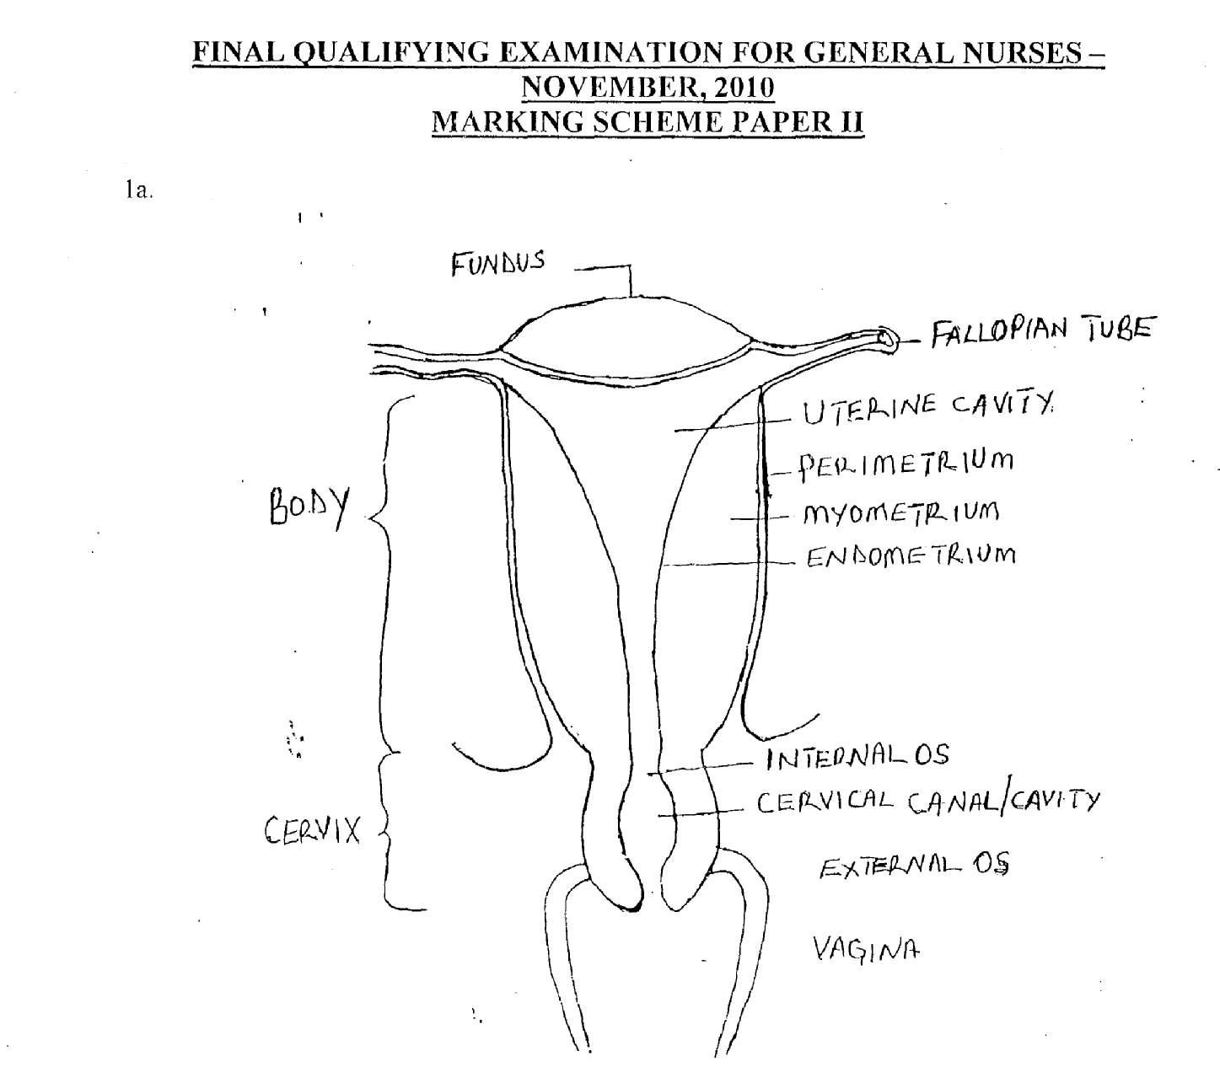

DIAGRAM OF THE UTERUS
Diagram = 1 ink
Labeling = ¼ mk each/or any correct 8 points 2mks.

DESCRIPTION OF THE UTERUS
The uterus is a hollow, muscular organ and pear shaped.
It weights between 30 — 40 grams, but it size varies depending on the parity of
- Position: The uterus is situated in the cavity of the pelvis between the and is held in position by several ligaments in anteverted and anteflexion position.
- The parts of the uterus are the fundus, body and the cervix.
- The fundus is a dome shaped part of the uterus above the opening of the fallopian tube.
- The body is the main part and forms the upper 2/3. The lower 1/3, is the narrowest.
- It ends at the external Os and is continuous with cervix at the internal Os.
- The cervix or the neck of uterus protrundes through the inferior wall of vagina and opens into the vagina at the external Os, there, it forms the fornices. It opens into the body through internal Os. Between is the cervical cavity
(¼ mk for any correct 4 points = 1 mk)

STRUCTURE
The uterus is made up of three layers of tissues.
- Perimetrium
- Myometrium
- Endometrium

- Perirnetrium: - This is the peritoneum and is distributed differently on the surfaces of the uterus. It entends antermy over the fundus, body, and the cervix posteriorly and covers on the fundus laterally.

- Myomctriuni: - Is the thickest layer of the tissues of the uterine wall. It is a mass of smooth muscles tissues and is interlaced with areolar tissue, blood vessels and nerves.
[
- Endometrium: It consists of columnar epithelium which contains a large number of mucus secreting tubular glands. The endometriurn has two layers

- Functional layer: - It is the upper layer which thickens and become rich in blood vessels during the first half of the menstrual cycle. It is the layer that is shed during menstruation.

- Basel layer: It lies nearer to the myometrium. It does not change and it is not lost during menstruation. It is the layer from which the functional layer is re-generated during each cycle.
(½mark each for any correct 2 points = 1½mk

Functions
i Recivers fertilized or unfertilized ovum
ii. It nourishes the fertilized ovum/ foetus to term
iii. It protects the fertilized ovum/foetus to term
iv. Menstrual function
(½ ink each for any correct 2 points = ½ mk)
description = 3 mks)
Total = 6 mks.

b. 6 Risk Factors Associated with Cervical Cancer
1 - Idiopathic
2 - Hereditary -
3 - Multiparity
4 — Multiple sexual partners
5 — Viral infection e.g. Human papiloma virus (H P V)
6 — Hormonal imbalance, and contraceptives
7 — Low socio economic status
8 — Early age in sexual intercourse
9 — Radiation
10 — Immunosupression
11 — Cigarette smoking
12 — Chemicals (uranium).
(½ mk each for any correct 6 points = 3 mrks).

c. Preoperative Nursing Diagnosis
(i). Anxiety related to unknown outcome of surgery evidenced by facial expression, verbalization and asking too many questions
(ii). Deficient knowledge related to the nature of surgery evidence by asking questions
(iii). Interupted family process related to hospitalization evidenced by frequency component reports by the family on what to do
iv. Risk for infection related to surgical incision operative heammhane.
v. Impaired physical mobility related to post operative restrictions and discomfort evidenced by inability to carryout activities of daily living.
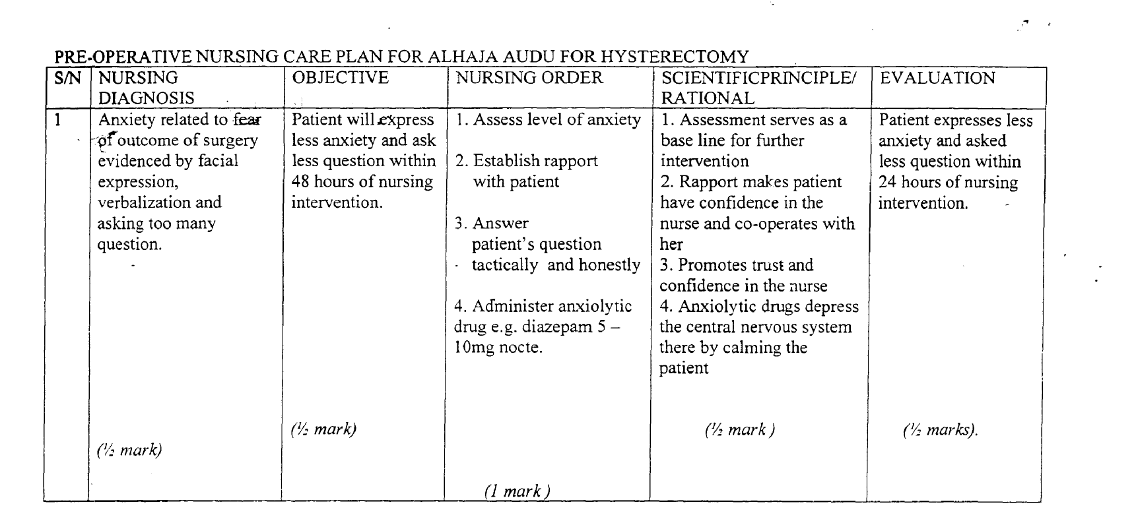
(vi). Risk for deficient fluid volume related to intra-operative haemorrhage.
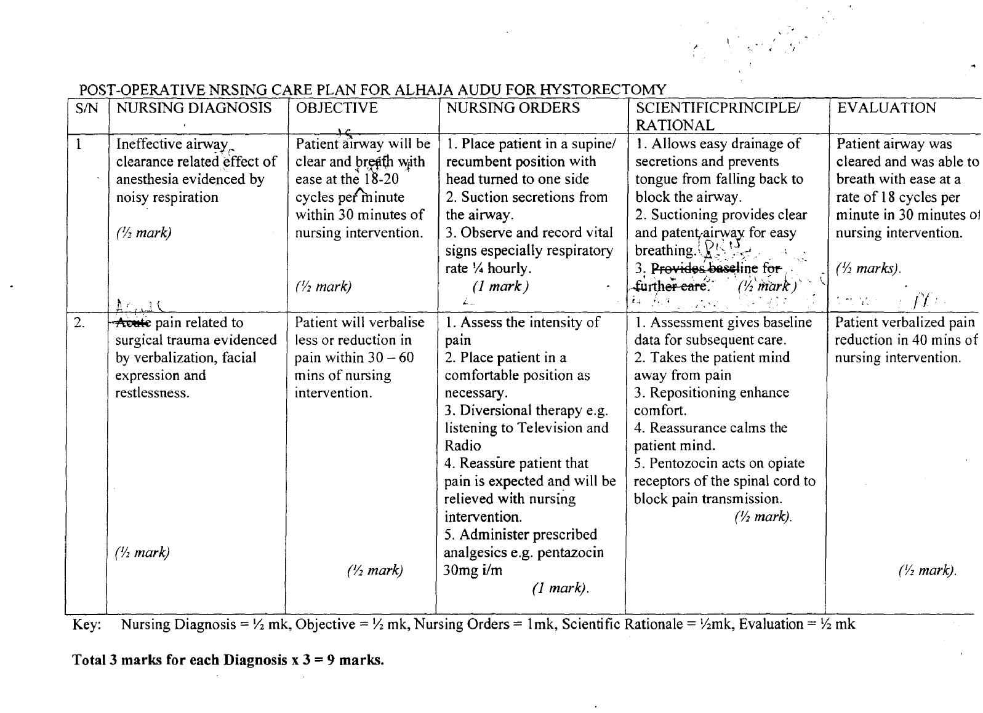

[

d. Advice on discharge
1. Avoid sexual intercourse for the next 3 months
2. Avoid strenuous activities for the next 3 month
3. Encourage to maintain personal hygiene
4. Encourage high protein intake
5. Explain the importance of taking her medications
6. Explain the importance of coming for follow up
7. The patient needs to know, there will be no more menstruation and child birth
8. The patient need to know sexual intercourse will still continue despite hysterectomy
9. Counsel for adoption if she, desires a male child.
(½ mk each for any correct 4 points 2 mks,).
Total = 20 marks.

2a. Definition of Traction
Traction is the application of pulling force to a part of the body to minimize muscle spans, reduce, align and immobilize fracture, reduce deformity and to increase space between opposing surfaces.
OR
The application of pulling force to a part of the body
(1 mark)

2b. Types of Traction
- Fixed traction
- Balanced traction (sliding traction)
iii. Skin traction
iv. Skeletal traction
v. Bucks extension traction
vi. Hamilton Russell traction
vii. Perkin’s traction.
viii. “Dunlop” traction
ix. Gallow’s traction
½ mark each for any correct 4 point 2 marks

c. Nursing Management of Mr. Thomas on traction
i. Physical assessment and preparation - Before traction is applied, check orthopaedic bed if the mattress is firm and level. Explain the procedure to the patient.
ii. Positioning — the patient is nursed flat with his back on bed (dorsal position) and remain so, otherwise immobilization of the fracture would be prevented.
- Explain to the patient and the family members the reason for proper position.
- A firm mattress or fracture board will help in maintaining body alignment.
- Use accessories to prevent foot drop (e.g. foot support).
iii. Skin Care — the skin over bony prominence such as the malleoli, elbow, sacrum and ischeum should be observed for signs of redness or irritation.
- Treatment of pressure areas should be carried out at least every 4 hour to prevent pressure sores.
- Keep the bed dry and free from crumbs and Wrinkles.
iv. Nutrition/Fluid Ensure adequate nutrition rich in protein, vitamins, mineral e.g. roughage calcium and increase fluid intake.
v. Elimination — Assist patient to make use of bedpan to evacuate rectum as reduced GIT mobility results in constipation.
- Ensure a diet high in fibre to stimulate gastric motility.
- Provide urinal when the need arises.
vi. Self Care/Exercise
- Assisted self care activities like bed bathing, oral toilet, deep breathing and coughing exercise should be encouraged.
- Active exercise in form of pulling up on the trapeze, flexing and extending the feet.
- Passive exercise within the therapeutic limits of the traction should be ensured to maintain muscle strength and tone.
vii. Observation observe the skin of the affected site for sensitivity/and circulation.
- Proper placement of traction.
- Patient’s comfort or pain should be assessed.
- Observe the pin site for infection.
- Observe the colour of the extremities

viii. Pin Site Care
- Observe pin sites daily for reaction and infection e.g. purulent discharge, pin loosening and odour.
- For the first 48 hours after insertion, the site is covered with a sterile absorbent, nonstick dressing and gauze.
- After 48 hours, apply loose cover dressing or no dressing.
ix. Divertional Therapy — the patient will likely experience boredom, depression e.t.c. Occupational therapy and divertional therapy in form of handicraft, reading material, radio and television should be provided.
x. Rehabilitation after the removal of traction, the patient is not allowed out of bed immediately, if the foot of bed has been elevated for a long time, otherwise he may experience fainting.
Elevate the head of bed so that lie may adjust to having his head and trunk in an upright position after being flat with his head lower than the body for so long. The elevation is gradual, passive and active exercises are necessary to prevent deformity and restore normal muscle function.
- The help of a physiotherapist is enlisted and to achieve this, crutches or walking sticks are usually useful in regaining independent mobility. This is gradually withdrawn as patient gains confidence in walking.
1 mark each for any correct 8 points = 8 marks

d. Physiology of Bone Healing
1. Haematoma stage — immediately a fracture occurs, there is bleeding from the injured vessels around the fracture site. This is followed by aseptic inflammatory response (except the skin is broken). Later the blood clots, the clot and inflammatory exudates fill the space between the fragments and around the fracture line.
2. Cellular growth stage/regeneration—the clot is not absorbed but becomes part of the bone itself as healing progresses. From adjacent connective tissue and blood vessels, fibroblast and capillaries invade the haematoma and exudates forming granulation tissue (cellular growth). The granulation tissue formed is referred to as provisional callus. Almost at the same time, osteoblast cells from the inner surface of the periosteum proliferate and invade the granulation tissue forming the callus.
3. Callus formation stage — at this stage, the osteoblasts will start depositioning calcium salts in the granulation tissue to form hard cement like tissue called temporary callus. The temporary callus appears like a collar around and between the bone ends of the site, thinking the site thicker than the original bone.
4. Callus (Ossification) stage — at first, the callus is comparatively soft but later becomes harder and converted into bone (permanent callus) due to more deposition of calcium salts by the osteoblasts. Medullary canal is gradually created by the osteoclast. Callus formation could usually be x-rayed around 10th day of fracture.
5. Remodeling/Consolidation stage — this involves re-organization of new bone into its former structural arrangements.
1 mark each for Jive correct point = 5 marks
[
e. Possible Complications that may arise
1. Malunion — This means healing of fracture in an abnormal position like angulation or overriding of one of the bones over the other at the fractured site. This alters the shape and length of the bone with impaired function. This is usually caused by poor reduction and or fixation during healing.
2. Delayed healing — Means that the fracture is not healing rapidly as expected. The cause may be due to a wider gap between the fragments or presence of a tissue or foreign body between bone fragments or due to poor blood supply to the site or due to surgical intervention or infection of the site or malnutrition.
3. Non-Union — This occurs when the granulation tissue which is formed between the fragments is converted to dense fibrous tissue, instead of normal temporary callus to permanent callus.
4. Pressure Ulcer — Skin breakdown result from irritation caused by contact of the skin with the tape or foam and shearing forces.
5. Foot Drop — May occur if pressure is applied to the peroneal nerve at the point at which it passes around the neck of the fibula just below the knee.
6. Circulatory Impairment — this may occur after skin traction is applied, the nurse assesses circulation of the foot and hand within 15 — 30 minutes and every 1 — 2 hours.
7. Atelectasis and Pneumonia —the nurse auscultates the patient’s lungs every 4 — 8 hours to assess respiratory status. The patient is taught deep-breathing and coughing exercises to aid in full expansion of lungs and moving pulmonary secretions.
8. Venous Thromboembollsm —venous stasis that predisposes the patient to venous thromboembolism occurs with immobility.
9. Acute Compartment Syndrome (ACS) — It’s a condition in which increased pressure within one or more compartment causes compromise of circulation to the area; common sites are the lower leg and the dorsal and volar compartment of the forearm. Infection, motor weakness, contracture and myoglobinuric renal failure can occur.
10. Hypovolemic Shock— Shock can occur as a result of haemorhage.
11. Infection — Osteomyelitis is very common.
12. Avascular Necrosis - Aseptic or ischaemic necrosis.
13. Gangrene.
Total =4 marks

½ mark each for any correct 4 points mentioned = 2 marks
½ mark for any 4 point explained = 2 marks Total 4 marks

3.a Definition: Gouty arthritis can be defined as a metabolic disorder characterized by deposition of uric acid crystals in the synovial joint which leads to inflammation and severe pain.
OR
Gouty arthritis is a systemic disease in which urate crystals deposit in the joint and other body tissues causing inflammation. (I mk)

b. Diagram of the basic structure of a synovial joint
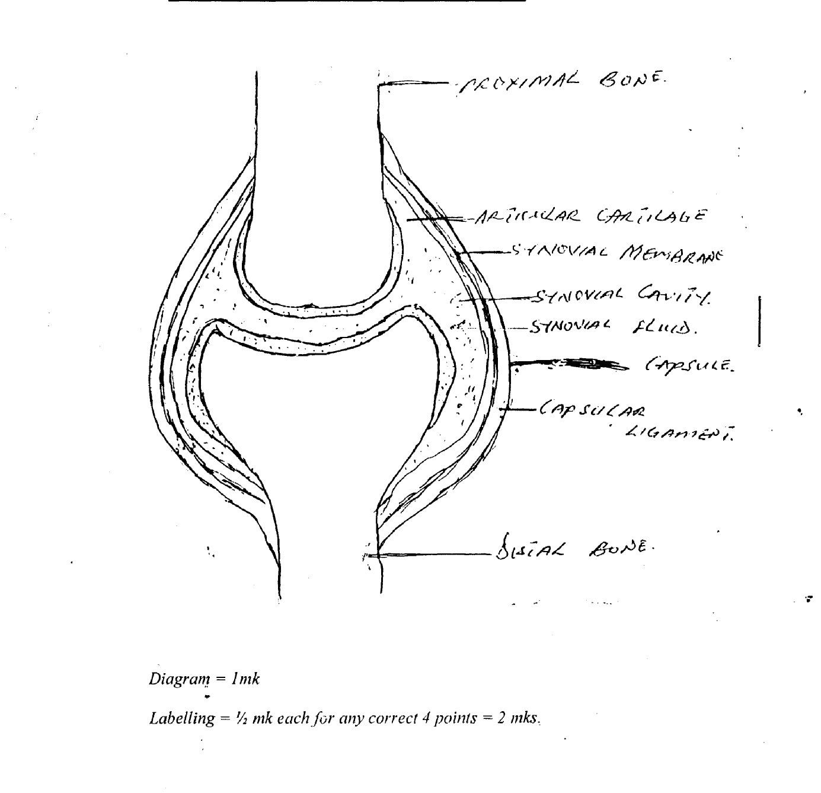

Description: - A synovial joint is a freely moveable joint enclosed in a joint capsule made extra capsular and intracapsular ligament which prevent excessive movement at the joint.
- Synovial joint secretes synovial fluid which helps to lubricate the joint structure preventing friction (¼ mk)

Classification
1. Ball and socket joint example hip and shoulder joint
2. 1-Tinge joint example elbow, knee and ankle
3. Gliding joint e.g. sternoclavicular joint
4. Pivot joint e.g. Atlas, Odontoid joint
5. Cond1oid and saddle joint e.g. wrist, temporamandibular, metacarpal phalengeal etc.
(¼ ink for correct one point ¼ mk)

Structure
1. The bones:- The proximal and the distal bones are held together by a cuff of fibrous tissue called the capsule ligament (¼ mk)
Capsule: The joint is enclosed a sleeve of fibrous tissue which hold the bones together. It is sufficiently loose to allow freedom of movement but strong enough to protect from injury. (¼ mk)
The synovial membrane made up of epithelial cells lines the capsule (¼ mk,)
The synovial Fluid: - A thick, sticky fluid of egg white consistency secreted by the synovial membrane into the synovial cavity made up of:-
- Phagocytes — removing microbes and cellular debris
- Acts as lubricant and shock absorber
- Maintains joint stability
- Prevents friction
- Provides nutrients for the structure
(¼ mk each for any correct 2 points = ½ mk).

Articular cartilage:- Beneath the membrane is anarticular cartilage that lies on the surface of each articulates bone. (¼ mk).

Extra Capsular Structure:- Ligaments that blend with the capsule and provides additional stability e.g., capsular ligament.
(¼ mk each for any correct 2 points =½ mk).

BLOOD SUPPLY:
Corresponding Arteries and veins depending on the location of the joint
(¼mk)
Nerve supply: The corresponding nerve based on the location of the joint
(¼ mk)

3c. NURSING MANAGEMENT
- Admission — Admit in an Orthopeadic ward
- History taking — Obtain history for factors predisposing to gout.
Observation — Observe patient’s pain level and his response to pain-control measures e.g. analgesics.
- Observe vital signs and record.
- Accurate intake and output chart to ensure adequate fluid intake to reduce or prevent renal calculi.
- Monitor joint range of motion ability and appearance of joint (swelling etc.)
- Monitor serum uric level regularly.
- Perform physical examination by inspecting the involved joints.

Pain Control
- Encourage bed rest.
- Immobilize/support painful joints on pillows.
- Apply cold packs to inflamed joint to ease discomfort and reduce swelling.
- Elevate the affected extremity.
- Protect the affected joint from excessive movement by splinting the affected part with casts or braces.
- Use bed cradles to-takeoff the weight of bed lines.
- Give diversional therapy.
[
Nutrition
- Restrict consumption of foods high in purines, especially organ meats (kidneys and liver), shell fish, sardines, meat extracts, wines, cheese as they raise the urate level.
- Give nutritions diet with moderate protein and little fat.
- Encourage intake of alkaline producing foods e.g. potatoes, citrus fruits and juices, milk and other diary products to increase urinary P.H.
- Weight reduction if patient is obese.
- Encourage adequate fluid intake for excretion of uric acid and decrease stone formation.
- Advice patient to limit alcohol intake and fat saturated diets which may precipitate a gout attack.

Exercises Encourage patient to perform as much self-care as his immobility and pain allow.

Psychotherapy
- Promote sleep with sleep aids e.g. extra pillow, bath or back rub.
- Provide emotional support.
- Encourage patient to express his concerns about his condition.
- Listen supportively and answer questions honestly.
- Explain treatments, test and procedures to allay his anxiety.
- Teach patient relaxation techniques.

Drug
- Serve prescribed pain relieving medications
½ mk each for any correct 12 points = 6 mks,)

MEDICAL MANAGEMENT
- Analgesis are provided to relief pain.
- Non steroidal anti inflammatory drugs (NSAID) are considered e.g. Ibuprofen diclofenac, feldene e.t.c.
- Uricosurics are given to increase the excretion of uric acid in urine e.g. colchicines, probecid, allopurinal etc.
- Monitoring of the uric acid blood level to determine improvement.
- Culture the synovial fluid to rule out infection.
- Supplementary drugs are given e.g. heamatinics, sedatives etc.
(½ mk each for any correct 6 points = 3 mks,)

d. Drug of choice in Management of Gout
AlIopurinol (LOPURIN, ZYLOPRIM)
Class - Uricosuric, antigout drug ( ½ mk)
Action Reduces the synthesis of uric acid hence preventing urates formation and it increases excretion of uric acid in the kidney.
(½ mk)
Route of Administration - Orally (½mk)
Recommended Adult Dose - 200 — 600mg in divided dose or 100 — 300mg in divided dose. (½mk)
CONTRAINDICATION - Acute gout, hypersensitivity, pregnancy and lactation
(¼ mk each for any correct 2 point = ½mk).

Side Effect:
- Vomiting, diarrhea & nausea

NURSING RESPONSIBILITY
- Give prescribed drugs correctly.
- Encourage fluid intake during therapy
- Diet of animal protein (red meat) should be reduced because of the high level purin.
- Warn’ patient to avoid hazardous tasks until drug effect is over.
- Take drugs with meals to prevent G.I.T ulceration.
- Discontinue medication if rashes or any other evidence of allergic reaction occurs. (4 mk each for any correct 2 points = 1 mk)

COLCHICINE
CLASS — Uri cosurics (½mk)
ACTION — It increases urinary excretion of uric acid thereby preventing accumulate of urates in the kidney and joint (½mk)
- Route—Orally (½mk)
- Recommended Adult dose
0.5 — 1mg every 2 hours (½ mk)
- Contra Indication: - Known G.I.T, renal or cardiac disorder, pregnancy and lactation (½mk)
- Side effects: - Vomiting, nausea and Diarrhea (½ mk)

Nursing Responsibilities
- Do not administer to patient with G.I.T, renal or cardiac disorders
- Give plenty of water
- Watch for side effects and treat promptly
- Take drugs with meal to prevent G.I.T. ulceration.
(½ mk each for any correct 2 points = l mk)
Piroxicam (feldene)
- CLASS: - Non —steroidal anti inflammatory drug (½ mk)
- ACTION:- Inhibits prostaglandin synthesis through a reversible inhibition of cycle oxygenase enzyme
* It inhibits neutrophil aggregation (½ mk)
- RECOMMENDED ADULT DOSE: 20-40 mg daily (½mk)
- ROUTE OF ADMINISTRATION: - Topically, orally, suppository and
intramuscularly (½mk)

- CONTRA INDICATION: Acute peptic ulceration, hypersentivity, nursing
mothers, pregnancy. (½ mk)
- SIDE — EFFECT: - Nausea, G.I.T. bleeding, peptic ulceration, indigestion, skin rash and constipation heartburn
(¼ mk each for any correct 2 points = ½ mk)

NURSING RESPONSIBILITY
- It should be discontinued if skin irritation develop
- Not to be administered to patients with G.I.T. disease
- Give with milk or meal to prevent G.I.T. irritation
- Watch for side effects of drugs
(½mk each for any correct 2 points = 1mk)

OTHER DRUGS ARE:
- Corticosteroids e.g. predinsoloñe
- Probenecid
- Aspirin
- Indocid (Indomathazine).

4a. Malaria is a disease of wide spread distribution caused by plasmodium.
OR
Malaria is an acute infection which is characterized by paroxysmal (recurrent) attack of fever, anaemia, splenomegaly caused by plasmodium.
I mark for any correct point = I mark
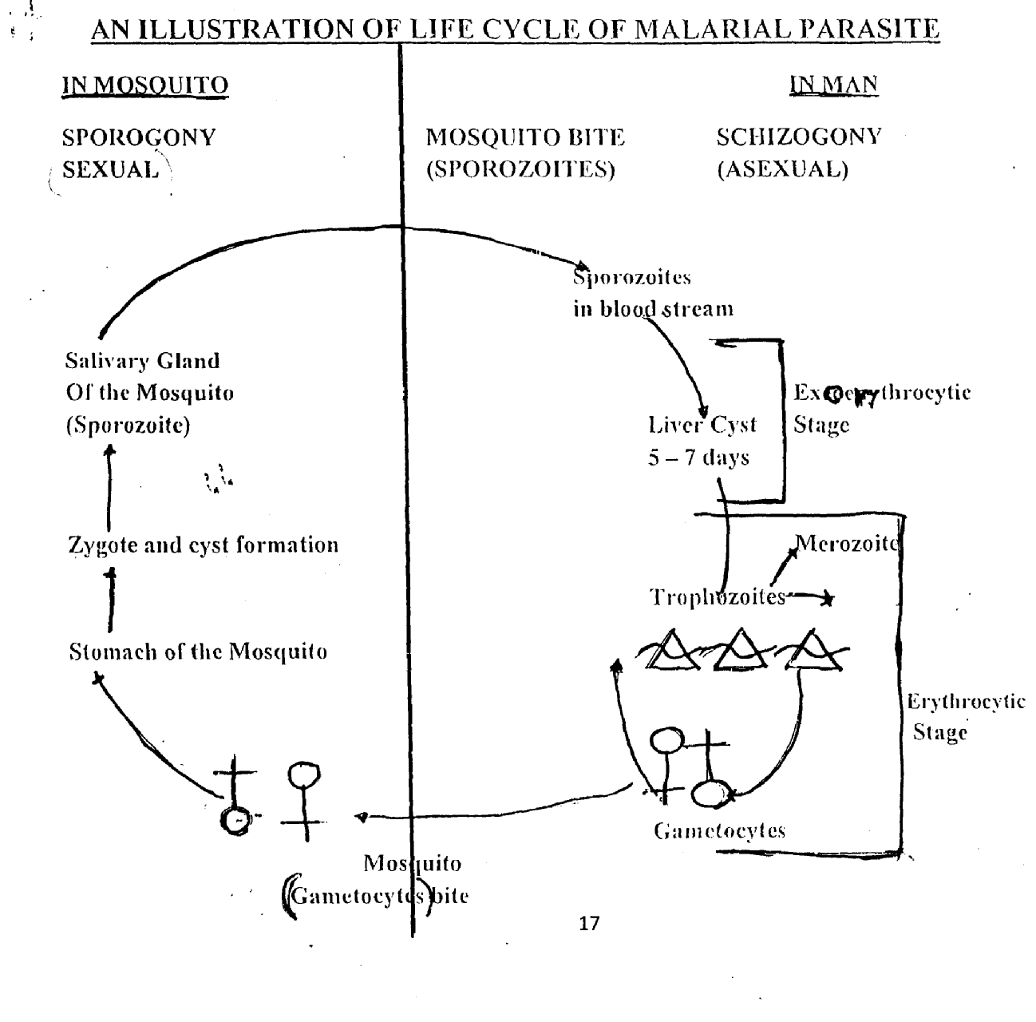

- When female anopheles mosquito bites a person infected with malaria (plasmodium) and sucks up their blood, it also picks the parasite (gametocytes).
- The male and female gametocytes of the plasmodium in the human blood enter the mosquito’s stomach.
- They unite and multiply and sporozoites develop (sexual phase)
- Sporozoites enter the insect’s salivary glands and are injected into another human when the mosquito takes a blood meal.
- Sporozoites stays in the blood stream for about 30 minutes and then travel to the liver and form a cyst and remains there for 5 — 7 days during this time they multiply into merozoite (pre-erythrocytic stage).
- Merozoites are then liberated into the blood stream, they invade the red blood corposcles and start destroying the RBC (depending on the host’s body defence mechanism) (Erythrocytic stage).
- Some merozoites develop into male and female gametocyte, which may then be sucked up by the mosquito.
- Some of the merozoites liberated from schizonts of the pre-erythrocytic stage do not enter the blood stream but re-enter the parenchymal cells of the liver while some re-invade the RI3C producing a relapse (Exo-erythrocytic stage). So life cycle begins again.
Illustration 2 marks
Explanation = ½mark each for any correct 8 point 4 marks

c. Prevention and control of malaria
2 Approaches in mosquitoes and humans (individuals)

1. Elimination of mosquito by:
- Applying long lasting insecticide sprays to the walls of all dwelling places at regular intervals.
- Keeping houses clean, good light and airy.
- Killing mosquitoes when they are seen.
- Using short acting insecticides in the home.

2. Prevention of breeding places of mosquito by:
- Draining swamps, ponds and collections of stagnant water.
- Removing any containers around the house that may hold water.
- Covering water containers around the house that may hold water.
- Covering water containers and tanks.
- Cutting grass and shrubs short around the household.
- Pouring oil on the water surface to prevent larvae from breathing.
- The use of larvicides to kill larvae.
- The introduction of larva-eating fish into reservoirs

3. Education (e.g. at school, clinics, market etc)
- Teaching the local population of the dangers of allowing mosquitoes to breed and of the prevention of breeding
4. House-to-house inspections and home visiting by local community health workers to encourage all preventive measures.
I mark each for any correct 4 points 4 marks
b. Protection of the individual by:
1. Using mosquito nets on doors and windows in the homes.
2. Taking anti-malaria drugs regularly (especially pregnant women, children under 5 years and non iminune newcomers to the area.
3. Using mosquito net at night.
4. Using insect repellant sprays, creams or mosquito coils.
5. Wearing clothing to cover the arms and legs at night.
6. Treating an attack when it occurs.
7. People receiving blood transfusions from donors who are likely to be infected should have routine anti-malaria drug.
8. Early detection and prompt treatment.
½mark each for any correct 8 point 4 marks

d. 4 diseases that could be transmitted by mosquitoes
• Malaria
• Dengue fever
• Lassa fever
• Heamorrhagic fever
• Arbovirus encephalitis
• West nile encephalitis
• Japanese encephalitis
• Malayan filariasis
• Bancroftian filariasis
• Elephantiasis
• Yellow fever
• Ebola fever
• Hepatitis
½ mark each for any correct 4 points = 2 marks
e. Roll back malaria initiative in Nigeria was introduced in 1998. Goals of
Roll Back Malaria
- Support to endemic countries in developing their national health system as a major strategy for controlling malaria.
- Developing the broader health sector i.e. all providers of health care to the community including the private sector (drug vendors and traditional healers, pharmacists and others).
- Encouraging the required human and financial investments for health system development nationally and internationally.
¼ mark each for any correct 2 points ½mark
Objectives
- The general objective is to significantly reduce the global burden of malaria through interventions adopted to local needs and by re-enforcement of the health sector.
- It will build upon existing initiative on malaria.
- Aim the WHO special fund for Africa and Medicines for Malaria Venture (MMV).
Any one correct point = ¼ mark
The elements of the RBM strategy are:
- Early detection
ii. Rapid treatment
iii. Multiple prevention
iv. Well coordinated action
v. Dynamic global movement
vi. Focused research
¼ mark each for any correct point = ¼ mark

Four (4) concepts involved are:-
1. Consist of the use of prophylactic anti-malaria drugs e.g. suiphadoxine pyrimetamine to boost he immunity of the individual and vaccination.
2. Consist of the use of insecticides treated mosquito net and environmental sanitation.
3. Involves giving information about the cause, preventive measures, control and management of malaria fever may be done through town announcers and mass media.
4. Operational research where a group of people find out about the incidence, epidemiology, prevalence and monitor the disease to make sure that it is eradicated.
½ mark each for any correct 4 points = 2 marks

5a. A man with a stab Wound on the head by armed robbers
1. Assess the extent of the injury to determine the depth of the wound, and internal and external haemorrhage.
2. Control or arrest bleeding by applying firm pressure (clean towel or handkerchief).
3. Lay victim safe and loose tight clothing.
4. Assess vital signs and/or level of consciousness
5. Calm the patient and famiIy members.
6. Control the crowd, the on lookers and passersby.
7. Nil per oral if signs of shock observed.
8. If skull fracture is suspected, immobilize head with a wrapper or head tie fastened over the head.
9. Arrange for the security agent to be informed.
10. Arrange for the transfer of the victim to the nearby hospital for further management.
Hospital
1. Assess and determine the extent of injury and patient’s general condition.
2. Shave hair around the wound.
3. Irrigate the wound gently with copious fluid.
4. Inspect the bleeding vessels, tie and clamp
5. Suture wound if necessary
6. Apply a non-adherent dressing to protect the wound
7. Fluid/Blood replacement.
8. Administer prescribed antibiotics ATS, ‘TT and analgesics.
9. Educate patient and relation on his condition.
10. Give a multidisciplinary team approach.
½ mk each for any correct 8 points 4 mks

b. A 4 year old child who swallowed a closed safety pin
1. Calm the child and reassure parents.
2. Loose tight clothing around the neck and chest.
3. Ensure patent air way.
4. ‘Fake history of how, when and the size of the safety pin.
5. Ask whether child is having any pains in the throat/oesophagus or having difficulty in swallowing water, food or feeling of sharp pains.
6. Monitor the vital signs.
7. Discourage or do not induce vomiting.
8. Prepare for a transfer to a nearby hospital.
9. Arrange for X-Ray and/endoscopy.
10. Observe the child’s stool
11. Plan for surgical removal if necessary
12. Parents should he educated on importance of home accident prevention.
½ mk for any Correct 8 points 4 mks.

c. Victims of a Collapsed 3 Storey Building
1. Alert emergency services, NEMA, Fire Services and security agents.
2. Reassure victims or survivors at a safer place.
3. Remove tight clothing.
4. Treat casualties based on danger level (triage)
5. Control crowd and traffic as needed
6. Establish breathing and proper circulation (life saving measures).
7. Seek assistance.
8. Transfer the critical victims to the hospital.
Hospital
9. Identify patients and document patients’ information.
10. Triage
11. Treat
½ mk each for any correct 8 points = 4 mks

d. A mechanic apprentice bleeding from a broken tooth after a fight
The nurse should stay calm, be focused and take charge.
1 Calm the victim or affected.
2. Inspect the affected site.
3. Assess for bleeding and arrest with clean cotton-wool or handkerchief.
4. Refrain the victim from talking.
5. Immobilize the affected side if fracture is suspected.
6. Observed vital signs.
7. Give mild analgesic and ice pack to relief the pain.
8. Transfer the victims to the hospital.
½ mk each for nay correct 8 points = 4 mks
c. A mason who mistakenly shoves sand into his right eye.
I. No attempt should he made to remove the foreign body (small or big)
2. Ask patient to deep and blink the cc in a clean bowl 0 water.
3. The eye should he protected using a metal shield or a still paper clip.
4. Avoid rubbing the affected eye.
5. Transfer to the hospital.
[
Hospital
1. Welcome and calm the patient.
2. Assess the eyes.
3. Arrange for eye irrigation
4. Give analgesic and antibiotics.
5. Arrange for eye specialists for further management.
½ each for any correct 8 points 4 inks

FINAL QUALIFYING EXAMINATION FOR GENERAL
PSYCHIATRIC/PERTOPFRATWE NURSES –NOVEMBER 2006
MARKING SCHEME- PAPER II
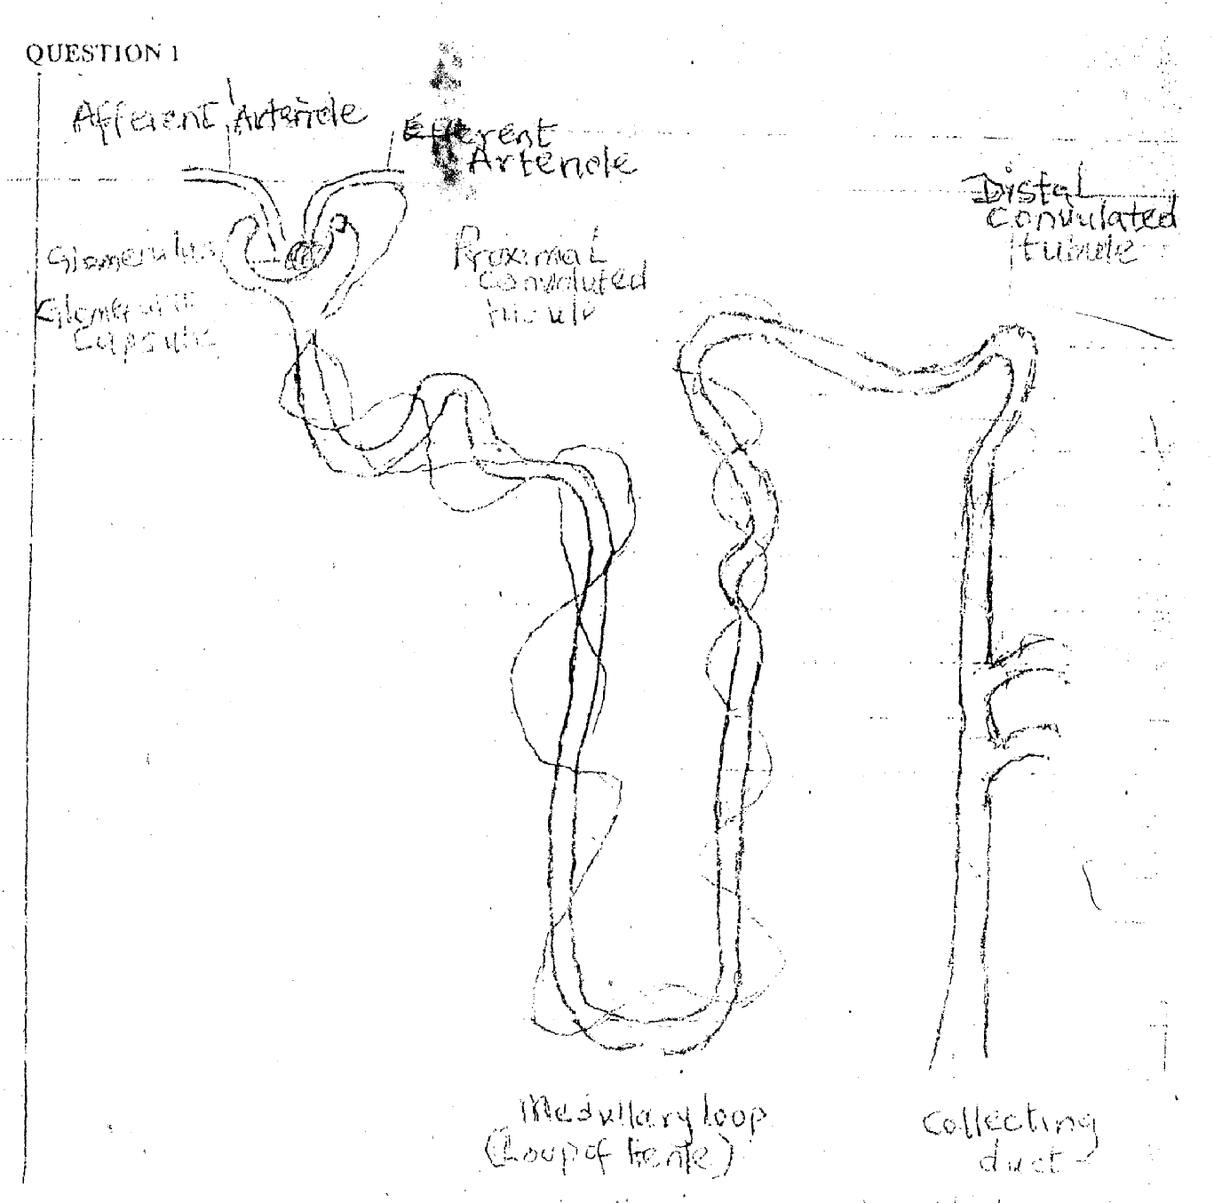
Diagram of the microscopic structure of the kidney

Scoring. Well drawn diagram 1mk
Labeling –Correct labeling of proximal convoluted tubule ¼ mk
Distal convoluted tubule - ¼ mk
Loop of Henle -¼ mk
Collecting duct - ¼ mk
Glomerular capsule - ¼ mk
Glomerulus’s -¼ mk
Afferent arteriole - ¼ mk
Efferent arteriole -¼ mk
Total = 2 Marks.
Description
- The microscopic and functional unit of the kidney is also called the nephron (¼mk)
- There are about million nephrons in each kidney
- It is closed at one end called the glomerular capsule or Bowman’s capsule and opens into a collecting tubule duct (¼ mark).
- Bowman’s capsule encloses a network of arterial capillaries called glomerulus (¼ mark)
- The remainder of the nephron that continues from the Bowman’s capsule is 3 cm long and is described in three parts.
• The proximal convoluted tubule (¼ mk)
• The loop of Henle (¼ mk)
• The distal convoluted tubule, that leads into a collecting duct
(¼ mk)
- The collecting duct unite to form larger ducts that empty into the minor calyces (¼ mk)
- The renal artery enters the Kidney at the hilum, divides into smaller arteries and arterioles.
In the cortex, an arteriole, the afferent arteriole, enters each glomerular capsule, subdivides into a network of capillaries to form the glornerulus. (½ mk).
- Blood vessels leading away from. the glomerü1u is the efferent arterioles, it supplies oxygen and nutrients to he remainder of the nephron (¼ mk).
- Venous blood drained from the capillaries leaves the Kidney in the renal vein which empties into the inferior vena cava (¼mk)
- The blood pressure in the glomerulus is higher than in other capillaries because the diameter of the afferent arteriole is greater than that of the efferent arteriole (¼ mk). Total 3 marks.

1b. CAUSES OF RENAL FAILURE
i. Myocardial infarction
ii. Heart failure
- Trauma
iv. Alcohol
v. Shock
vi. Sepsis
vii. Tumours
viii. Kidney Stones
ix. Glomerulon-ephritis
x. PylonelonPhitis
xi. Nephrotoxic agents
xii Prolonged renal ischaemia
xiii. Heamorrhage
xiv. Benign prostatic hyperplasic
xv. Urethral Stricture
xvi. Blood clots. (½mk each for any four correctly written 2 marks)
Ic. Pioritized Identification of Mr. Adio’s Nursing Diagnoses
Acute Renal Failure).
1. Excess fluid volume related to decrease urinary output and retention of sodium and water.
2. Anxiety related to decreased urinary output.
3. Imbalance nutrition, less than body requirement related to disease condition o anorexia or nausea and vomiting.
4. Deficient knowledge regarding condition and ‘treatment
5. Actively intolerance related to fatigue, anaemia, retention of waste products and sepsis.
6. Hyperthermia related to systemic involvement and disturbance in 11w thermo regulating system.
7. Low self esteem related to role changes and sexual dysfunction.

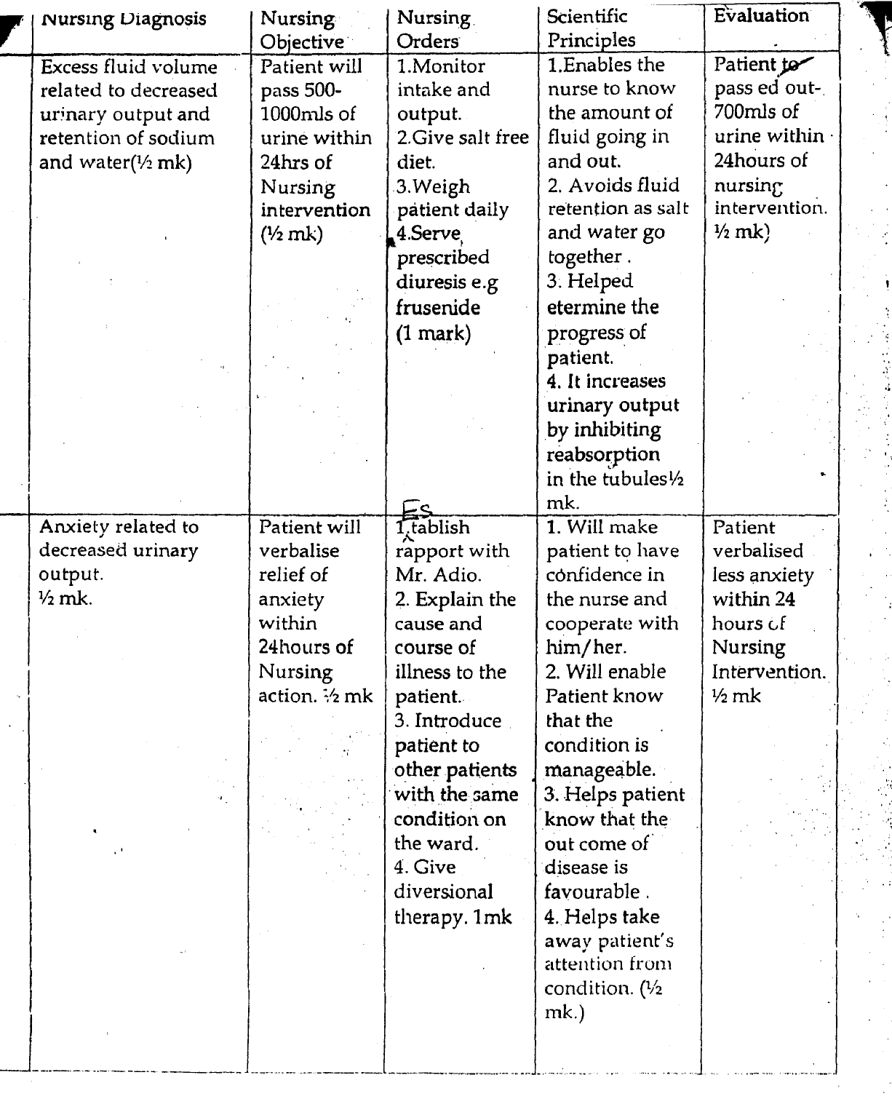

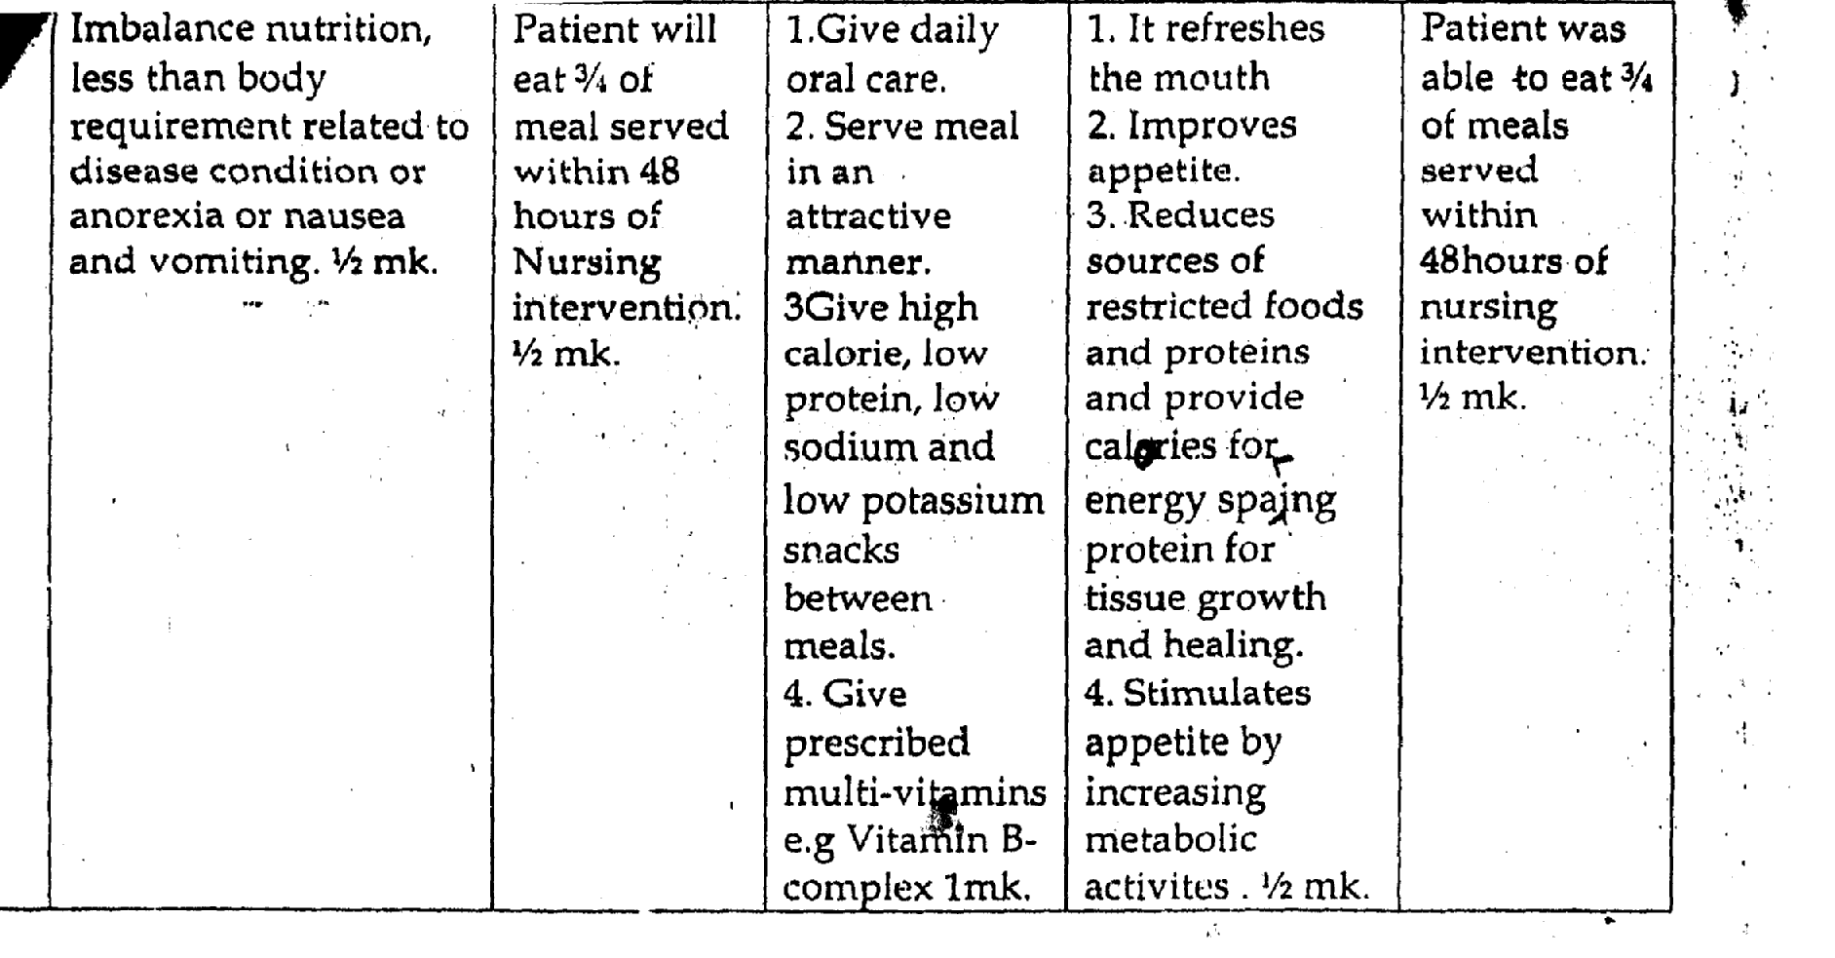

Id. Dialysis is a technique used to remove waste products from the blood and excess fluid from the body and treatment for Kidney failure. There are two methods of dialysis. Haemodiatysis and peritoneal dialysis. In both methods, excess water and wastes in the blood pass across a membrane into a solution (dialysate) which is then discarded.
a. Peritoneal Dialysis - In peritoneal dialysis, the peritoneum, a serous membrane that cover the abdominal organs and lines, the abdominal wall, serves as the semi permeable membrane. Sterile dialysate fluid is introduced into the peritoneal cavity through an abdominal catheter at interval. Urea and creatinine, are cleared from the blood by diffusion and osmosis as waste products move from an. area of higher concentration (the peritoneal blood supply) to an area of lower concentration (the peritoneal cavity) across a semi-permeable membrane (the peritoneal Membrane), Ultra filtration. (Water removal) occurs in peritoneal dialysis.
b. Haemodialysis - Haemodialysis filter out waste by passing blood through on artificial Kidney machine. The process takes 2 —6 hours. Blood flows from an artery (usually an arterial catheter in the radial or femoral artery) to a haemofilter.
Cannulation of the artery and vein provides the necessary gradient in arterial and venous pressure. The filtered blood then returns to the patient’s circulation through a venous cather. Electrolytes are eliminated only as they are pulled along and removed with the fluid. Ultrafiltrates is collected in a drainage bag, measured and discarded.
Mentioning of the two types = ½ mk,
Definition =½ mk.
Explanation/Description 1 mark each = 2 marks.

QUESTION 2
Definition
a. Vesico - Vaginal fistula is an abnormal opening between the vagina/and the urinary bladder. (1 mark)
[
Anatomy and Physiology
b. Introduction.
The human vagina is an elastic fibro muscular tube lined with stratified squamous epithelium. Usually about 100 mm longs and 25mm in diameter It is a canal running from the vestibule to the cervix. It runs obliquely upwards and backward into the pelvis at an angle of 45⁰. The posterior wall is 10 cm long while the anterior wall is 7. 5cm in length. .

Structure
The vagina, has an outer covering of areola tissue, a middle Layer of vascular connective tissue and an inner linning of stratified squamous epithelium that forms ridges or rugare, these allow the vaginal well to stretch during intercourse and child birth. It has no secretory glands but it is moistened by mucus from the cervix.
The upper end of the vagina called the vault. It is divided into four (4) fornices. The posterior fornix being the largest behind the cervix. The. anterior fornix lies in front of the cervix and is in contact with the base of the bladder. The lateral fornix lies the area of the vagin1on either side.
Related Organs.
Anteriorly - Bladder and urethra
Posterioly - Pouch of Douglas
Laterally — Ureters, muscles of the pelvic floor.
Superiorly - The uterus
Inferiory — The external gentalia

Blood Supply.
From branches of internal iliac artery and vaginal artery.
Venous drainage - Corresponding internal iliac vein.
Lymphatic drainage — It is through the deep and superficial iliac gland.
Nerve supply — Parasympathetic and sympathetic nerve.

Function
- It is a passage which allows the escape of menstrual flow.
- It receives penis and the ejected sperm during sexual intercourse
- It provides an exit for the foetus during delivery.
(¼ mark for any correct point x 20 points)
[
c. Pathophysiology of Vesico —Vagina/Fistula
Normally, there should be no communication between the bladder and the vaginal because the bladder is one of the urinary organs while the vagina is one of the reproductive organ
In vesico — vagina fistula, there is an abnormal communication or opening between the bladder and vagina due to either of obstructed labour, instrumental delivery, traumatic injury or surgery etc causing the bladder and vagina that are being in close lie to compress against each other and against the pelvic bone along with its blood vessels depriving the tissues of blood supply. Subsequently, there will be tissue necrosis, sloughing and perforation leading to fistula.
Since the perforation invokes the bladder and the vagina, the bladder is unable to store urine and urine drips from the bladder into the vagina tissue causing pruritus and soreness of the vvlva and vagina giving rise to other signs and symptoms.
Introduction (½ mark)
Actual Pathophsiology (2 marks)
Conclusion (½ mark)

d) Identified Nursing diagnosis (Problems)
i) Ineffective breathing pattern related to effect of anaesthesia
ii) Altered body comfort (Pain), related to effect of surgery or
Acute pain related to effect of surgery
iii) Risk for infection related to effect of catheterization.
iv) Anxiety related to hospitalization

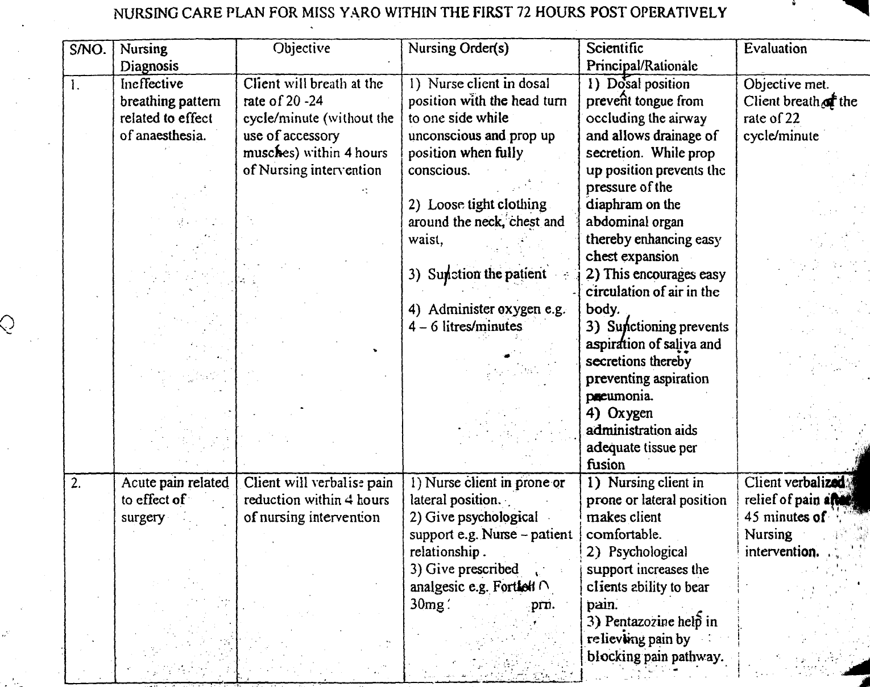

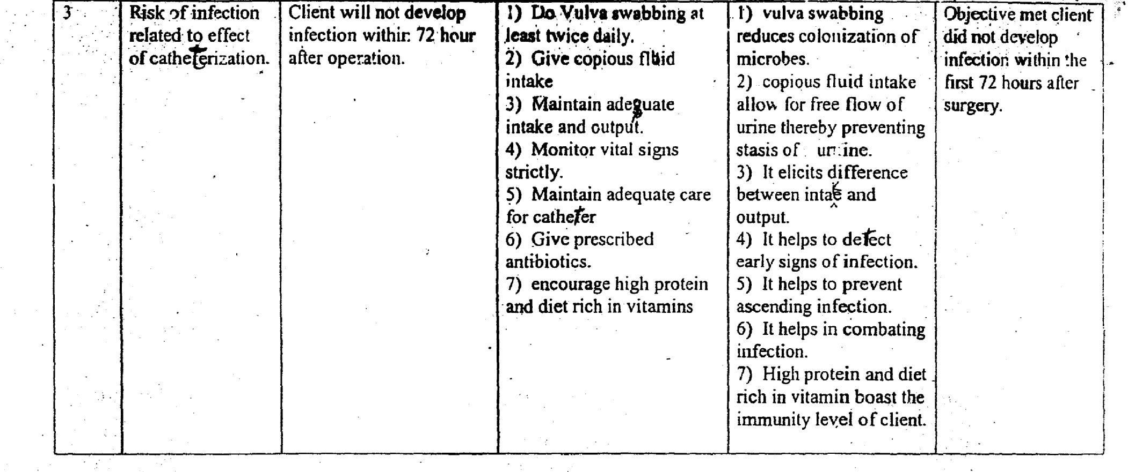
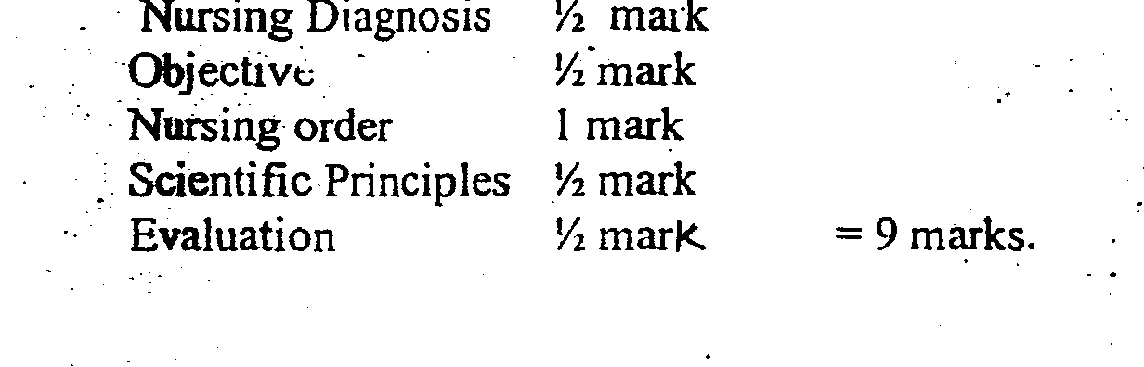
2(e). Psychosocial Implications of vestico—vaginal Fistuala:
1. Neglect by the partner, because of the dribling and the ammonia odour of urine.
2. Psychological trauma leading to depression.
3. Avoidance of social interraction and subsequent rejection by the society.
4. Unafordable costs of repair and elective caesarian section among those who ‘get pregnant later.
(½ mk each for any correct paint — 2 Marks)

QUESTION 3
3a. Definition — Glaucoma is an eye disorder characterized by increase intraocular pressure above the normal range (15-22MMHg) which causes damage to the, optic nerve and loss of visual field. (1 mark).

3b. Pathophysiology of Glaucoma (4 marks)
Increase intraocular pressure occurs when the rate of formation/secretion of aqueous humour by the ciliary’s body supersedes the rate of its drainage or outflow through trabecular mesh of the filtration angle into the canal of schlemm. (1 mark)
Glaucoma could be classified as primary, secondary or congenital. The priiary1 acute form may be referred to as acute angle closure glaucoma; the primary chronic type is called open angle or simple chronic glaucoma. The secondary glaucoma is associated with infections, inflammation, trauma, or tumour within the eye. (I mark)
In any of these precipitating factors, there is structural damage and blockage of the.’ canal of schlemm, trabecular mesh and thickening of iris. These lead to blockage of the• normal flow of the aqueous humour leading to increased intraocular pressure in the anterior chamber of the eye.
(1 mark)
The increased intraocular pressure compresses the optic nerve, retina and blood vessels within the eye leading to atrophy and blindness which could be permanent or transient. (½ mark)
As a result, the patient experiences severe pain, nausea, vomiting and blurring of vission. The pupil becomes dilated and fixed. There is evidence of congestion, Oedematous or steamy cornea with loss of transparency.
(½ mark)

3c. Management of Pa Osi
- Admission - the patient is admitted to the eye unit, followed by all admission procedures. (½ mark)
ii. Assessment - through assessment of patient is to be carried out. The following’ specific assessment should be highlighted. (½ mark)
- Patient health history, social and family history
- Physical assessment
- Assist in- diagnostic procedures such as
- Ophthalmoscopy and tonometry
- Blood test - ESR, WBC etc.
iii. Medical management (1 marks)
- Prescribed medications are administered e.g. mydriatics, timolola miotics and diamox
- Antibiotics to control infection
- Antiemetics to control vomitting
- Analgesics to control/relief pain
iv. Surgical intervention e.g. Trabeculectomy, or Iridectomy, Trabeculoplasty, drainage implant (shunt)
v. Nursing Managements (7 marks)
(a). Preoperative Nursing Management.
1. Educate on the importance of the operation i.e. it will help in improving sight and prevent permanent damage
2. Explain the condition to the patient e.g. that one of his eyes will be covered following the surgery
3 Assess and treat upper respiratory trait infection
4 Give psychological support and reassure the patient
5. Show patient those who have undergone similar surgery in the ward.
(b). Post operative Nursing Management.
- Place the patient in supine position for the first 24 hours.
- Observe vital signs and record your finding.
- Observe operated eye for bleeding.
- Observe unoperated eye for involvement e.g. visual acuity.
- Dress and pad the eye with gauze.
- Instil eye drops as prescribed.
- Give copious fluid or fruit juice.
- Give semi solid food for the first,3 days then followed by soft diet to prevent chewing
Give food rich in vitamins A, B and C.
Restrict sodium intake to prevent fluid retention
Give prescribed laxatives to prevent straining
vi. Patient and family teaching (2 marks)
- Instruct patient to avoid chewing for 3 day instruct patient to avoid bending forward or lifting heavy
Object for 3 months following surgery
- Teach patient early signs of upper respiratory tract infections and seek for prompt treatment.
- Teach patient how to instill eye drop and recognize it
- Side effect
- Instruct patient that he, may initially have poor adaptation to light but it will improve later.
- Educate the patient on importance of drug compliance and Keeping to his appointment.
- Instruct family members to go for periodic eye. check.
- Encourage patient on regular measurement of intraocular pressure.
(¼ marks for any 4 point).

vii. Rehabilitation (1 mark) (½ mark each 2 mentioned)
1. Teach patient on the care of eye, eye socket and artificial eye e.g.
i. Cleaning and dressing it
ii. Instillation of eye drop or ointment
iii. Avoidance of rubbing or friction on the eye
2. Restriction cm normal activities required to avoid intraocular pressure.
-Restrictions on reading, watching television, driving, avoid straining on the eye.
3. Depending on the degree of visual impairment encourage patient to make use of other Senses, by teaching the patient on how to use walking sticks, learn.
Braille etc.
4. Refer the patient to the medical social worker e.g. occupational therapy. (½ mark each)

TIMOLOL (3marks)
Group- Beta adrenoceptor blocker (½)
Action- Decrease aqueous humou production or secretion by the cilirary body (½mk)
Dose - Recommended adult dose - 1 drop twice daily then
Later I drop daily as the condition improves. (¼mk)
Side effect — Brady cardia, hypoten ion, syncope, urticaria, complications of pulmonary disease e.g. asthma and chronic ob ructive pulmonary disease. (½mk)

Nursing Responsibilities
Teach patient how to instill the drug (by using eye drop finger)
Wash hands before and after instillation
Avoid touching dropper - tip to the eye, tilt the head back, drop medication into the conjunctival sac and close the eyes.
Apply tight finger pressure oplacrimal sac for one minute after instillation. Monitor for systemic effect of the drug. (½mark for any 4 points)
3e, Other eye conditions:
Conjunctivitis
Blepharitis
Keratitis
Uveitis
Chalazion
Hordeolum
Trachoma
Strabismus
Keratoconus
Macular degeneration
Cataracts
Retinal detachment
Vitreous haemorrhage
Neoplasm of the eye
Trauma of the eye (½ mark for any 4 points = 2 marks)

4a. 4 methods of arresting haemorrhage
- Direct digital pressure
- Application of bandage (pad)
- Ligation of bleeders
- Suturing
- Cold application to affected area
- Vasoconstrictors e.g. adrenaline
- Coagulation by diathermy
- Application of gelatine forma (surgical) to hasten clotting.
- Apply tourniquet with great caution.

Explanation
- Digital pressure can be applied to the nearest artery known to supply the part. The pressure is applied to the artery where it passes near the surface and superficially over a bone. This area is described as pressure points. “
- Application of bandage or pad pressure is applied directly to the wound if there is no foreign body. This can be done by placing a pad over the clean dressing arid bandaging it firmly into position. A pa can be made from any available material e.g. rolled-up scaring or hand towel.
- Wound must be covered immediately, will4jclean dressing as possible. This may do with a newly laundered handkerchief. This should be applied to the would and bandaged in position.
- Tourniquette is used as the last resort with great caution as its application is fraught with dangers.
- If part involved is a limb t should be raised as high as possible and maintained in this position. This limits the amount of blood flowing to the part.
- Suturing is done, under sterile procedure in which sutures are applied to injure4 blood/vessels and tissues around.
- The number of Sutures applied depends on the size of injury sustained, Catguts for internal and silk or nylon sutures for the skin
One mark for each method mentioned and described.
(One mark for each for 4 correct points. Maximum 4 Marks.)

4b. Outline the emergency Management
- Place patient in a comfortable position explain the condition to the patient and significant others.
- Psychological assurance to patient and significant others.
- On the spot baseline assessment of vital signs.
- Assess the area of injury
- Apply pressure to affected area,
- Observe for signs of shock
- Inform the Doctor and alert the theatre.
- Prepare relevant trays e.g. i.v.f, transfusion, suturing.
- Secure patient or relations consent.
- Clean wound with necessary antiseptic to prevent infection
- Maintain calmness
- One mark each for any six correct points. Total =6 marks.

4c. Process of Wound Healing
Wound heals by primary secondary or tertiary intention otherwise referred to as 1st, 2nd or 3rd intentions. However, the process involve the following stages.
- Haematoma formation
- Cellular proliferation and cellular formation - Maturation or granulation

Explanation of Stages of Wound Healing
- Traumatic or inflammatory Stage
This occur between time of injury up to 24 hours, and its is the process by which the body reacts to an irritant which may be chemical or mechanical injury causing the wound. Whenever the skin is incised, this means that the epidermis and the dermis of the skin, and the blood vessels have been damaged. Histamine is then released by the damaged tissue to stimulate the capillaries to, dilate to enable more blood tallow to the area and to become more permeable to phagocytes and plasma proteins. Blood then escapes from the injured vessels to fill the gap: As at tills time signs and symptoms of inflammation will appear at the wound site.
Dgenerative or Repair or Proliferation Stage.
This is the process by which damaged cells are being replaced by similar cells. This takes between 2 to 5 days. Within some few minutes following inflammatory stage, the blood clotting mechanism begins leading to the formation of glue-like not of cells called fibrin and blood clots. Fibrin helps to bind the edges of the wound together.
Cellular debris from epidemic more among the blood to the wound to fill the gap. The phagocytes (neutrophils and monocytes) more from the blood vessels to demolish the blood clots by ingesting the micro organisms, cellular debris and other foreign matters within the blood clots.
Less than 24 hours later, the clotted area becomes delydrated forming a scald on wound surface.
By the end of 2-2 to 4 days there is proliferation of epidermal cells and tissue-forming cells called fibroblasts approaching the wound to fill the gap formerly filled by demolished blood clots.
These fibroblasts cannot multiply if the plasma protein is low, hence the importance of adequate intake of protein for efficient wound healing. The epidermal cells at the edge of the wound continue to proliferate and start to close up ‘the wound under the scar. The protective scab starts to slough off around the second day after epidermal cells might have sealed off the surface of the wound completely.
Epithelization or scar formation
This occurs between 5 to 14 days. This is a stage of healing the injured tissue with fibrous connective tissue. As the phagocytes continue their function, the fibroblasts (i.e. pre-collagen fibres) become converted collagen fibre with the help of vitamin C. The collagen fibres help to reconstruct and strengthen the epidermai and dermal tissue. This finally leads to the formation of scar tissue. Maximum strength of scar tissue changes from pink to white. There is also replacement of damaged connective tissue like blood vessels and lymphatic vessels as scar tissue continue to form
- The absence of tension that can reduce the scar tissue formation. The healing process continued over weeks until the damaged and repaired tissue has regained its former anatomical and functional States. All wounds heal rapidly where there good blood supply.
- Epithelization or scar formation.
- ½ each for mentioning each process.
- ½ mark for correct explanation of each stage.
Total = 4 marks.

4d Bed Bath
- It reduces the population of micro or ganisms on the skin thereby preventing infection
- It refreshes the body and encourages relaxation
- It allows for dose physical examination, while in the process
- It is a basis for health education.
- It encourages peripheral circulation.
Two (2) marks for any two correct point. Total = 2 marks.

Mouth care
- It prevents oral infection
- It encourages and. stimulates appetite
- It prevents halitosis
- It keeps the mouth clean
- It prevents Cracking of the lips or keeps it supple
Two (2) marks for any two points. 2 marks.

Tepid Sponging
- It lowers body temperature by radiation
- It lowers body temperature by conduction
- Lowers temperature by connection
- Lowers temperature by evaporation
Two (2) marks for .two correct points.

QUESTION 5
5a. (i) Research Design
Can be explained to mean the pattern or style a researcher or individual employs in carrying out the work. Therefore, it starts from the beginning to the end of such work. This is because the research design determines when, where and how data would be collected arid the reporting of findings. To that effect some authors refer to research design as methodology
Research design can be quantitative or qualitative.
- It may be described as longitudinal, detailed and selected.
- OR Experimental, survey and/or case study.

(ii) Hypothesis
- This is a statement of fact(s) that has to be proven right or wrong.
- Some consider it as educated guess indicating its relationship with two or more variables.
- Hypothesis to a large extent serves as an axis on which the research designs spines or rotates; this is because it guides the action of the researcher throughout his/her work.
- A hypothesis can 1e stated in a null or alternate form.
- It appears in two sections in a research work/project e:g. in chapter one it is mostly stated in a positive form; while in chapter four under data presentation and analysis; it is stated in both the null and alternate.
The one accepted or rejected determines the result/outcome of your field work and your conclusion thereafter.

(iii) Theoretical framework
- Is a structure on which an argument is based:
- For any researcher to be relevant and acceptable, a theoretical framework is very important or necessary.
- Theoretical frame work enables a scholar to carry out his argument with the aid of a known framework
- The argument can be contemporary in retrospect.
- The, scholar is expected to define the chosen frame work, apply and state rationale for its source.
- Theoretical framework in a nutshell is or are various bodies of knowledge (theories) which each group of scholars (profession) employ in discussing their problems.
- Nurses generally borrow theoretical perspectives or framework of other professionals.
- It appears usually in chapter two.

(iv) Sampling
- It is taking any portion of a population or universe as representative of that population or universe.
- The chosen sample proportion is considered representative because it is assumed that all within the universe has the same characteristics and therefore, react in the’ same manner when exposed to the same condition.
- It is therefore expected that certain techniques must be applied to ensure that the chosen portion (sample) is representative.
- That method is called sampling techniques.
- The researcher must systematically select each unit in a specified way.
- Sampling technique has types:-
a) Non-probability - convenience, quota, purposive and judged.
b) Probability — simple random, stratified, cluster and systematic
- Sampling has function and process.

(v) Data Analysis
- Can be defined as the ordering and breaking down of data into constituent part
- Consists of the statistical calculations performed with the raw data to provide answer to the questions.
- The interpretation takes the results of analysis, makes inferences and draw conclusions.
- It also implies that at the beginning of the research, the scholar must outline the plan of analyzing the data.

This plan of analysis must incorporate the objective, hypothesis (es) and the research design
Explanation = ½ mk
Uses/Benefit = ½mk
Advantages = ½mk
Examples if any = ½ mk Total - 2mks

5b Ethical Consideration in Nursing Research
- It should be considered as very important especially as nurses deal with human beings.
- It concerns itself with finding facts to test hypotheses and not to judge the people and why the investigation must be carried out.
- Also it is concerned with the degree to which research procedures adhere to professional, legal and obligations to the study participants. ‘
- Participation is voluntary — Researcher must inform prospective participant about the study and obtain their voluntary consent.
- Do not falsify data - Research findings are supposed to be pure and not adulterated.
- Respect for Research Subject - Researcher should maintain respect for self and others and the subjects.
- Avoid plagiarism- Researcher should not use or copy someone’s idea, word without referencing.
- It must follow a scientific, process and be carried out in a society under the following principle:-
i) Principle of Beneficence which includes
a) Freedom from harm (b) Freedom from exploitation (c) Benefits from the research (d) The risk/benefit ratio
ii) Principle of Respect for human dignity (a) The right to self determination (b) The right to Lull disclosure
iii) Principle of Injustice e.g. (a) Right to fair treatment (b) Right to privacy
iv) Informed consent
v) Right of vulnerable subject e.g. The aged and young child.
(l mk for each correct point. Total 4 points (4mks)

5C i. Questionnaire
- Is an instrument employed to elicit information from respondents or subjects.
- When a questionnaire is made up with wrong questions, automatically the result of the research effort is completely deceitful and wrong.
- It is very useful when the sample size is large and sampling them would involve a lot of money and time.
- Questionnaire can be open ended or structured.
- Structured questionnaire is more preferred to open ended one - Reason is that it is less subjective and biased and easier to analyze.
- It is divided into two sections:- first, personal data (characteristics), second main issues of the work.
- In designing a questionnaire, some facts are pertinent:-
• Questions kept at a minimum, questions short and clear.
- Offensive questions avoided
• Questions should be easy etc.
ii. Interview - A method of data collection in which one person (an interviewer) asks questions of another person (a respondent). Interviews are conducted either face to face or by telephone
- A side research purposes interview can be used during counseling, employee selection etc
- It is a conversation between two people or more aimed at obtaining specific information.
- It helps to validate and get reliable information from respondents
- It can be structured or unstructured whether structured or not it has its bias and advantages etc.

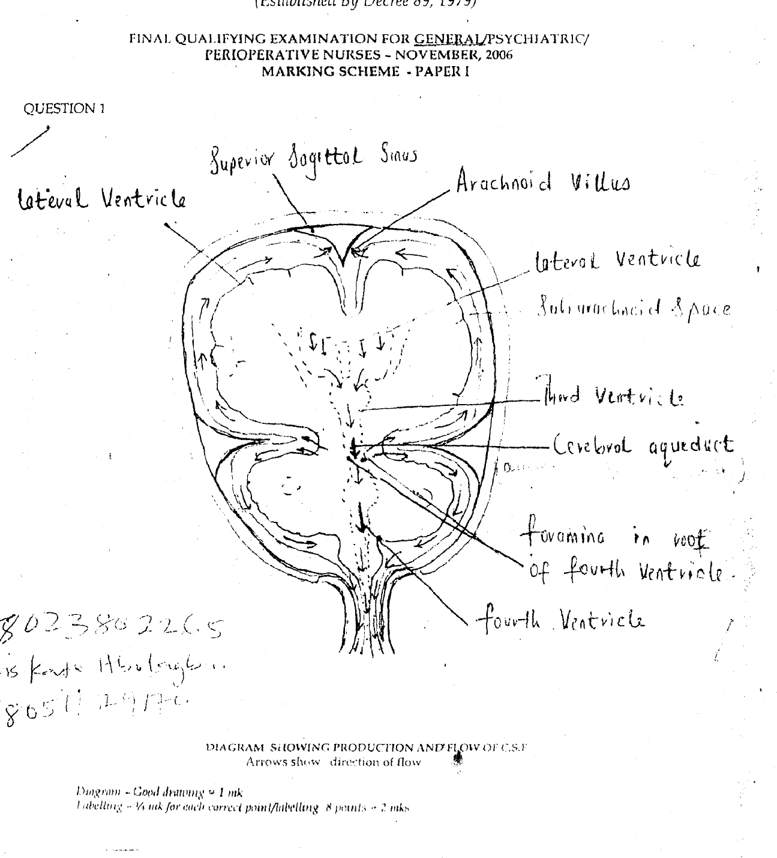
Question 1
1a.
- The CSF is produced by the choroid plexuses..
- 720ml/day and 0.5m1/min is secreted into each ventricle of the brain
- It is clear, slightly alkaline with specific gravity of 1005, consisting of Water, mineral salts glucose, proteins, creatinine and lekocytes,
- It flows into the 3 ventricle through the foramen of rnonro, then through the aqueduct of the midbrain to the foramen in the root of the 4th ventricle.
- To the subarachnoid Spare of the brain and the spinal cord.
- It also flows into the 4th ventricle from the aqueduct of the midbrain, to the canal of the spinal cord.
- It is absorbed by the arachnoid villi, (½ mark for each correct point. 6 3marks).
1b.
i. Lumbar puncture for CSF analysis, gram stain, culture and sensitivity of CSF.
ii. Culture and sensitivity test of blood, sputum, urine, nose and throat swab.
iii. Karnig’s and Brudzinski’s sins procedure
iv. Skull x ray to discover area of influence (½ mark for each points =4 points 2 mks.
I. c
i. Pa in (headache) related to meningeal irritation.
ii. Hyperthermia related to inflammatory process.
iii. Deficient fluid volume related vomiting
iv. Risk for ineffective cerebral tissue perfusion.
v. Risk for injury, seizures related to cerebral irritation.
vi. Risk for spread of infections,
vii. Knowledge deficit related to unfamiliar disease process.
viii. Imbalance nutrition less than body requirement related to Nausea and vomiting.
[
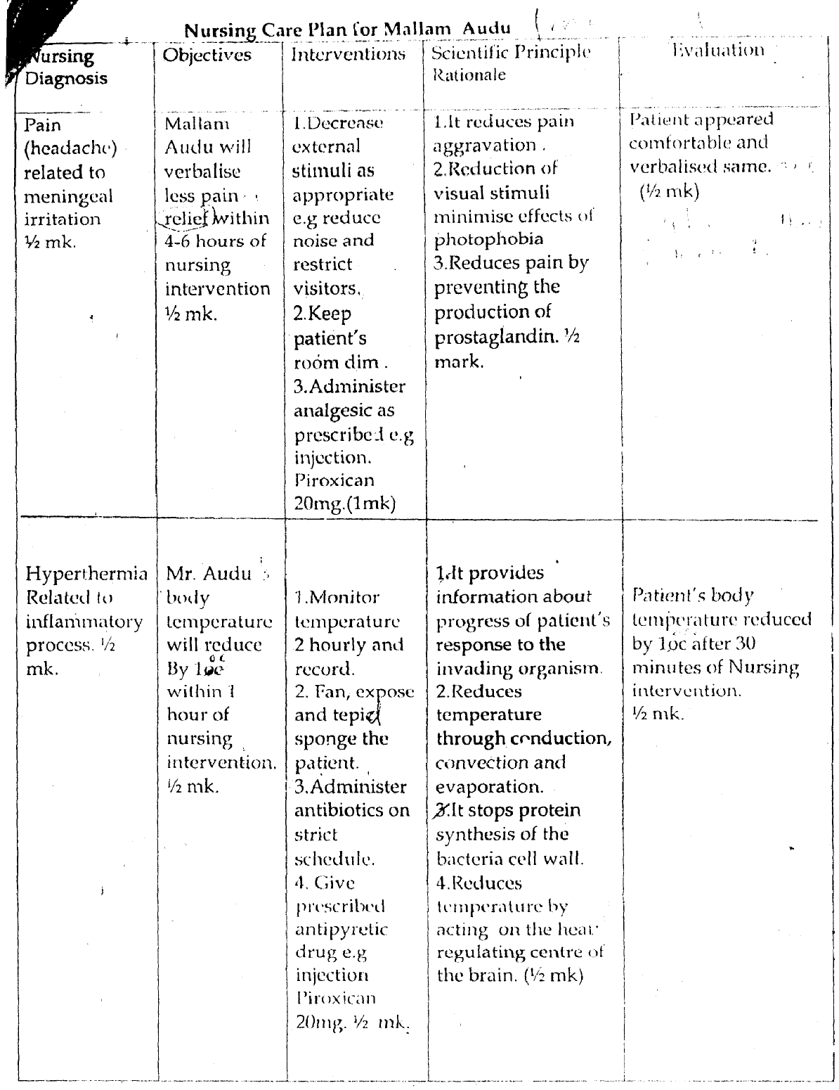
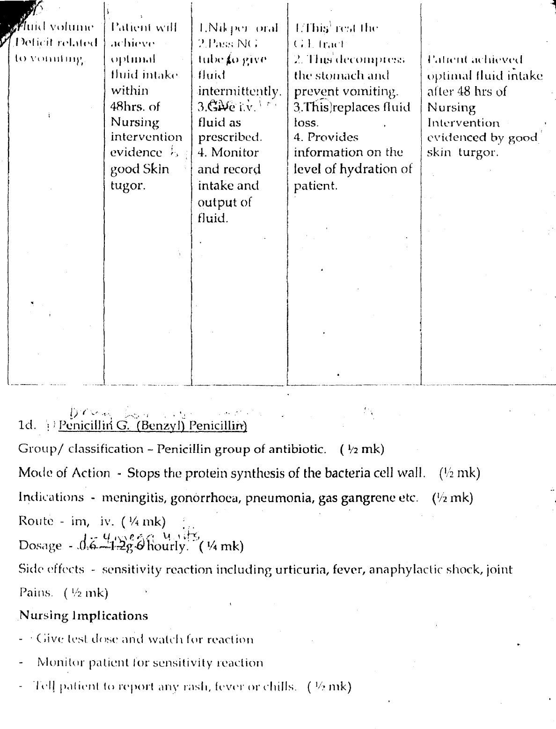
Cefataxine
Group
Bactericidal antibiotic (¼ mk)
Indication
Against gram positive and gram negative organisms. RTTs, ear, nose, throat, UTI Gynaecological and obstetric infections, skin, soft tissue and bone infections (¼ mk)
Dose
Oral 250mg x 2 daily for 10 - 14 days
I gram in single dose.
im/iv 750mg x 3 daily to 1.5gm x 3 daily (¼rnk)
[
Contra-indications
Hypersensitivity to penicillins, pregnancy, breast feeding. Interacts with loop diuretics, amino-glycosides (½mk)
Side effects
Hypersensitivity reactions, G.I.T disturbances, positive comb’s test, candidosis, pain at injection site, transient increase of liver enzyme levels, headache.
(½ mk for any 2 points)

Nursing Responsibilities
- Not to mix with aminoglycosides in same bottle or bag.
- To obtain C & S test before the first dose.
- Administer round the clock.
- Observe signs and symptoms of anaphylaxis during first dose.
- Monitor renal, hepatic and haematologic functions periodically.
- Give deep im into large muscles
- Tablet is bitter and difficult to mask even with food (inform the client).
(1mk for 4) (¼ each)
[[
v. Dexamethasone
Group
Action
Anti-inflammatory (corticosteriod) (¼ mk)

Indication
Acute and chronic keratitis and Conjunctivitis, Iritis, Scleritis, Sympathetic Ophthalmia (¼ mk for 2)
Contra-indication
Hypersensitivity injuries and ulcerous processes of the cornea, Herpes Simplex, other viral infections, and myocosis, glaucoma, severe blood disorders with bone marrow depression, dry eyes ( ½ mk for 2).

Side effects
Slight transient burning sensation and bitter taste in the mouth, palpation, hypertension, tremor, pre-coccular dermatitis and impaired wound healing especially topical administration.
Long term administration with reversible increase in eye, corneal perforation. (1mk for 4).
Dosage
Adult 200 — 300mg 8 hourly
I drop 3 — 5 times daily. (¼ mk)

Nursing Responsibilities
- Give with meal or drink to reduce G.l.T upset.
- Avoid abrupt withdrawal to prevent adrenal crisis
- Give deep i.m.
- Client to report early signs of adrenal insufficiency. (1mk for 2)
2a.
Malnutrition is a condition where the body is poorly nourished. One form of malnutrition is over-nutrition. This occurs when there is excess quantity of nutrients in the body above body requirements. Example of this condition is obesity and over-weight. Another form of malnutrition is under-nutrition. In this firm, there is deficient quantity or/and quality of nutrients for body cells. The insufficiency could be in Macro-nutrients as in protein energy malnutrition or in micronutrients as Nutritional deficiency diseases. The condition can he cause by inability of the digestive organ to make use of the food nutrients even though it is in satisfactory quantity and quality
Introduction (½ mark).
Explanation of under nutrition- (½ mark)
Explanation over nutrition - (½ mark)
Examples and other explanation ½ mark = Total 2 marks

2b.
- Beri beri
- Pellagra
- Osteomlacia
- Xerophthalmia
- Rickets
- Scurvy
- Endermic Goitre
- Pernicious anaemia
- Megaloblastic anaemia
- Iron deficiency anaemia
- Aribo flavinosis
- Dental caries
- Marasmus
- Kwashiokor
- Hyponatraemia
- Night blindness.
½ mark for 1 point
5 marks for any 10 points.
2C.
1. Food in-availability
The quantity of food available by a number of factors such as poor transport network and storage facilities. Thus food items are more available is areas where they are produced but scarce mostly in the cities and in areas where needed.

2. Ignorance
Many Mothers do not know the importance of good food combination necessary for their health. Lack of knowledge of nutrients and their local food sources is prevalent in our society. Others believe that some food items are poisonous e.g. soya beans.
3. Poverty
This causes insufficient money to purchase enough quantity and quality of food required for adequate growth. Poverty makes parents not able to seek early medical aid when children are sick and this leads to chronicity of illness.
4. Disease condition e.g. Infection and malabsorption
- Infection increases the body’s need for energy and nutrients and ii this demand is not satisfied it may lead to severe depletion in the persons nutritional stores.
- Malabsorption causes loss of nutrients even though readily available hut are not absorbed.
5. Worm Infestation
Worms compete with the child for the available nutrients.
6. Cultural Practices.
Child in some society are not given eggs, snail, fish or meat to prevent them from stealing or drooling saliva.
7. Religious beliefs. Some religious forbid their members from eating certain foods for instance Moslems do not eat pork.
8. Food faddism some people prefer some food item irrespective of their nutrient value.
[
Cultural implications
- Social isolation
- Stigmatization
- Loss of inheritance
- Economic deprivation
- Abandonment
- Discrimination
- Divorce
- Polygamy
(½ mark each for any correct ten (10) points from the two factors. Total = 5 marks)

Diagnostic Tests
Male
- Semen Analysis — To estimate the volume (2 —6mls), total sperm count =40 x 10⁶ per ml, motility 60% and morphology 60%
- Testicular biopsy
- Hormonal analysis
- Chromosomal studies from blood or buccal smear
- Post coital test
- Ultra sound scan
½ mark each far any correct 3 answers 1½ marks
Female
- Test to establish ovulation
- Cervical mucus examination
- Ultrasound scanning to detect ripening of graffian follicle, follicle tracking and thickening of the endometrium.
- Luteinising hormonal (LH) level can be measured with simple hormone test
- Hormonal assay to reveal fluctuations in circulatory oestrogen and progesterone FSH and LH.
- Endometrial biopsy
- Hysterosalpingograph HSG
- Visual inspection by Laparoscopy and dye test of Hysteroscopy
½ mark each far any correct 3 answers 1½ marks
Total = 4 marks

[
f. Psycho—social implications
- Guilt
- Anger
- Anxiety
- Depression
- Aggression
- Grief
- Low self—esteem
- Feeling of worthlessness
- Inadequacy
- Failure
- Mental instability

Other deforming nursing diagnosis
- Bleeding risk for of hypothalamus, pituitary, adrenals and thyroid glands
- Deficience volume mellitus, ccoeliac disease, renal failure
- Activity intolerance disorder: Trauma, hydrocele, undescended testis, long distance lorry driver, varicocele, tight clothing, cancer,
- High temperature.
- Absence of seminal duets
- Nsg Impaired sacretions from prostate or seminal vesicles due to infection, metabolic disorders
- Rograde ejaculation
- Scientific psychological or drug induced ejaculatory dysfunction
½ mark each for any correct 3 points = 1½ marks
Evaluation for infertility
Total = 3mks
- Endocrine disorders of hypothalamus, pituitary, adrenal and thyroid glands.
- Systemic disease i.e. diabetes mellilus, celiac disease, renal failure
- Physical disorder i.e. obesity, anorexia nervosa or strict dieting, excessive exercise.
- Ovarian disorders i.e. ovarian cysts or tumours, ovarian endometriosis
- Psychosexual problem (vaginismus)
- Congenital anomalies
- Cervical trauma or surgery e.g. cone biopsy
- Hostile mucus
- Anti—sperm antibodies in mucus
- Defective implantation
½ mark each for any 3 correct points = .1½ marks
(3 points from male and 3 from female)
Total =3 marks

d. Primary infertility occurs when there is no previous pregnancy while secondary infertility occurs when there had been one or more previous pregnancies irrespective of the outcome but a further pregnancy has proven impossible.
(2 mks)

e. Investigations on infertility
- History taking to highlight health compromising factors like drug abuse.
- Occupational displacement
- Smoking habit.
- Alcoholism
- Contraceptive use
½ mark each for any correct 2 answers I mark

2.
a. Is defined as a couples inability to achieve pregnancy after 1 year of regular unprotected sexual intercourse (1mk.)
OR
WHO - definition based on 24 months of trying to get pregnant is recommended as useful in clinical practice and research among different discipline.
b. Definition — The menstrual cycle is a series of physiological change that occurs within 5 woman of child bearing age and the cycle depends on individual woman. It vary in length, with average cycle taken to be 28 days. It commence at puberty and cud at menopause except when pregnancy interupts. There are 3 main phases with each cycle, and they affect the tissue structure of the endometrium, controlled by the ovarian hormones.
The phases are menstrual, proliferative and secretory (1 mk)
(i) The menstrual phase — This phase is characterized by vaginal bleeding, which last for 3-5 days Physiologically, this is the terminal phase of the menstrual cycle when the endormetrium is shed down to the basal layer along with blood from the capillaries and with the unfertilized ovum
(1 mk.)
(ii) Proliferative phase — This follows menstrual phase and last until ovulation. The first few days while the endometrium is reforming is described as the regenerative phase. This phase is under the control of estrogen. It consists of the regrowth and thickening of the endometrium. At the completion of this phase the endometrium consist of 3 layers:
(½mk)
(a) Basal layer which never alters during menstrual cycle and contain all necessary rudimentary structures for building up new endometrium. (½ mk)
(b) Functional layer which contain tubular glands and changes according to the hormonal influence of the ovary. (½ mk)
(c) A layer of cuboidal ciliated epithelium which covers the functional layer an dips down to line the tubular gland (½ mk total =2 marks)
(iii) Secretory phase — this follows ovulation and is under the influence of progesterone and oestrogen from the corpus luteum.
The functional layer thickens to 3.5mm and becomes spongy in appearance because the glands are more tortuous.
(1mk)
Other performing Nursing Diagnosis
- Bleeding Risk.
- Deficient fluid volume (anaemia)
- Activity intolerance
Nsg Diagnosis — ½ mk
Nsg Objectives — ½ mk
Intervention — (¼ x 4) = 1 mk
Scientific rationale - ½ mk
Evaluation — ½ mk
Total = 3mks

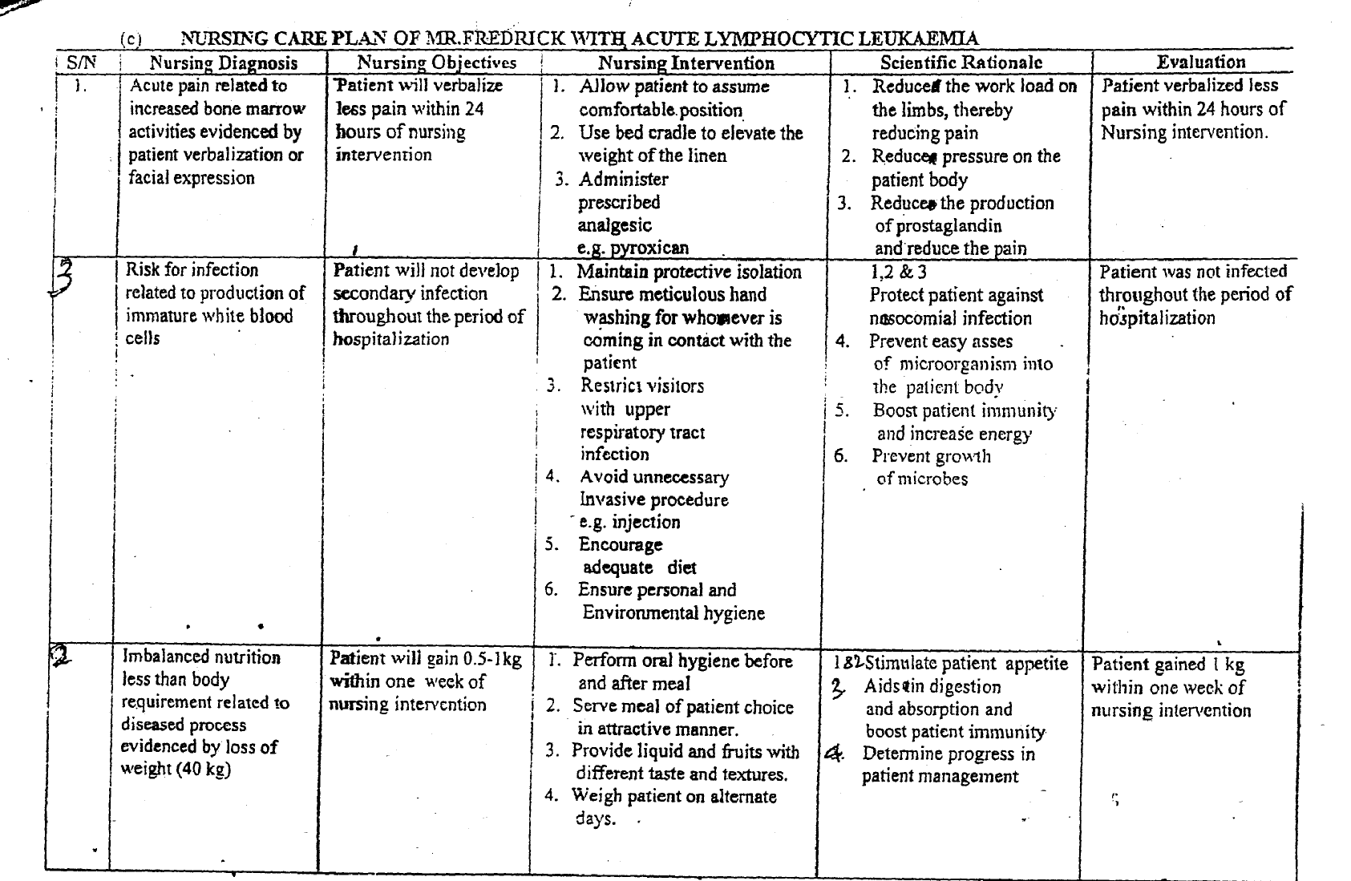

Function
1. Immunity
2. B cells produce antibodies for destruction of bacteria
3. T cells protect against viruses and other intracellular micro organism
(⅛ mark each for any correct 2 points = ¼ mark)

b. Pathophysiology
- The malignant cells of acute lymphocytic leukaemia are lymphoid precursor cells (i.e. lymphoblass) that are arrested in an early stage of development. (½ mk)
- This arrest is caused by abnormal expression of genes, often as a result of chromosomal translocation. (½ mk)
- The lymphoblasts replace the normal marrow elements, resulting in a marked decrease in the production of normal white blood cells.
(½ mk)
- Consequently, anaemia, thrombocytopenia, and neutropenia occur to varying degree (½ mk)
- The lymphoblasts also proliterate in organs other than the marrow,
(½ mk
- Particularly the liver, spleen and lymph nodes (½ mk)
- As a result, leukocytes cannot perform its physiological function as it is not mature, (½ mk)
- Thereby exposing the patient to risk of infection. (½ mk)
Total = 4 marks

C. Other types of Leukaemia
i. Chronic lymphocytic leukaemia
ii. Acute myelogenous leukaemia
iii. Chronic myelogenous leukaemia
iv. Acute promyelocytic leukaemia
v. Hairy cell leukaemia
vi. Polymphocytic leukaemia
(½ mk each for any correct four points =2 mks)

MAY 2009
GENERAL NURSING
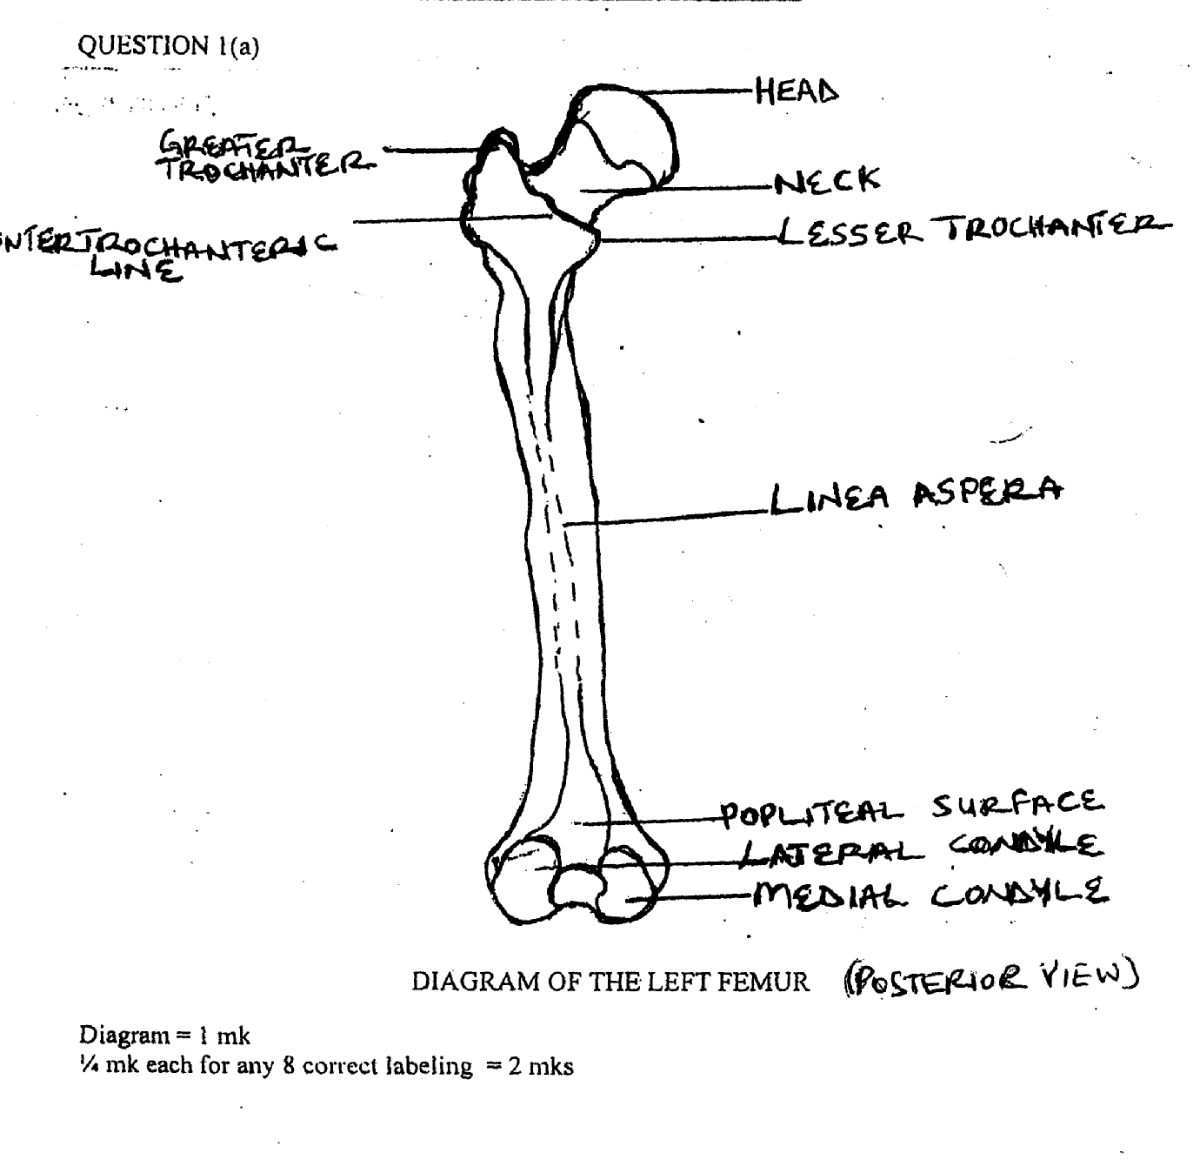
MARKING SCHEME PAPER II

- It has two extremities and a
- The proximal extremity consists of the betrochanters.
- In between the trochanters anteiorly is a less prominent ridge of the bone called the inter-trochanteric line.
- The shaft is cylindrical in shape, and it becomes larger and wider at the lower part. It has a smooth anterior surface and a rough posterior surface with roughened prominence called the linea aspera for the attachment of muscles.
- The distal extremity consists of the medial and lateral epicondyles, as well as the medial and lateral condyles.
- Anteriorly at the distal extremity, the two condyles are less prominent and are separated by a shallow depression called the patellar surface which helps to receive the patella or knee cap.
- Posteriorly, the distal extremity has a triangular area called the popliteal surface.
- Blood supply:
- The arterial blood supply is by the femoral artery and nutrient artery while the venous drainage is by the femoral vein and nutrient vein.
- Nerve supply:
- This is through the parasympathetic and sympathetic nerves.
- Function:
The femur helps in bearing the weight of the body.
(¼ mk each for any 12 correct points = 3 mks)

1(b) TYPES OF TRACTION COMMONLY APPLIED IN THE ORTHOPAEDIC WARD
1. Skeletal traction
2. Skin Traction
3. Hamilton Russel’s Traction
4. Perkin’s Traction
5. Balanced skeletal traction
6. Buck’s Traction
7. Fixed Traction
8. Balanced (sliding) Traction
9. Gallow’s Traction
1 0. Scalp Traction
II . Pulp Traction
12. Pelvic Traction
(½mk each for any 6 correct points 3 mks)
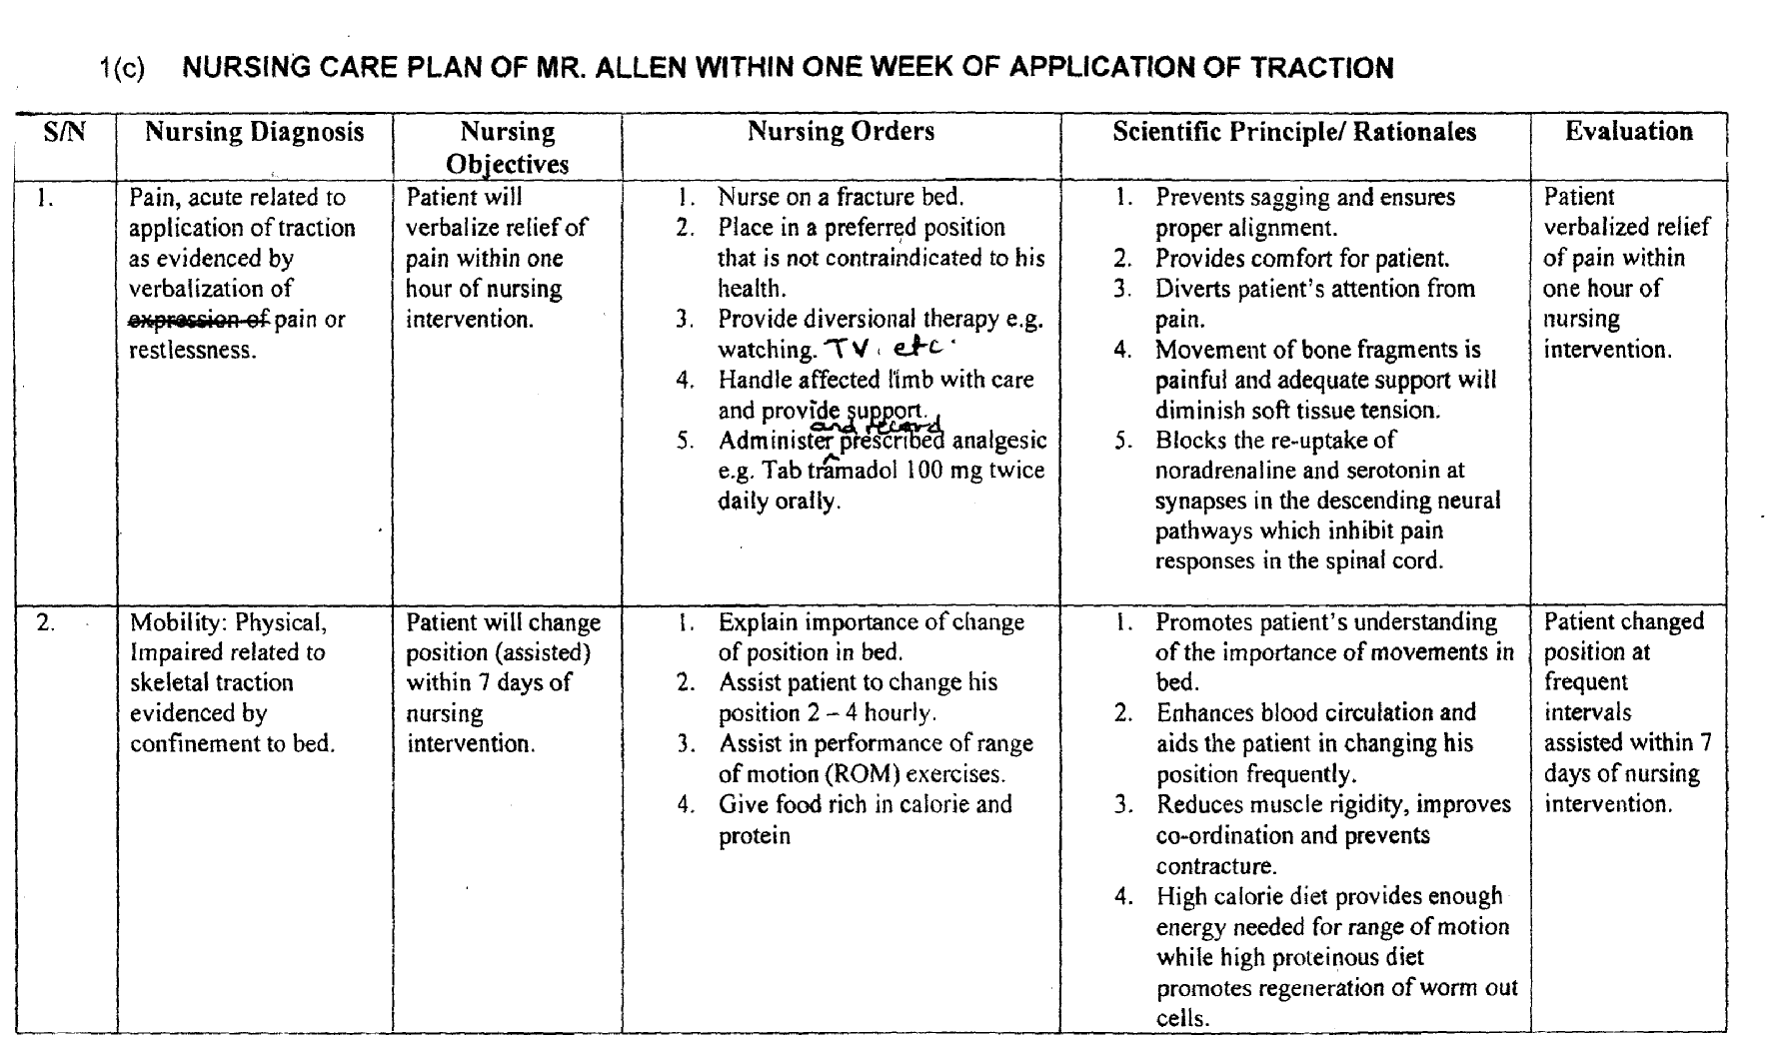
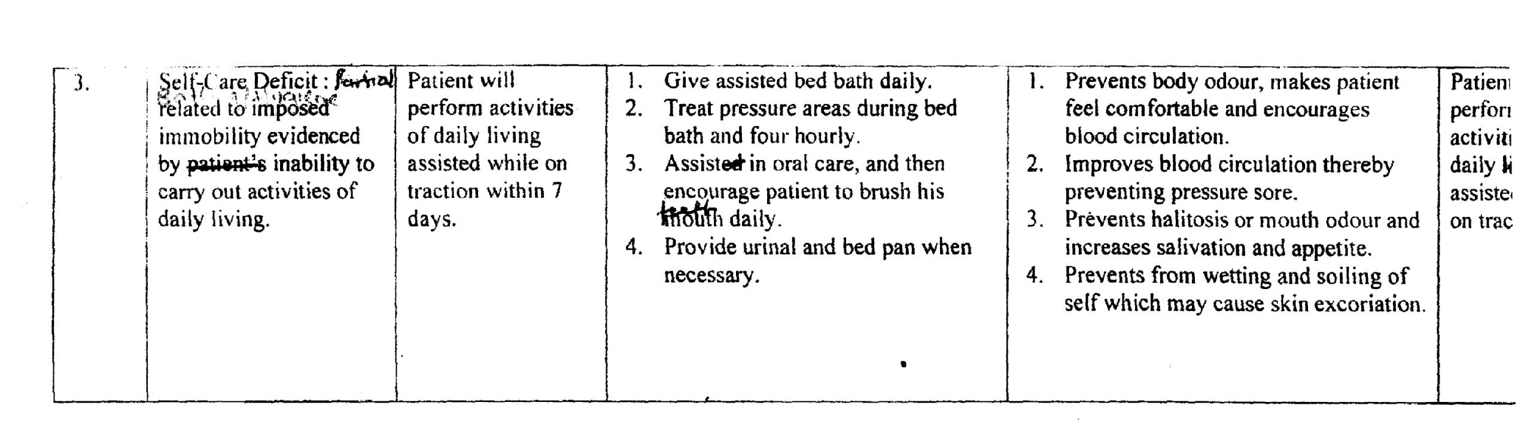

Others:
4. Anxiety (moderate), related to skeletal traction evidenced by sleeplessness or restlessness.
5. Skin integrity, impaired, related to skeletal traction evidenced by visible wound.
6. Infection, risk for, related to skeletal traction.
Scores:
Nursing Diagnosis = ½ mk
Nursing Objectives = ½ mk
Nursing Orders = ¼ mk each for any 4 correct points =1mk
Scientific rationale = ½ mk
Evaluation = ½ mk
(Total = 3mks x 3 = 9 mks)

1(d) Complications that may develop on a patient with traction
1. Haemorrhage
2. Peripheral neurovascular dysfunction
3. Deep venous thrombosis
4. Pressure sore
5. Infection
6. Fat embolism
7. Disseminated intravascular coagulation.
8. Delayed union
9. Malunion
10. Non-union
11. Hypostatic pneumonia
12. Constipation
13. Urinary stasis
(½ each for any four correct points 2 mks)

QUESTION 2
a. MENSTRUAL CYCLE:
DEFINITION: - Refers to sequence of events or cyclical activities that takes place in the reproductive organs of a non-pregnant woman of child bearing age, occurring averagely eve
28 days. (½ mark)
PHASES (3)
i. PROLIFERATIVE (FOLLICULAR)
ii. SECRETORY (LUTEAL)
iii. MENSTRUAL (½ mark)

DESCRIPTION
i. PROLIFERATIVE (FOLLICULAR)
- Start at end of menstruation to about 14 days
- Hypothalamus releases Human Gonadotrophic hormone (HGI-I) which stimulate the anterior pituitory gland (APG)
- APG releases FSH
- FSH stimulate growth of premodial ovarian follicle
- Maturing ovarian follicle secretes oestrogen
- Oestrogen stimulates the proliferation of the functional layer of the endometriun in preparation for the reception of a fertilized ovum.
- As the concentration of oestrogen rises, FSH decrease and that of LH increases.
- LH complete the maturation of the follicle and triggers Ovulation
(½marks) i.e. ¼ for each point x 6 points
ii. SECRETORY PHASE:
- Begins with ovulation and last 10— 14 days
- LH stimulates the remains of the ovariam follicle to produce corpus luteum
- Corpus luteum produces progesterone and some Oestrogen which makes the endometrial lining to become Oedematous due to further increase in the number of glands and blood vessels
- If pregnancy occurs, the corpus luteum remains secretory by the action of HGH.
(½ marks)(½ mark for any point x 3).

iii. MENSTRUAL PHASE:
- If fertilization fails to occur, the corpus luteum begins to degenerate
- Levels of progesterone and Oestrogen falls
- Functional layers of the endometrium breaks down and is shed
- Last 3 — 5 days, the cycle begins again
(¼ mk each x 4 points =1 mark)
Total = 5 mks

b. PROTEIN-ENERGY MALNUTRITION (PEM)
I. DEFINITION:- This is a nutritional deficiency disorder in which there is inadequate intake of carbohydrate, protein and fat (½mark)
ii. INCIDENCE: More common in under 5 years especially the older children
(½mark)
iii. TYPES
o Marasmus
o Kwashiorkor
o Marasmic-Kwashiorkor (½mark for any two points)
iv. CAUSES
o Oral thrush
o Fever
o Congenital anomalies e.g cleft lip, cleft palate etc
o Diarrhoea and vomiting
o Complications following acute infectious fever e.g. measles, fever etc.
(½ mark for any two points)
v. PREDISPOSING FACTORS
- Ignorance
- Poverty (low. socio-economic status)
- War
- Coeliac diseases
- Poor weaning techniques
- Famine
- Natural Disasters e.g. flood.
- Cultural Practices
(½ mark for any two points)
vi. SIGNS AND SYMPTOMS
o Apathy
o Weakness
o Muscle wasting (½ mark for any two)
o Scanty brittle hair
- Skin discoloration
o Pedal oedema
o Failure to thrive
o Dry scaly skin
o Old man appearance
o Potbelly
o Irritability

vii. MANAGEMENT
- Mild cases are managed as out patient while serious cases are admitted for care
- Teach the patient and family about the disorder and its planned management
- Treat underlying cause
- Provide the patient with frequent rest periods and space activities throughout the day as anaemia — induced fatigue is common
- Encourage a high — calorie, high protein diet if the patient can tolerate an oral diet
- Ensure a conducive environment for eating
- Arrange for small frequent feedings rather than large meals
- Incorporate patient’s food preference and cultural habits as much as possible during all nutritional planning
- Keep an accurate record of the patient’s weight and record calorie counts if ordered
- Care for the patient receiving tube feeding.
(¼ mark x 4 = 1 mark)

Viii. PREVENTION
o Exclusive breast feeding for the 1st 6 months and continue till
2 years of life
- Adequate complementary feeding from 6 months
- Educate mothers on classes of food and proper combination
- Encourage backyard gardening and husbandry
- Encourage women empowerment and adequate child spacing
- Early detection and treatment of likely causes
- Immunization of preventable childhood diseases
(½ mark each for any two points)

ix. COMPLICATION
- Anaemia
- Low immunity
- Failure to thrive
- Hypoglycaemia
- Severe electrolyte in balance
(½ mark each for any two points)
Total 5mks
C. NATIONAL PROGRAMME ON IMMUNIZATION
Definition— National Programme on immunization is a programme designed to control, prevent and eradicate diseases that can be prevented through immunization. (½ mark)

ii. AIMS AND OBJECTIVES
o To boost routine immunization coverage
o Strengthen and improve data collection and management, integrating public and private immunization data
o Conduct accelerated immunization of measles, yellow fever, cerebrospinal meningitis, neonatal tetanus, hepatitis B, and eradicate poliomyelitis
o Improve vitamin A status of children aged 6 — 59 months and women of child bearing age
o Develop sustainable systems of monitoring, evaluation and surveillance of vaccine preventable disease.
(½ mk for any point x 2 =1 mark)

iii. TARGET DISEASES
- Tuberculosis
- Poliomyelitis
- Hepatitis B
- Measles
- Yellow fever
- Whooping cough
- Diptheria
- Tetanus
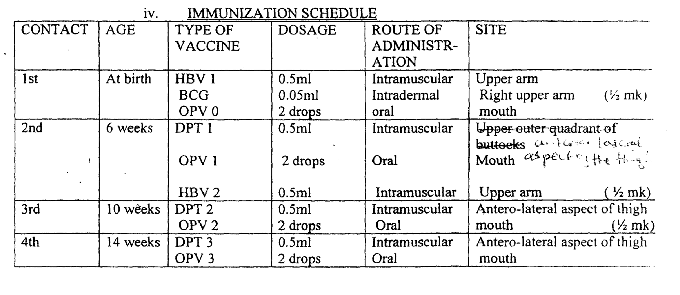
(¼ mark for any 4 points 1 mark)

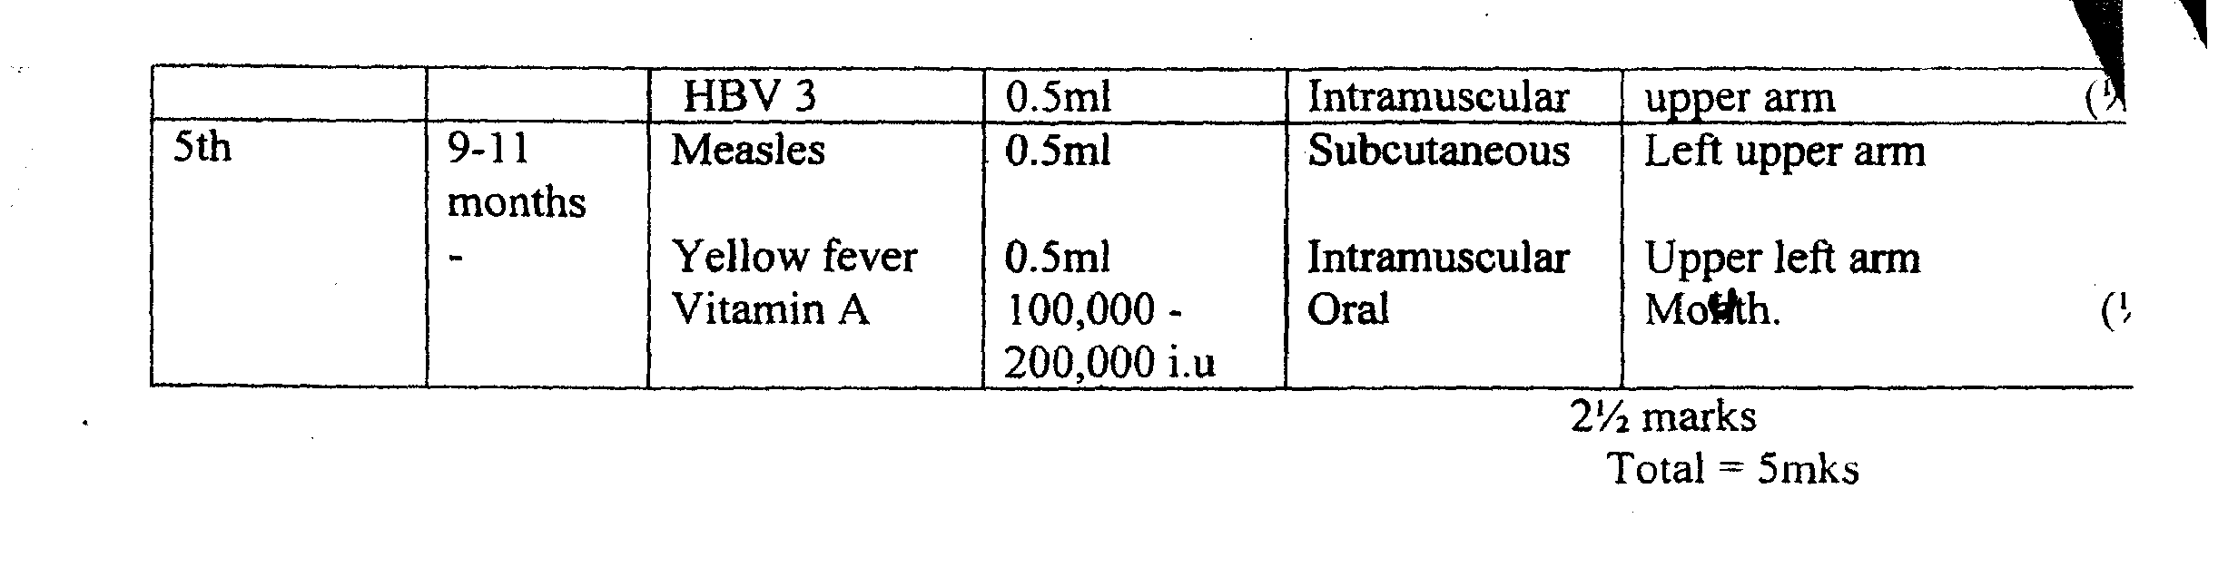
[
d. ETHICAL CONSIIDERATIONS IN NURSING DEFINITIONS:-
ETHICS – Standard, principles or rules that governs proper conducts
(½mark)
- ETHICAL CONSIDERATION:- Are those issues, rules and principles governing proper conduct which guides and directs the nurses actions and utterances in her dealing with the clients or while delivering heath care services. (½ mark)

HIGHLIGHTS AND DESCRIPTION
1. AUTONOMY:- Includes individual right
- Right to independent decision making
- ‘Right to consent or refuse treatment

2. BENEFICIENCE
- Doing or promoting good
- Promote patient’s best interest and striving to achieve optimal outcomes
- Provide beneficent effort to provide accessible, affordable care to all those who need it.

3. NONMALEFICENCE
- Avoid doing harm
- Remove harm
[
4. JUSTICE
- Principle of fairness
- Treat all patient alike without bias
- A just decision is based on client need and a fair distribution of resources.

5. CONFIDENTIALITY
- Required information about client is to be kept private
- Information is accessible to only those providing care
- Divulgence of information to others should be based on signed informed conse by the client
- Information can only be shared if doing so would substantially benefit someon else, and the benefit outweighs harm
[6. VERACITY
- Obligation to tell the truth
- Obligation to be honest
- Give accurate, unbiased and understandable information
[[[
7. RESPECT
- Respect to life, dignity, and patient’s view

8. DOUBLE EFFECT
- Is a principle that may morally justify some actions that produce both good and evil effects
- Action being carried out on a patient must be intended for good before the principle can cover the nurses action.

9. FIDELITY
- Faithful to one’s commitments and promises
- Requires good judgement
- Fidelity includes both implicit and explicit promise to a patient.
(½ mark for any 8 points mentioned and explained =4 mks).
Total = 5mks
3a. Possible causes of pelvic inflammatory disease
i. sexually transmitted infections as caused by the following organism
- Neisseria Gonorrhoeae
- Chlamydia, and staphylococcus aureus etc
ii. Post abortal sepsis
iii. Salphingitis
iv. Endometritis
v. Infection of intra-utenrie contraceptive device
vi. Post partum infection (sepsis)
vii. Invasive procedures, example, endometrial biopsy, illegal abortions etc
viii. Ascending infection from such conditions like female genital multilation etc
ix. Poor perineal hygiene.
½ mark each for any 4 correct points =2 marks

b. Detail management for Miss Sharon from admission to discharge
I. Admission:
Admit the patient in gynae ward, conduct thorough physical examination
2. Position:
- Place the patient in a semi-fowler position to facilitate drainage
- Ensure complete bed rest

3. Investigations:
- Prepare patient for the following investigations
- High vaginal swab
- Blood investigations
- Uterine ultra sound
[
4. Observations:
- Check initial vital signs temperature, pulse respiration and B/P. Continue these observations two times daily as patient’s condition improves.
- Check the characteristics and amount of vaginal discharge which serve as baseline for evaluation
- Check for any signs of itching for appropriate action to prevent discomfort.

5. Physical Care;
- Physical grooming and perineal hygiene are necessary during acute phase to prevent bacterial multiplication and further spread of infection
- Perform meticulous hand hygiene
- Encourage the patient to take her bath as aften as possible and ensure genera clealiness
- Heat application through sitz bath: to improve circulation and relief pain
- Patient is encouraged to participate in ADL — advice patient to wear iron-dry clothing’s.

6. Psychological Care:
- Explain the causes of PID to the patient to relieve anxiety- Encourage the patient to express feeling of stress
- Encourage patient to learn the act of relaxation example, watching television, reading papers and novels (divisional therapy)
[
7. Specific Care:
- Nutrition — give adequate diet
- Encourage increase fluid intake
8. Medication:
A gynaecologist may prescribe the following group of drugs
- Antibiotics e.g.;
Lerofloxacin 500mg orally once daily x2/52
- Antimicrobial example
Metronidazole: 200 - 400mg tds x 7 days
- Anti-inflamatory/Analgesic example
Cap felden (piroxicani) 20mg b.d x 1/52
Infusion and where necessary a surgical intervention is adopted
9. Advice on discharge/patient teaching
- Encourage the patient to comply with the drug regimen
- Encourage the treatment of other sexual partner (s) to prevent re-infection if any
- Advise the patient on the importance of adequate diet (to boost immunity against infection)
- Discourage sexual intercourse during treatment
- Emphasize on follow up care.
(1 mark each for any correct stated point x 9 = 9 marks)
c. Metronidazole
- Group—Anti amoebic, anti- microbial, anti- protozoa, anti—trichomonal drug.
(¼mk)
- Mode of action — it alters biosynthesis of cell wall of the protozoa or microbe, there by changing cell permeability with loss of intracellular constituents.
(¼rnk).
- Indication:
- Pelvic inflamatory disease, candidiasis, vaginal and urethral trichomoniasis, septic abortions, pre, intra and post operative management, ulcerative gingivits, liver abscess, amoebic dysentery etc. (½ mk)
Dosage: — 400mg bd x 14 days. (½ mk)
Route of administration
Orally, intravenously (¼ mk)
Side effects: Neusear vomiting
* Gastrointestinal disturbances, unpleasant taste, headache, rashes
- Darkening of urine. Peripheral neuropathy. Seizures. Reversible leucopenia, dizziness, hypersensitivity (¼ mk)
- Contraindications
- Known hypersensitivity reaction
- Hepatic encephalopathy
- CNS diseases
- Pregnancy
- Blood dyscrasias (½ mk)
- Nursing Responsibilities
- Administer with caution in pregnancy (avoid especially the first trimester) and lactating mothers. Patient with known hypersensitivity reactions, hepatic encephalopathy; nervous system disorders
- Intake of alcohol is to be avoided within 24hours of its administration.
(¼ for 2 correct points) = ½ mk
d. Complications:
• Generalized peritonitis
• Pelvic abscesses
- Fallopian tube obstruction
• Ectopic pregnancy
- Infertility
• Septic shock
• Repeated abortions
• Chronic cervicitis
(½ mk each for any 4 correctly listed points =2 marks).
e. Counseling Miss Sharon on discharge:
- Counsel her on the importance of adequate diet and how she could boost her Immunity against infection
- Educate her on the importance of personal hygiene
- Educate her on the risk associated with multiple sexual partners
- Teach her early signs and symptoms of PID and what to do when infected
- Avoidance of coitus and douching for a while
- Compliance to treatment regimen
- Non strenuous exercise and the need for adequate rest
- Abtinence from sex or adopt the use of condoms.
- Trace and treat contract or sexual partner.
(1 mark each for any 4 points = 4 marks).
Question 4
a. Description of the location of the tonsils:
Tonsils are masses of lymphoid tissues abound in shape located just beneath the epithelium of the mouth and throat; ½ mk
Types: There are three namely:
- Pallatine tonsils on either side of the soft palate.
- Pharyngeal tonsils (adenoids) which lies behind the nose on the back wall of the upper pharynx.
- Lingual tonsil: at the back or root of the tongue.
(½ mk for each point 1½ mk
Functions of the tonsils:
- Guards against infections of the nose and throat by micro-organisms.
- Phagocytic in action.
(½ mk for each point) 1 mk
(Total =3mks)
b.
i. Pre-operative Nursing diagnoses
- Ineffective breathing pattern related to airway obstruction evidenced by loud snoring or noisy breathing.
- Acute pain related to tonsilar enlargement evidenced by difficulty in swallowing.
ii. Post — operative Nursing diagnoses
- Acute pain related to surgical incision evidenced by restlessness (inability to speak).
- Risk for aspiration related to post-operative drainage and impaired swallowing evidenced by spiting bloody secretion. Or
- Ineffective airway clearance related to effect of anaesthesia evidenced by difficulty breathing (dyspnoea).
- Risk for deficit fluid volume related to decreased intake! swallowing difficulty post operative restrictions.
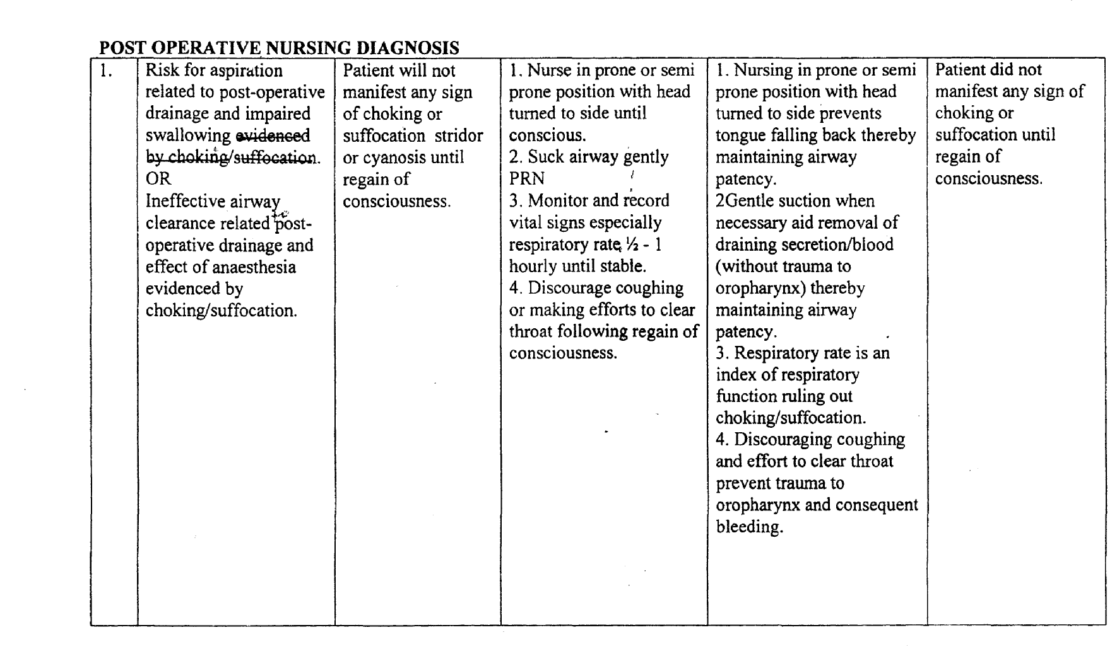
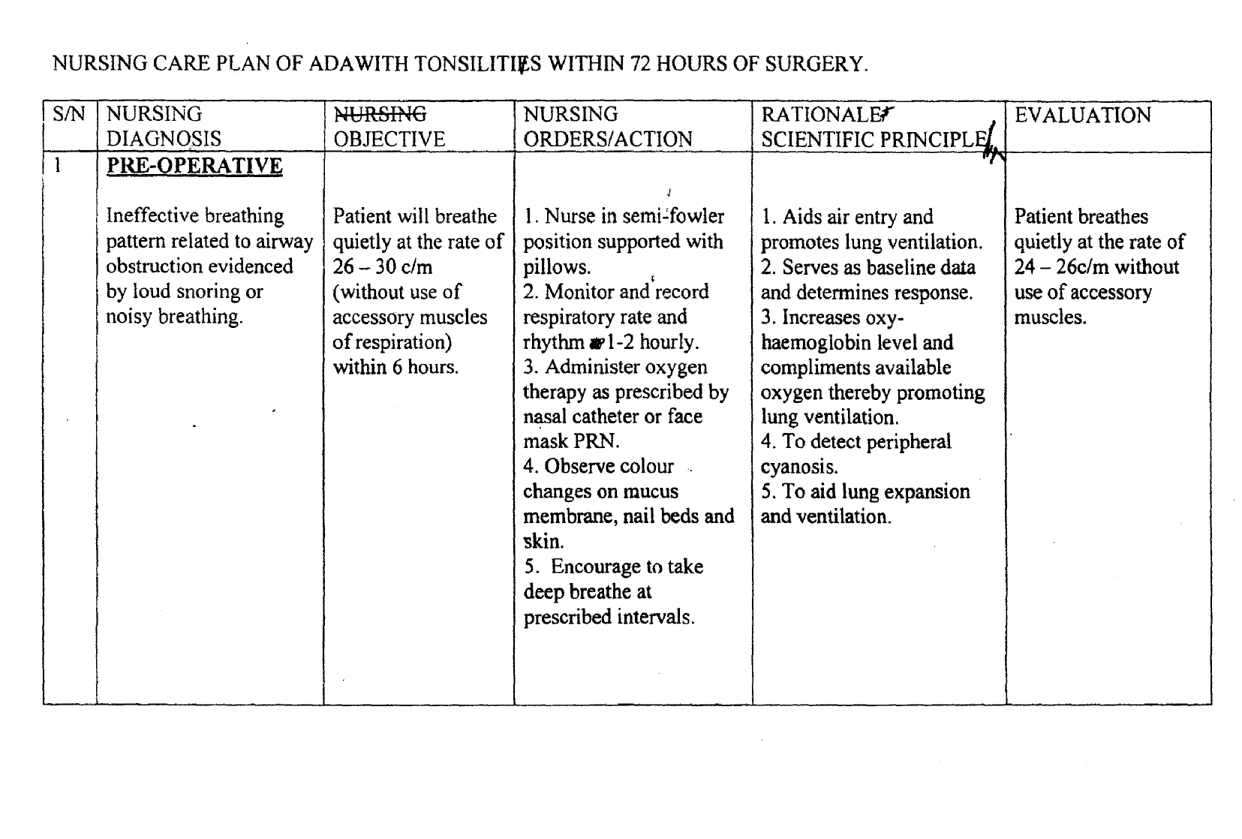
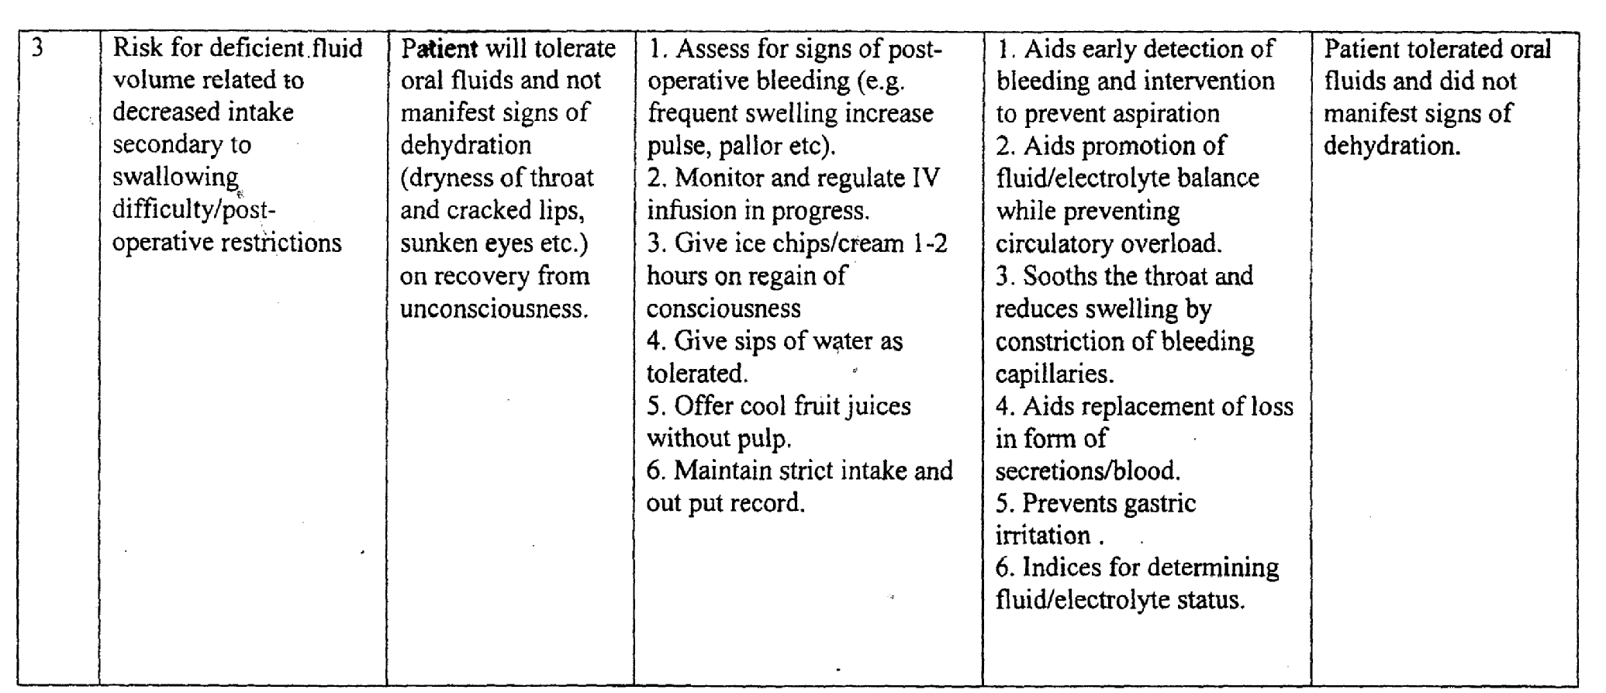
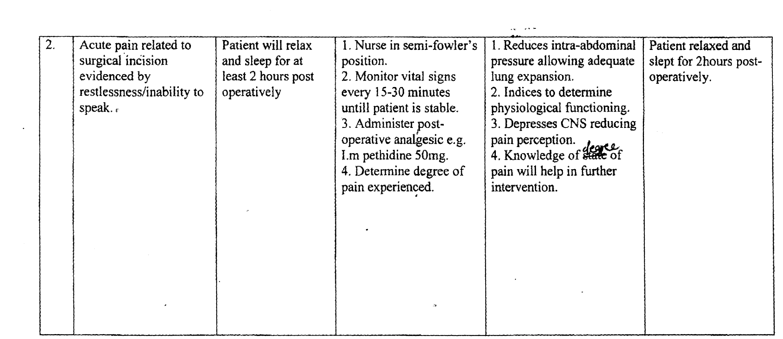

Pre-Op
- Anxiety
- Pain
- Hyperthermia

Scores:
Nursing Diagnosis = ½ mk
Objectives = ½ mk
Nursing Orders = ¼ mk each for 4 correct points = 1 mk
Scientific rationale = ½ mk
Evaluation = ½ mk
(Total 3 mks each x 3 =9 mks)

C.
Four (4) conditions that may arise as a result of the spread of infection from the tonsils.
- Otitis media
- Peritonsilar abscess
- Meningitis
- Sinusitis
- Pharyngitis
- Mastoiditis
(1 mark each for any correct 4 point).
d. Brief note on Epistaxis:
Epistaxis is nose bleeding or heamorrhage from the nose.
Causes:
Local:
- Dryness which leads to crust formation — bleeding occurs with removal of crust.
- By nose picking
- Nose rubbing or blowing
- Trauma from direct blow.
- Nasal tumor.
Systemic
- Hypertension
- Athero-sclerosis
- Bleeding disorder e.g. haemophilia ¼ mk each x any4 = (lmk).
[
Nursing Management
- Reassure patient
- Loose tight clothing around neck and chest.
- Place in upright position leaning forward to reduce venous pressure. Monitor vital signs every 30 minutes.
- Instruct patient to breath gently through the mouth to prevent swallowing the blood
- Instruct or assist to compress the soft part of the nose with index finger and thumb for 5-1 Minutes to maintain pressure on the nasal septum.
- Insert gauze soaked in adrenaline 1:1000 or a vaso — constrictor to constrict tiny bleeding capillaries.
- Use humidifier if the environment is dry.
- Advice patient to stop picking or blowing nose after a nose bleed.
(¼ mk each x any 8 points) 2 marks.
NURSES - MAY, 2009
MARKING SCHEME - PAPER I

QUESTION la
Major Serum Electrolytes
i Sodium
ii. Pottasium
iii. Calcium
iv. Magnesium
v. Phosphate
vi. Chloride
vii Bicarbonate
viii. Sulphate.
½ mark each for any 6 correct points = 3 marks
b.
- Hypokalaemia
- Hyperkalaemia
- Hyponatremia
- Hypernatremia
- Hypercalcemia
- Hypocalcaemia
- Hypermagnesemia
- Hypomagnesemia
- Hypochioremia
- Hyperchioremia
- Hyperphosphatemia
- Hypophosphatemia
½ mark each for any 6 correct points = 3 marks

[
C. General Management of a patient with electrolyte imbalance
i. Assess the level of electrolyte imbalance through history and biochemical examination of the patient, identify and treat the cause of imbalance.
ii. Admit patient into a medical ward and reassure.
iii. Administer prescribed I N. fluid, regulate and monitor the rate of flow of I/V. Infusion and maintain strict fluid intake and output chart.
iv. Check vital signs example T.PR. and B.P, weigh patient daily. Observe client for central nervous system changes example twitching, seizures e.tc, monitor jugular venous pressure and the lungs for crepitation.
v. Restrict fluid intake for a client with fluid retension.
vi. Observe dietary adjustment example avoid food with high potassium content for client with hyperkalemia, or food rich in sodium for those with hypernatremia.
vii Encourage and assist patient on personal hygiene (ADL)
viii. Maintain aseptic technique during I/v infusion to avoid possible complications such as- infection, air embolism, haematoma e.t.c.
ix. Give psychological support to patient and family throughout the period of nursing intervention.
x. Health educate patient on the causes, dietary management, prevention and follow up care.
½ mark each for 10 correct points 5 marks.
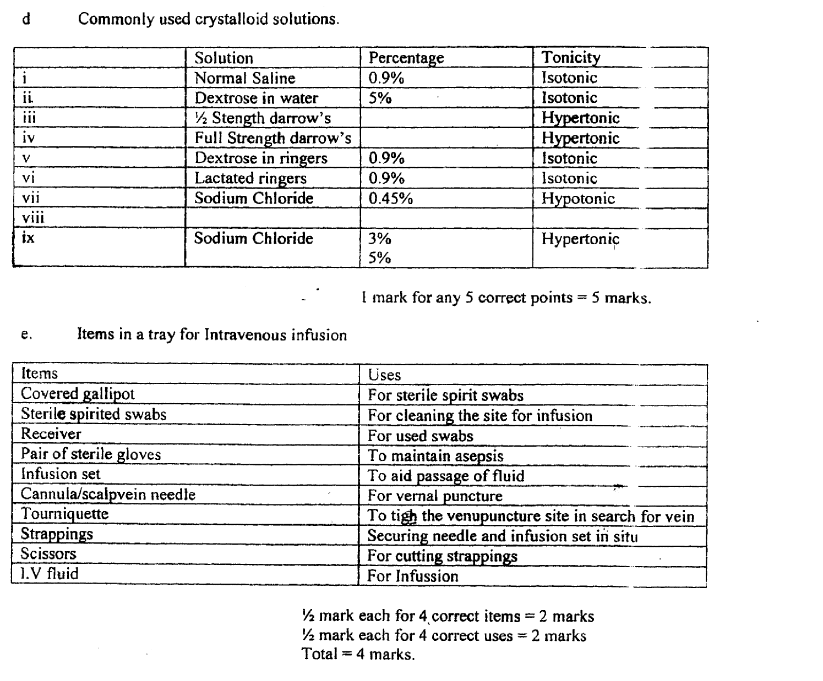
[[
[[
Question 2
2a. Epilepsy is a group of Syndromes characterized by paroxysmal transient disturbances of brain function
OR
Epilepsy is a brain disorder in which the normal pattern of neuronal activity becomes disturbed, causing strange sensation, emotions, and behaviour or sometimes convulsions, muscle spasms and loss of consciousness.
OR
Epilepsy is an episodic disorder of consciousness caused by abnormal electrical discharge in the brain
(I mark for any of the three definitions with
Emphasis on the under-listed words)

b. Four (4) Classifications of epilepsy:
i. Petit mal epilepsy/simple partial seizure
ii. Grandmal epilepsy/Complex partial seizure
iii. Jacksonian epilepsy/motor/Focal epilepsy
iv. Temporal lobe epilepsy/psychomotor seizures
v. A-typical absence seizures/Generalized non-convulsive.
½ mark each for any4 points = 2 marks)
[
c. Stages of grand mat epilepsy and the nursing management:
i. Aura or warning stage:
ii. Tonic stage
iii. Clinic stage
iv. Coma stage
½ mark for each identified stage= 2 mks)

i. Aura (warning) stage:
- It precedes loss of consciousness or seizure which may last up to two (2) seconds.
- The patient experiences a peculiar smell, taste, noise, flash of light, epigastric “turning or twisting” feelings (or indescribable feeling in the stomach).
- This may rise to the throat or head, dizziness or vertigo related to body or head.
- A sense of unreality (depersonalization) or familiarity, sudden remembrance of past experience or “memories just out of reach” etc.
(¼ mk for each point = 1 mk)

Nursing Management:
- Sit the patient down and allow for rest
- Remove all tight clothing around the neck, chest and waist.
- Remove all the materials that can be dangerous to the patient from the surrounding.
- Provide emotional support to the patient and relatives
(¼ mk for each point 1 mk)
ii. Tonic stage:
- It starts with loss of consciousness with the patient falling to the ground and may sustain injuries like cuts, fractures, etc.
- There is muscle rigidity and spasms with clenched teeth and jaws lasting for about 30-45 seconds.
- There is tonic contraction of respiratory muscles, epileptic cry due to sudden contraction of the thoracic and abdominal muscles causing obstruction to breathing.
(½ mk for each point = 1mk)

Nursing Management
- Put the patient in supine position the head turned to one side
- Do not restrain the patient but guide movement to prevent injury
- Give nil per oral
- Send on-lookers away to allow for ventilation
- Put a padded spatula in the teeth to prevent patient biting the tongue.
- Wipe mouth with clean cloth or tissue paper.
(¼ mk for each point = 1 ½ mk)

iii. Clonic Stage:
- The patient remains unconscious for about 1-5 minutes.
- There is twitching with jacking of head, trunk and limbs, (biting of tongue
- Foaming in the mouth, faecal and urine incontinence ensues.
(½ mk each for any 2 points= 1 mk)

Nursing-Management,
- Place patient in lateral position
- Clear the airways if possible
- Put padded spoon or spatula In-between the teeth
- Remove dangerous equipment or articles near-by
- Control crowd around patient
- Continue observation, noting on-set and completion episode
(¼ mk for each point l ½ mk)

v. Coma Stage:
- It is the relaxation phase when the corneal and tendon reflexes are absent.
- There could be heavy breathing through blowing of lips.
- Body becomes flaccid
- Patient falls into deep sleep or becomes drowsy for several hours.
- May vomit, become confused, exhausted or complains of headache on recovery
(¼ mk for each point= 1¼ mk)
[Nursing Management
- Turn the patient to one side and clear airway.
- Continue observation of vital signs.
- Note any injury sustained any incontinence
- Change soiled clothing and make patient comfortable
- Give mouth wash and prevent wandering away
(¼ mk for each point 1¼ mk)
[
2(d) Support measures:
Family:
- Acceptance of patient to promote positive self esteem
- Treat with empathy not sympathy to enhance self worth
- Do not expose patient to danger e.g., cooking, driving and climbing or operating machines.
- Ensure drug and hospital appointments are maintained.
- Avoid exposure to stressful situations or events.
Community
- Provide skilled training devoid of risk
- Rehabilitate patient to a safe job.
- Avoid stigmatization/promote self acceptance and enhance positive body image.
(1 mk each for any 5 points 5 mks)

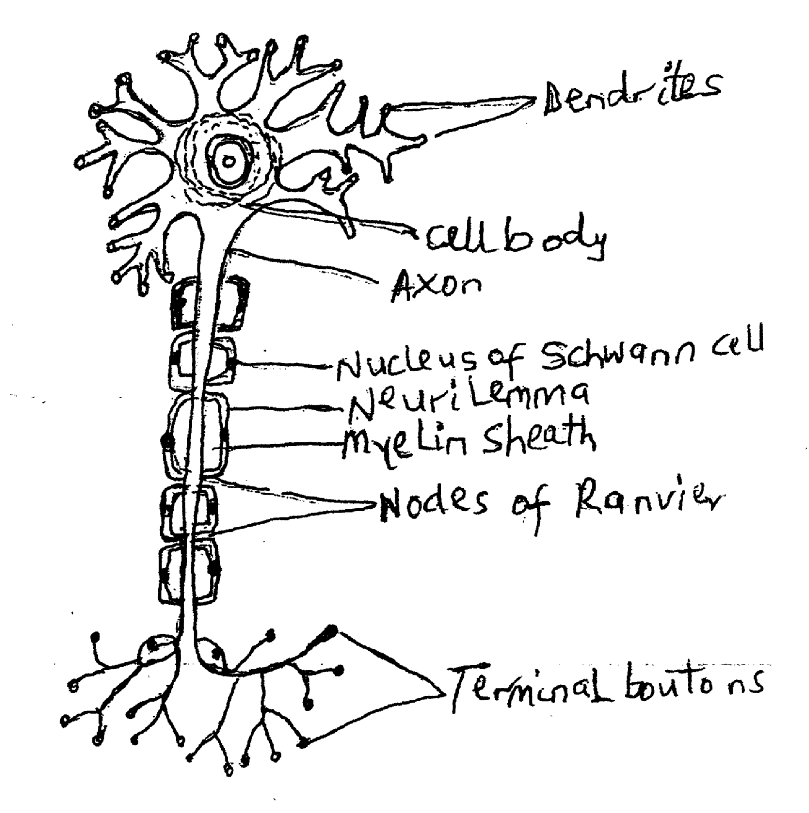
DIAGRAM SHOWING A TYPICAL NEURONE
Diagram =1 mark
¼ mark each for any 8 correct labelings which should include Dendrite. Nerve cell, Myelin sheath, Axon. Others:
Nucleus of Nerve cell. Neurolemma, Node of Rangier. Synaptic Terminals
(2marks

DESCRIPTION:
For descriptive purpose the neurone is divided into: The cell body, Dendrites, Axon, the synapses and terminal boutons.
- The cell body: The cell body of the neuron functions as any other cell. It forms the peripheral grey matter of the brain and the central grey matter in the spinal cord. Groups of cell bodies found in the centre of the brain are called nuclei. Cell bodies also form the ganglia in the peripheral nervous system.
Each cell body contains a nucleus by which a)] the activities of the neurone lie.
(½ mk)
- Axon: The structure extends from the cell body. The axon is the central axis cylinder surrounded by a fatty sheath called myelin sheath. It varies in length from few centimeters to one meter. Myclin sheaths are found only in myelinated neurone. Axon extends from the cell body and conducts impulses from one neurone to reach another. Axon branches out towards the terminal to form synapses. The synapses end in terminal buttons.
(½ mk)
- Nucleus of Schwann cells are found inside the myelin sheath. The sheath acts as insulator, speeds up nerve impulses and supply nutrition to the axis cylinder. A delicate membrane called neural lemma surrounds the myelin sheath. Gaps are found between the myelin sheath forming4iodes of Rangier along the axon.
(½ mk)

Dendrites: These are fibers sprouting out from the cell body. Dendrites are usually short and carry impulses towards the neurone cell body.
(½ mk)
Terminpl Boutpns/Synapses
At the end of the neurons are many finger like projections in which the neurone spreads into the muscle unit or ends up with another neurone at a gap. When it ends in a muscle, it is known as neuromuscular junction, when it ends with another nerve, it forms a neuronal junction.
(½ mk) Total = 2marks
(b) Neurotransinitters
- Acetylcholine
- Serotonin
- Dopamine
- Noradrenaline
- Adrenaline
- Gamma aminobutyric acid (GABA)
- Ericephal ins
- Endorphins
- Substance P.
(½ mk each for any 4 points)
Nursing Care Plan
(c) Three Nursing Diagnoses in order of priority
Identified nursing problems
- Inefficient breathing pattern related to intercostals muscle weakness
- Ineffective airway clearance related to impaired cough and gag reflees,
- Nutrition, imbalance: less than body requirement related to difficulty in chewing and swallowing.
- Activity intolerance related to muscle weakness and fatigue
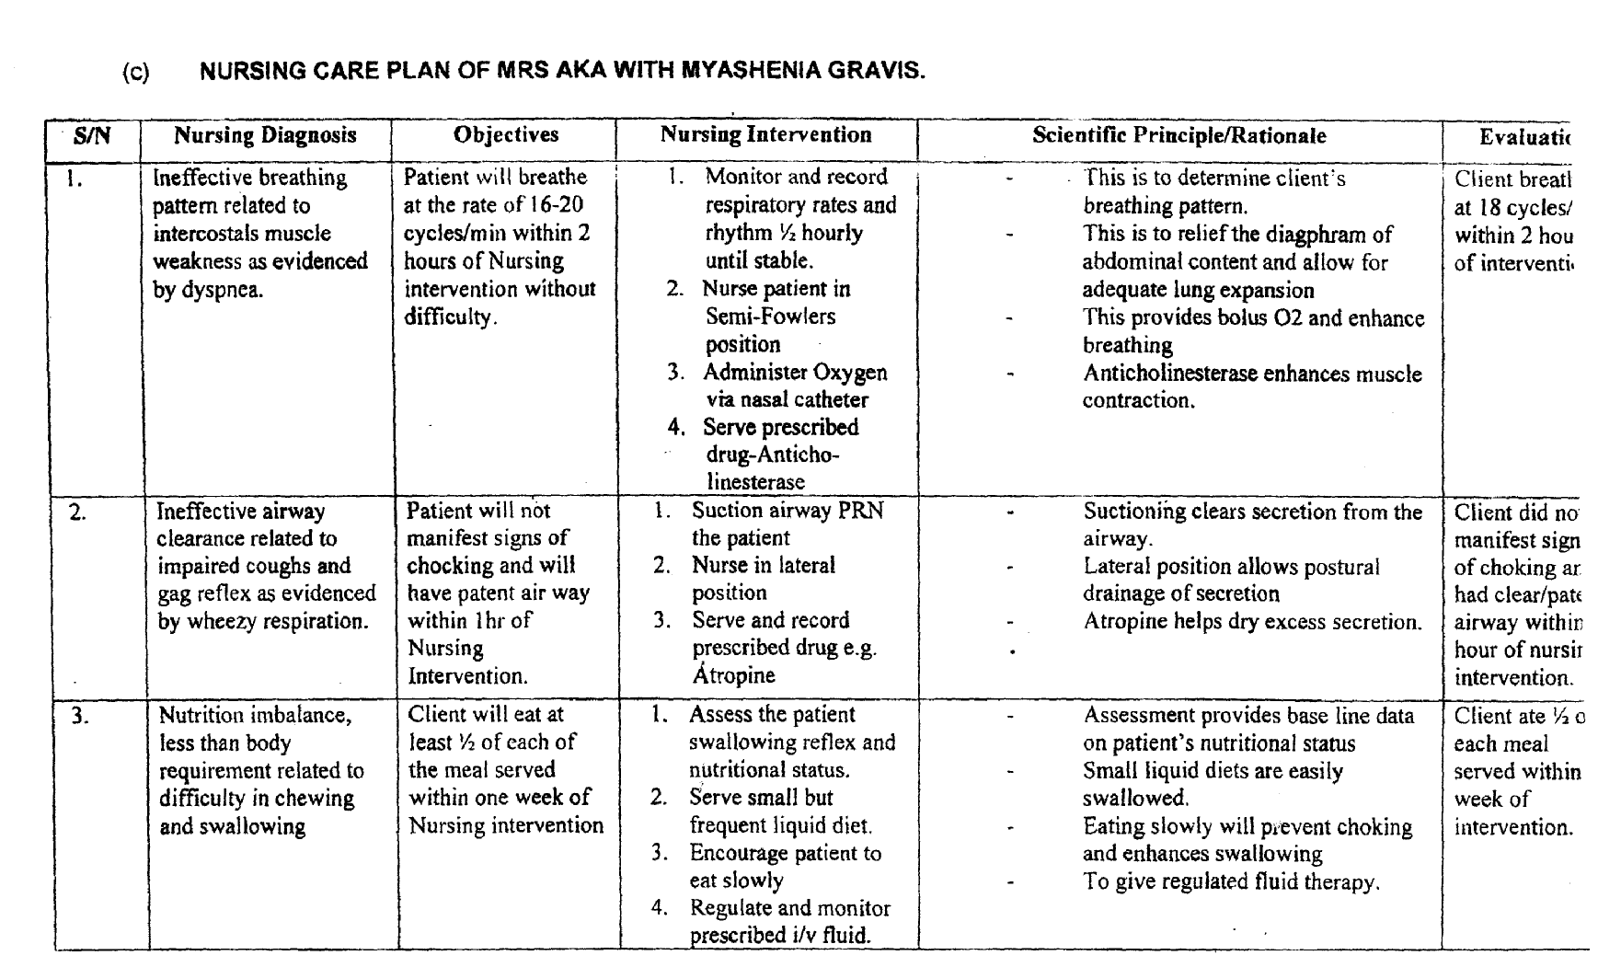
- Impaired verbal communication related to weakness of laryngeal muscle, lips and jaw.

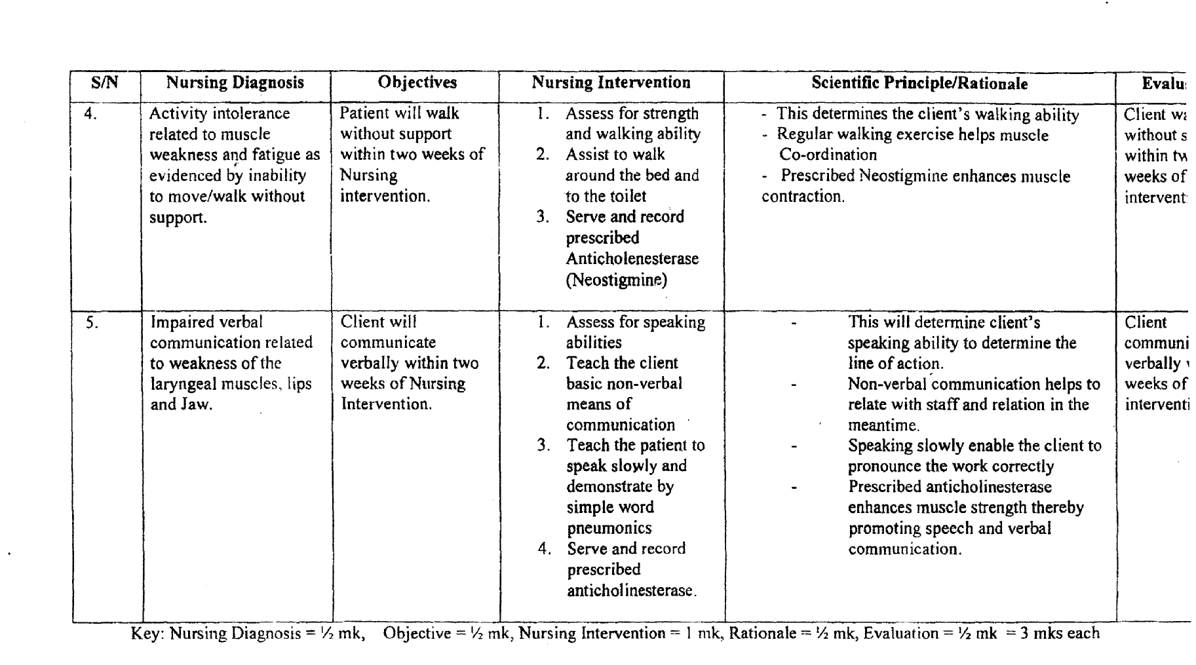
[[(d) Complications
- Respiratory Distress
- Pneumonia
- Respiratory failure
- Autonomic dysfunction
- Dysphasia
- Ptosis
- Diplopia
- Myasthenia crisis (extreme muscle weakness)
- Speech impairment
(½ mk each for any4 points)
(e) Drug of Choice in Treatment of Myasthenia Gravis.
- Neostigmine (Prostigmin)
- Pyridostigmine (mestinon)
1. Pyridostimine:
Classification: A cholinesterase inhibitor
Mode of Action: It acts by inhibiting acetyicholinesterase thereby prolonging the action of acetylcholine and thus enhancing neuromuscular transmission.
Indication: Myasthenia gravis
Adverse Effect: Diarrhoea, abdominal cramps salivation, nausea and vomiting.
Route of Administration: Orally, intrarnuscu larly, subcutaneously and intravenously.
Dosage:- Orally 30-120mg at suitable interval throughout the day.
Contraindications:- Recent intestinal or bladder surgery, mechanical intestinal or urinary tract obstruction, pneumonia, peritonitis.

Nursint Responsibilities
- Give oral prescription on an empty stomach for better absorption.
- Monitor patient’s vital signs
- Observe for and record bronchi spasm, hypotension, Respiratory depression, Headache, dizziness and convulsion. If any of these occur, discontinue therapy and inform the Doc
- Evaluate patients therapeutic response namely increased muscle strength, hand grasp and improved gait.
(b) Neostigmine (Neostigmine bromide)
Indication-Myasthenia gravis
Mode of Action: It acts by inhibiting acetyleholinesterase thereby prolonging the action of acetyl chorine and thus enhancing neuromuscular transmission.
Adult dose -15-30mg at suitable interval initially, gradual increase in dosage to maximum 75 300mg daily until desired response is obtained.
Children-7.5-15 mg initially,
Maximum of 90mg daily at suitable intervals.
Route of Administration Orally
Intramuscularly
Intravenously
Side effects
- Increased salivation skin rashes
- Nausea and vomiting, insomnia
- Abdominal Cramps, diarrhoea, anorexia and irritability.
Contra Indications
- Asthma, Urinary tract infection
- Cardiovascular diseases, Hyperthyroidism
- Hypotension, peptic ulcer, epilepsy
- Renal impairment and Parkinsonism.

Nursing Considerations
- Administer with food or milk if G.I.T. upset occurs.
- Observe patient for bronchi spasm, hypotension, respiratory depressions, headache, dizziness and convulsion.
- Monitor Patient’s vital signs especially respiration
- evaluate patient’s therapeutic responses.
Marks
Classification/Group ¼ mk
Dosage: ¼ mk
Route of Administration ¼ mk each for any 2= ½ mk
Mode of Action ¼ mk
Contraindication ¼ mk
Side Effects ¼ mk for any 2
Nursing Consideration I mark
Total = 3 marks
Question 4
(a) Defination
Communication is the process by which information or idea is transmitted from one person or group to another, through a medium so that the recipient (receiver) can initiate a response or action (feed back).
OR
It is an of exchanging ideas/messages between a sender and a receiver through a medium.
(¼ mk each for any 4 underlined words I mk)

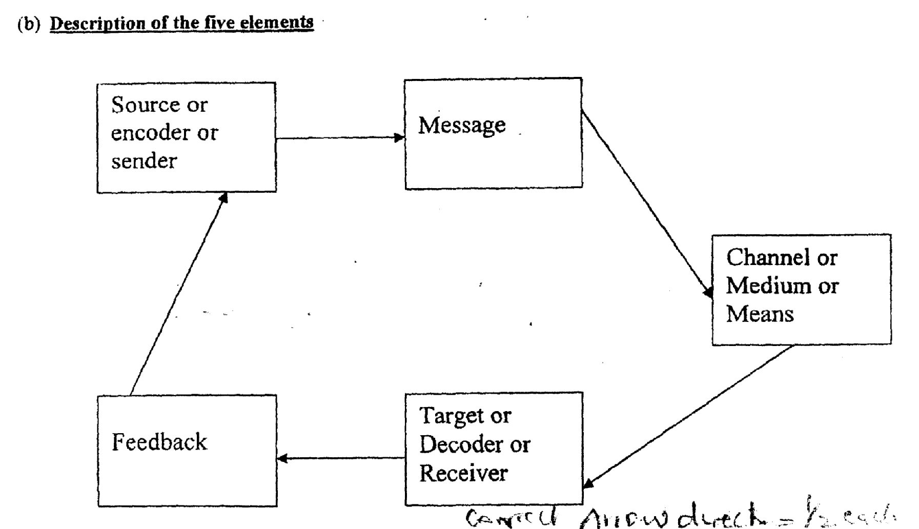

Elements of Communication.
Correct direction of arrows = ½ mk
(Illustration=2marks, Title = ½ ark)
(i) Sender: (½ mk)
- This is the person who initiates, encodes or packages a message.
(½ mark)
- The person who transmits or passes a message. (½ mark)
(ii) Message: (½ mk)
It is the idea being communicated which may be an instruction, information or a request.
(1 mark)
(iii) Channel: (½ mk)
This is the means or medium chosen to relay/transmit the message . tekphone, radio. (1 mark)
(iv) Receiver: (½ mk)

(v) Feed back: (½ mk)
- It is the response of the receiver to the message. (¼ mk)
- It confirms the objective of communication. (¼ mk)
- It could be positive, negative or neutral. (¼ mk)
- It is a response to a stimulus. (¼ mk)

Illustration 2 mks, Title = ½ mk
Each element mentioned = ½ mk x 5 = 2 ½ mks
Each element explained I mk x 5 = 5 mks
Total= 10 inks
[
(c) Barriers to Effective Communication:
- Personality
- Language barrier
- Cultural background
- Mannerism
- Pitch, tone of voice
- Physical disability e.g. hearing defect
- Attitude
- Poor knowledge of the subject matter
- Physical barriers e.g. distance appearance, etc.
- Noise
- Timing
- Moods/emotion e.g. anger
- Lack of interest
- Stress/fatigue
- Poor interpersonal relationship
- Mode of dressing/appearance
- Age/developmental level
- Message over load
(½ mk each for any 10 points = 5 mks)
[
(d) (1) Verbal Communication
This is the use of words. (1 mk)
Example:
A: Spoken words - talking, singing, etc.
b. Written - letters, memo, report, circulars, print-media.
Description I mk
Examples= ½ mk each x2= 1 mk Total2mks

(2) Non-verbal Communication The use of unspoken words.
Examples:
- Body language: facial expression, gestures, etc
- Symbols: e.g. “staff of office”
- Cartoons
- Silence, whistling, hissing, etc.
- Signs warning
- Description 1 mk
Examples = ½ mk each for any 2 examples = 1 mk
Total 2 mks

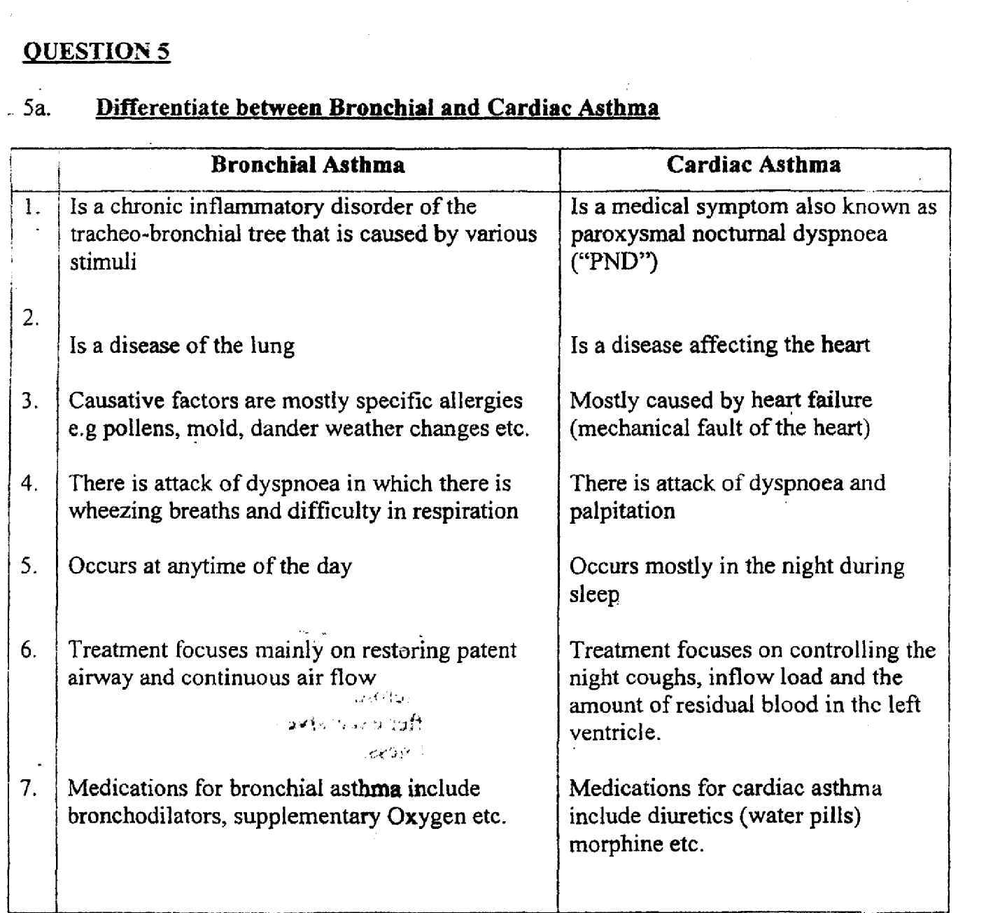
(½ mark each for any 3 correct points in bronchial asthma and any 3 correct point in cardiac asthma
(3 marks) (Corresponding points).
b. Pathophysiology of Bronchial Asthma
- Allergy i the strongest predisposing factor for asthma.
Chronic exposure to airway irritants or allergens such as grass, tree and weed, pollens, molds, dust roaches, triggers such as air pollutions, cold or hot weather changes, strong
odours or perfume, viral infection (respiratory tract), emotional upset, frequent laughter etc.
- This may lead to airway inflammation resulting into obstniction due to swelling of the mucosal membrane (oedema)?
- The swelling reduces the airway diameter which causes the contraction of the bronchial smooth muscles (called bronchial constriction/spasm)
- The spasm cause further narrowing and increased mucus production which further reduce the diameter of the airway and may entirely plug the bronchi.
- Inflammation caused by the offending antigen, results into increased 1gB with mast cells causing release of chemical indicators such as histamine, prostaglandin, bradykinis which causes increased blood flow, increased secretions by glands and mucosa edema.
- Bronchial muscles and much glands enlarge, producing thick tenacious sputum, while the alveoli hyper — inflate due to air flow limitation causing wheezing, cough, dyspnoea and chest tightness
- These eventually cause prolonged expiratory effort with alteration in residual and tidal volume, vital capacity and forced expiratory volume.
(1 mark each for any 6 correct points = 6 marks).
c. Management of Miss Ovine within the first two hours in the hospital

Nursing Management
- Admit in a well ventilated room for rest
- Place patient in an upright or sitting position with bed table, sputum mug and bell within reach
- Administer oxygen preferably using oxygen mask if necessary
- Reassure patient and relatives as it will calm them down and reduce fear and Anxiety brought about by the condition
- History taking from the relatives and family
- Observe her colour, cough, wheezing respiration and sweating
- Monitor vital signs Y2 hourly until stable
- Observe degree of restlessness
- Stay with patient during attack
- Encourage c 5pious fluid and steam inhalation to liquefy mucus and aid expectoration
- If on intravenous infusion, monitor fluid balance chart and maintain rate of flow
- Administer prescribed bronchodilator, tranquillizer, and corticosteroids and cough expectorant
- Attend to physical needs, especially mopping of the body after excessive sweating
- Give easily digestible nourishing diet after active stage of illness

Medical Management
- Bronchodilators e.g. Aminophylline 250-500mg intravenously, ventolin (salbutamol) 4mg 6 hourly.
- Adrenalin 0.2-0.5mg subcutaneously
- Corticosteroids e.g. Hydrocortisone 50-100mg intramuscularly or intravenously depending on patient’s age, weight, etc.
- Saturated potassium iodide 250-500mg to loosen thick mucus for easy expectoration
(½ mark each for any 14 correct points = 7 marks).
d. Outline of a health talk to a group of asthmatics on measures to prevent attack
The nature, types, causes, precipitating factors of asthma
- Avoidance of causal or precipitating factors such as
• Exposure to indoor or outdoor allergies
• Occupational hazards
• Respiratory infection
• Air pollutions
• Active, passive smoking

PSYCHIATRIOI PBRIOPIRATIVE NURU. NOVEMBER 2007
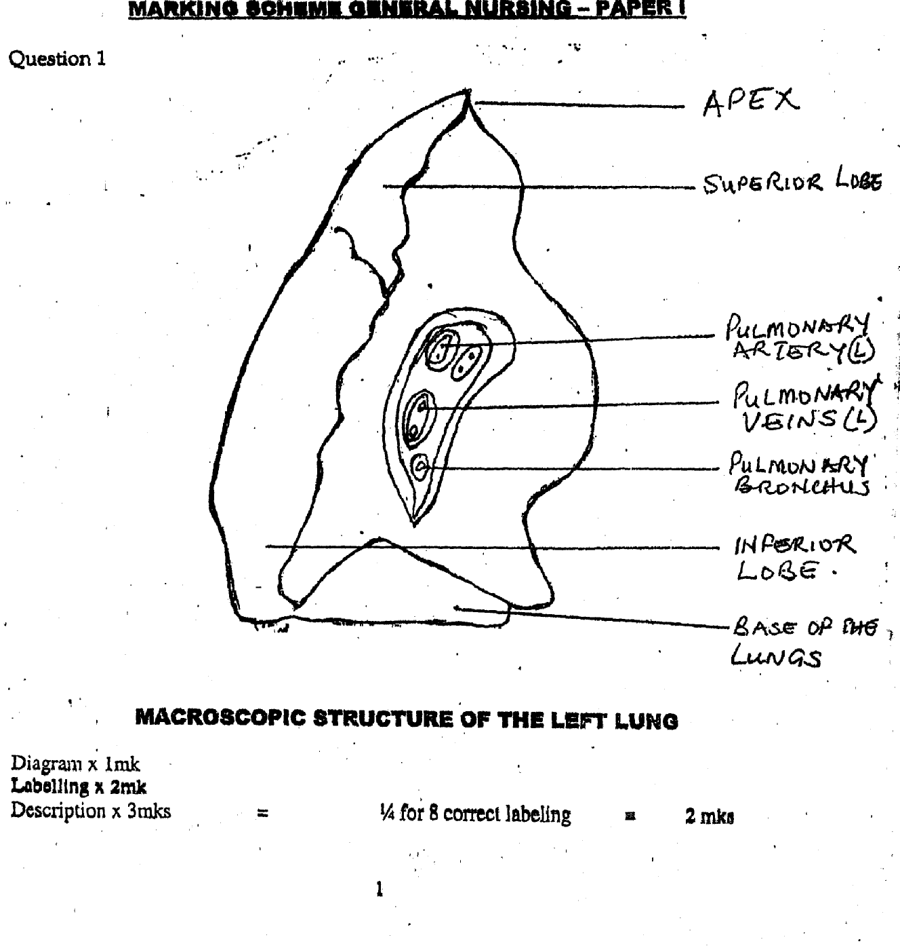

QUESTION 1
a.
Descriptor of the left lung:
Introduction.
The left lung is smaller than the right lung. It is divide4into two lobes namely the superior and the inferior lobes1 it is cone shaped and it has an apex, a base, costal surface and medial surface, (½)
Apex: Rounded and rises into the root of the neck, about 25mm (1 inch) above the level of the middle third of the clavicle. The structures associated with it are first rib, and the blood vessels and nerves in the root of the neck. (¾ mks)
The base: This is concave and semilunar in shape. It is closely associated
with the thoracic surface of the diaphragm. (¾)
The Costal Surface: This surface is convex and is dose related to the costal
Cartilages, the ribs and intercostals muscles. (½ mk)
The Medial Surface: This is concaved and has a roughly triangular shaped called the helium at the level of the 5th, 6th and 7th thoracic vertebrae. Structures which form the root of the lung enter and leave at the helium. These include the left pulmonary bronchus, the left pulmonary artery and pulmonary veins, the lymphatic and nerve supply to the left lung, (½mk)
Total of 3marks.
b. Outline 4 clinical diagnoses of Pulmonary Tuberculosis
(i) Chest x- ray
(ii) Cliuiical manifestation
(iii) Sputum test for A F B (Acid fast Bacilli)
(iv) Manitou x test (Tuberculin Skin Test)
(v) Head test
(vi) Computed Tomography (C.T. Scan)
(vii) Bronchoscope
(½ mk each for any4points) = 2mks.

C. Nursing Care Plan:
(1) Ineffective breathing Pattern related to accumulation of secretions in the lungs evidenced by changes in the respiratory rates (22 beats minutes and above).
(ii) Imbalance nutrition less than body requirement related to anorexia evidenced by weight loss.
(iii) Activity intolerance reedited to fatigue altered nutritional status and fever evidenced by inability to carry out activities of daily living.
(iv) Ineffective thermoregulation related to inflanirnatory process evidenced by low grade fever.
(v) Arxlety related to outcome of disease condition evidenced by patient asking a lot of questions.
(vi) Sleep pattern disturbance related to persistent coughing evidenced by patient’s complaint.
(Candidates are to identify No 1 plus any other two)
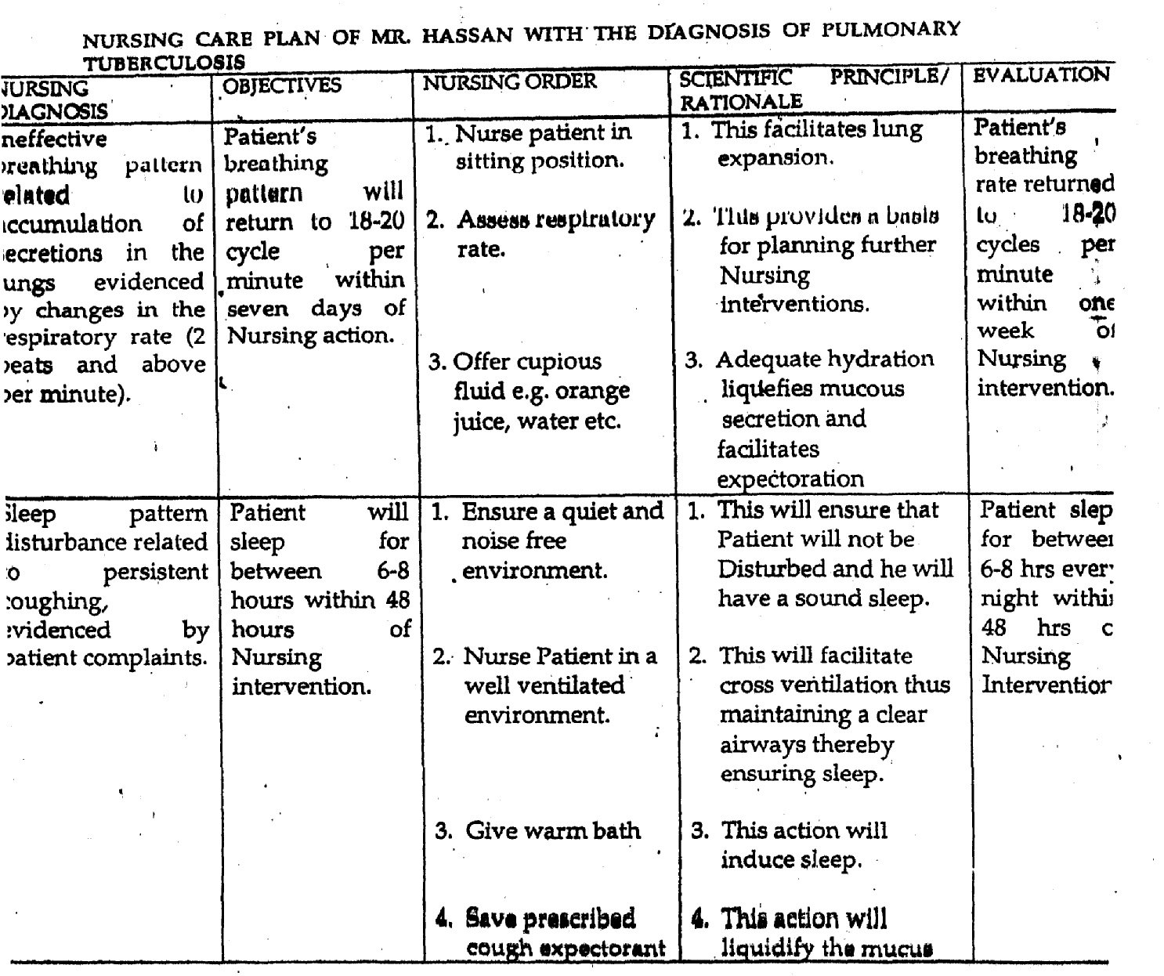

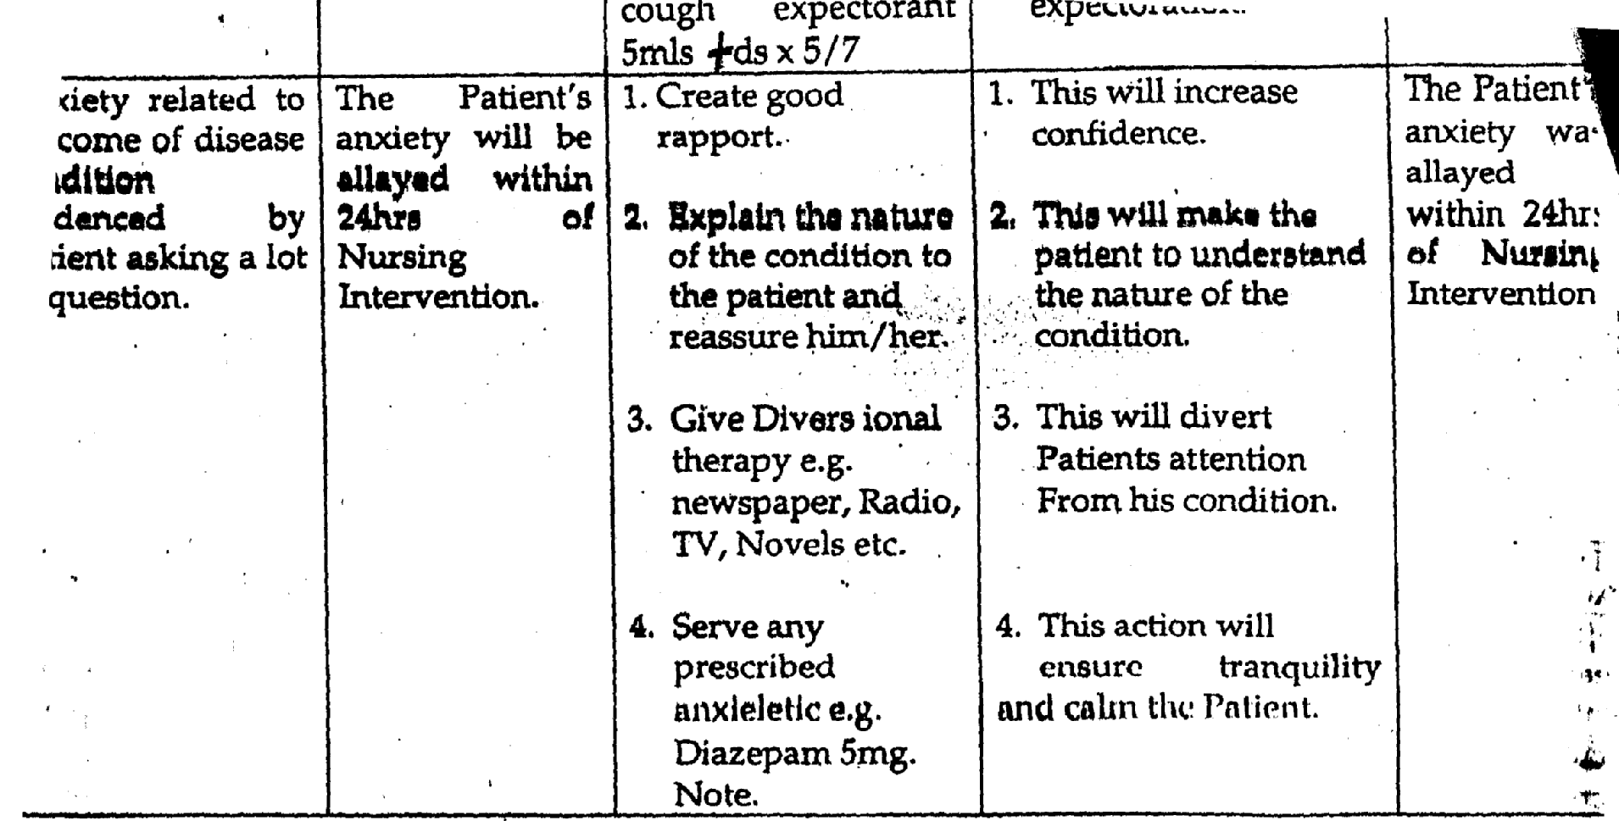
[

Note: Nursing diagnosis ½ mk
Objectives ½ mk
Nursing Action (at least 3) 1 mk
Scientific Rational ½ mk
Evaluation ½ mk
Total = 3mks
d. Six measures.

- Health Education
- Immunization of children with BCG vaccines
- Good personal and environmental hygiene.
- Proper nutrition to build up immunity.
- Prompt and proper treatment of infected cases.
- Avoidance of overcrowding
- Adequate surveillance for tuberculosis by periodic tuberculin skin
testing.
(viii) Report cases to public Health authority as soon as possible.
(ix) Early identification and treatment of persons with active tuberculosis.
(x) Prevention of the spread of droplet nuclei by source control methods.
(xi) Avoidance of smoking, proper disposal f sputum.
(½ mk each for any 6 points)
Total =3 mks)

QEST1ON 2
a. Formular = prescribed dose x volume
Stock Strength 1 = (½ mk)

Calculation = 180 $×2ml$
500mg 1

= 180 $×2$ = 18 =0.72mg
500 1 25

(1mk)

Since i1 is prescribed in 2 divided doses = 0.72 =0.36m1 (½ mk)
2

Total = (2 mks)

b. Formulary = dose x. Frequency
Stock Strength = (½ mk)

Calculation = 90mg. x 5 doses
500mg

= 90x5 = 450 = 0.9
500 500 (lmk)

Approx. = 1 vial will be supplied = (½ mk)
OR

1 dose = 180mg = 90mg (½)
2

$∴$5 doses = 90 x 5 = 450mg (1 mk)

$∴$ 1 vial should be supplied by the pharmacist = (½ mk)
OR

0.36m1 x 5 doses
2 = (¼mk)
= 0.36x5 = 1.8 = 0.9 = (l mk)

0.9 is approximately vial = (1 mk)
Total mks = (2 mks)

c. Formula = Volume in ml $×$ Drop Factors
Time in Minutes 1 = (I mk)

Calculation = 500mg $×$ 15 8 hours x 60 minutes 1

500 125 x 15 1 = 125
8 $×$ 60 41 8 = (2mks)

Answer = 125 15.62
8

= 16 drops per minute = (1 mk)
Total mks = (4mks)

2 (d) (i) Ceftazidine (Tazicef)
Group: cephalosporin antibiotic = (½ mk)
Route of administration = (½mk)
Mode of Action:
- It interferes with bacterial cell wall and cross link synthesis.
- It is broad spectrum antibiotic which is active against gram negative and gram-positive micro-organisms.
- It is both bacteriostatic and bactezocidal antibiotic.
(½ mk each for any 2 points = lmk)
Contra Indication:
- Penicillin hypersentivity.
- Pregnant women
- Renal insufficiency
- Hepatic insufficiency
¼ mk each for any 2 = (½ mk)
Side Effects
- Prutis
- Arthrialgia
- Urticciria
- Soreness of mouth
- Nausea and vomiting
- Skin
- Rashes
- Abdominal discomfort V
- Aplastic
- Anaemia
- Agranulocytosis
- Insomnia (¼ mk each for any 2 points s ½)

Nursing Responsibilities
- Give intravenously after dilution with normal saline, dextrose water or sterile water,
- Confirm that patient is not allergic to penicillin prior to use.
- Change injection site every 3 days.
- Teach patient to report sore throat, easy bruising, bleeding and joint pains which may be signs of blood clyscrasia.
- Do not administer with Aminogly cosides in same bottle.
- Observe for signs and symptoms of anaphylaxis during first dose.
- Mopitor closely for signs of super infection.
- Decrease in amount of urine may indicate nepbrotoxicity hence, notify the physician.
- Discontinue drug if severe diarrhea occurs. (¼ ink each for 4 points)
= (1 mk)

d. (ii) Pvrlmethamlne (Darupiim)
Group: Antimalarial = (½ mk)
Route of Administration: Orally = (½ mk)

Mode of Action:
(i) It destroys the pre-erythrocyte forms of plasmodium especially the falcipaxium species.
(ii) It interferes with the uptake of folic acid by the parasite.
Any correct mode of Action = (1mk)

Contra indication
- Hypersensitivity to pyrimethaznine
- Severe hepatic impairment
- Severe Renal impairment
(¼ each for any2 points) = (½ mk)

Side Effects
- Gastritis
- Rashes
- Insomnia
- Macrocytic anaemia
- Atrophic glossitis
(¼ mk each for any2points) = (½mk)
Nursing Responsibilities
- Advise on intake of liberal] oral fluids and fruits
- Give falcate supplement
- Take with meals to minimize vomiting
- Watch for side effects and discontinue at first signs of skin rash and inform the physician.
(¼ mk each for any 4 points) = (1 mk)
d. (iii) Maben calzone (Vennox)
Group: Anthelmintic = (½ mk)
Route of Administration: Orally = (½ mk)
Mode of Action
- It inhibits uptake of glucose and other nutrients in susceptible helminthes causing weakness and subsequent death of worms.
(iii) It exerts local action on worms in the GIT.
(½mk each for any 2 points) = (1 mk)
Side Effects
- Gastro intestinal disturbances, hcctache, dizziness with high doses.
- Allergic renetion
- Raised liver enzymes
- Alopecia
- Bone marrow depression
(¼ mk each for any 2 points) = (½ mk)
Contraindications
Pregnancy and infants
Hypersensitivity to Mebendazole
(¼ mk each for any 2 points)= (½ mk)
Nursing Responsibilities
- Tablet may be chewed, swallowed while or crushed and mixed with food to minimize GIT upset.
- No dietary restrictions
- No enema or laxatives required
- Advice on the need for good personal hygiene especially hand washing technique.
- Advise patient to avoid preparing food during infestation.
- For avoidance of re infection, teach patient to wash perinea area daily.
- Wash all fruits and vegetables before eating.
- De worm all family members.
(¼ mk each for any 4 points) = (1mk)

Q3
a. Causative organism of Chicken Pox is varicella zoster virus (lmk)
b. 6 clinical manifestations of Chicken Pox
(I) High fever
(ii) Headache
(ii) Vomiting
(iii) General Malaise
(iv) Anorexia
(v) Dehydration
(vi) Loss of weight.
- Insomnia
- Rashes is symmetrical in more on trunk, back and shoulder
- Crops of macula, papule, vesicular rash and scars (All the different rashes may be present at the same time. (Pleomorphism).
(½mk for any 6 points = 3mks).
Management of Olu from Admission till discharge.
ADMISSION:-
- Receive and admit patient with courtesy in isolation’ unit of the ward or barrier nurse in a corner of the ward.
- All isolation precautions must be maintained such as use of face masks, hand gloves and good hand washing after any procedure.
- Ensure adequate ventilation of the room by opening the nearby windows.
(½ mk each for any 2 points = l mk)
POSITION:
- Put patient in a comfortable position and change position every 2 hours.
(½mk).
OBSERVATION
Patient is observed from head to toe and an assessment is made as regards to:
- Vitals signs — Temperature, Pulse Respiration and Blood pressure.
- If the temperature is high apply measures to reduce fever.
- Observe the nature of the rash and its distribution.
- Observe for skin irritation and itching. Observe for sign. of dehydration.
½ mk each for any correct 2 points = I mk
NUTRITION
- Give patient high nourishing diet including high protein, vitamins, minerals and moderate carbohydrate. This is to ensure repair of the worn out tissues, encourage healing, improve energy, and boost immunity to avoid secondary infection.
- Encourage copious fluid intake to avoid dehydration. (½)
INVESTIGATION
- Laboratory teat Is rarely required as clinical signs are usually evident or visible. But teat done may ilude serum Electrolytes and full blood count. (l mk).
PHYSICAL CARE
- Provide skin comfort measures use of calamine lotion. Potassium,
Permanganate added to bathing water.
- Let patient have his finger nails trimmed to avoid injuring himself and prevent him from scratching to reduce the chances of secondary infection.
- Encourage use of loose fitting clothing’s and change clothing daily.
- Assist him in the performance of activities of daily living e.g. bathing, oral care, feeding until he can do them unaided in order to conserve energy.
- Care of the pressure areas.
- Disinfection of articles soiled by nose and throat discharges.
- Ensure daily ambulation
(½ mk for each for any correct 4 points = 2mks)
PSYCHOLOGICAL CARE:
- Reassure patient and relatives to allay fears and anxiety.
- Explain all procedures to them before carrying them out.
(½ mk).
DRUGS
Give the following drugs as prescribed:
- Prophylactic antibiotics e.g. Ampicillin or Ampiclox 6 hourly.
- Antipyretic and analgesics e.g. paracetamel.
- Antihistamine e.g. Portion
- Vitamins e.g. Vitamin C.
- Intravenous fluids e.g Nominal saline, Dextrose Saline.
(½ mk each for any correct 2 points = l mk)
ADVICE ON DISCHARGE:
- Educate patient and relatives on the cause, mode of transmission and prevention of chicken pox.
- Advice to provide good ventilating at home.
- Practice good personal and environmental hygiene.
- Advice to eat high nourishing diet.
- Advice to observe for signs of complications.
- Encourage to take prescribed drugs at home.
- Come for follow up appointment and to report back to the hospital if condition worsens or any sign of complication arises.
(½ mks each for any correct 4 points = 2mks).
Total mks=to mks
d. STEPS TO BE TAKEN TO PREVENT SPREAD OF CHICKEN POX IN THE SCHOOL/COMMUNITY.
(a) Steps To Prevent Spread Of Chicken Pox in The School
Early notification of epidemics of chicken pox to the local health authority.
- Early diagnosis and treatment of Identified cases.
- Isolation of students with chicken pox in the hospital..
- Disinfection of articles soiled by nose and throat discharges.
- Health education of School children on good personal hygiene (hand washing, avoid sharing of clothes, towels, handkerchiefs) and environmental hygiene.
- Administer immunoprophylaxis with varicella — zoster immune globulin (VZ1G) within 72 hours of exposure to individuals children in contact or exposed to the case.
(½ mk for each for any correct 6 points =3 mks).
Steps To Prevent Spread Of Chicken Pox In The Home/Community.
- Early notification of epidemics of chickpea pox to the local health authority.
- Early detection: An active search for cases amongst family and community.
- Early diagnosis and treatment of identified cases.
- Isolation of cases for about six days after the onset of the rash in the hospitals.
- Disinfection of articles soiled by nose and throat discharges.
- Health education of families and community on good personal hygiene and environmental hygiene.
- Administer immunoprophylaxis with varicdlla — zoster immune globulin (VZIG) within 72 hours of exposure to individuals in contact with the infected person and likelihood of developing severe or complicated disease.
(½mk for each for any correct 6 points =3 mks).
QUESTION 4
a. Mental health is not mere absence of mental illness.
- It is the ability to respond to the many varied experiences of life with - flexibility and a sense of purpose.
- A state of harmony between oneself, and others.
- A coexnetence between the realities of self, that of other people and the environment,
- It is a successful performance of mental function resulting In productive activity.
- It provides people with the capacity for rational thinking, communication, skills, learning, emotional growth, resilience and self esteem.
(½ mk each, any4 points = 2mk)

b. Factors that contribute to the Promotion of Mental Health
These include:
A. Biological Influences.
- Pre natal, pen natal and neonatal events. Good care given at these periods in life will promote mental health.
- Physical health status e.g. exercises, sleep.
During sleep, muscles of the body relax and the individual wake up refreshed and re-invigorated.
Exercise promote blood supply to the brains thus preventing unnecessary irritations that may occur due to cerebil arterial
insufficiency.
- Nutrition/Diet: Balanced and nourishing diet is essential for the sPrevention of the death of brain cells, and thereby promote mental health.
B. Psychological Influences
- Positive relatkmnship with family, peer grouftiends etc.
- Positive self concept.
- Creativity
C. Soclocultural Influences
- Family stability
- Good Housing
- Good Child rearing patterns
- Religion
- Value and belief
(Any2points from each subhead 6 points=6mks)
4c. - Ability to handle and resolve internal conflicts.
- Well adjusted. Ability to get along with others, accepts criticism and not easily upset.
- Searches for identity
- Has strong sense of self esteem
- Knows his/her needs, problems and goals.
- Has good self control, balances rationality and emotionality.
- Faces problems and tries to solve them intelligently i.e coping with stress and anxiety.
4d. - Signs that may assist in daily detection of impaired Mental Health.
- Social Isolation/Withdrawal: They prefer to slay alone to avoid
Social Interaction. The also loose Interest in whatever activity going on around them.
Perception disorders:-
- The way they see, feels or think about things or issues varies from every other’ person.

Neglect of personal hygiene:
- The individual looks unkempt and has a tendency to be carefree or non challant in the area of dressing and personal hygiene.
Loss of attention span:
- Cannot concentrate on the happenings around them.
- They reject food or may eat less.
- Failure in performances at work (offices) and in School, lateness to working place or school.
Truancy:-
- Unnecessary argument overt issues which may result into violence.
Depression: They are unhappy and inactive most of the time. Isommin - inability sleep wall.
(Any 4 points with description 8 inks. 2 mks each),
(Mentioning I mk, Description = 1mk)
QUESTION 5
- Explam four (4) principles of management
Division of Labor
Identifying the goals to be achieved, translating them to objectives then job components as duties, tasks and responsibilities. These are then allocated to individuals or groups; possession of relevant skills informs the job components that would be allocated to an individual or groups.
ii. Authority and responsibility:
This principle presupposes that certain degree of responsibility should carry on equal degree of authority.
iii. Discipline:
Norms, values, standards and acceptable ways of behaviour. Sanctions are outlined for failure to comply. These ensure compliance. This illuminate in the establishment of rules and regulations.
iv. Equity:
Fairness, that is extending equal treatment to all subordinate staff irrespective of relationship or affiliation.
v. Order:
Maintenance of peace and tranquility
vi. Remuneration
This refers to methods of payment which should, be fair and afford the maximum possible satisfaction to employees.
vii, Initiative
Employee should be encouraged to brhig up ideas on measures to be taken in order to improve the organization
viii. Stability of Tenure:
There should always be a lender at every level of the organization.

xi. Unity of Direction:
The organization should be pulled towards one direction which IH the goal(s) of the organization.
x. Scatter Chain
This is a chain of relationships. It entails hierrharchy dictated by principles of unity of command.
xi Espirit De Corps.
This principles acts on the philosophy of a family, therefore employees should behave as members of the family, to ensure collective consciousness.
OR
Principles of Management are also viewed as Functions, Elements/Processes, therefore;
1. Planning
ii. Organizing
iii. Directing / devision or Lason
Iv. Co-ordinating
v. Controlling
vi. Staffing
vii. Motivating
viii. Communication
ix. Budgeting
x. Reporting
xi. Decision Making

i. Planning:
Entails focusing, formulating, objectives, fixing the method by which goals are to be accomplished.
ii. Organizing:
Is the process of engaging two or more people in a structured way to achieve the specific goals - either short or long terms.
iii. Directing:
It is the processes of getting the organization work accomplished. It involves issuing of orders and directing, creating a climate in which order are easily accepted and executed or its’ involves. Managing workers and the work environment through effective communion motivation and proper leadership.
Co-ordinating
It ensures that the various divisions of the organization work smoothly and the interrelated tasks in them are co-ordinited In harmony and unity.
v. Controlling:
Is the process of guiding an activity towards pre-determine goals using the set measuring yard stick to determine the level of achievement, it compares event with plan criterion and makes necessary corrections where events have deviated from the plan.
vi. Staffing:
Selecting, appointing, placing of people to do work as defined in an organization. It attempt to ensure that the personnel placed in a particular job are suitable and capable to perform the job (recruitment).
vii. Motivation:
Can be defined as need, urges, motives or wants, that make people, balance in a particular manner or the propensity outcome or, set of out come. Motivation is closely intertwined with behaviour (linked up with behaviour) many and diverse variables affecting it.
viii. Communication:
The art and science of transmitting information, ideas attitudes or opinions from one common system of symbol or is a two way continuing process of interchange of facts, ideas, feelings, and courses of action. The basic elements are source of information (encoder), the message, the chancel receiver (decoder).
ix. Budgeting:
Is a continuous planning covering manpower materials, capital expenditures and financial expenses to meet objectives for a specific period of time.

x. Reporting:
Is getting feedback or result for necessary corrective measures, reappraisal Re-orientation and re-direction as may be necessary.

- Decision Making:
It involves identifying and defining the felt problems or needs and deciding what to do as well as evaluating alternatives and selecting the best one to meet organizational goals
(¼ mk each for 4 points = I mks, explanation of the 4
points ¾ mk each 3)
b. Traditional Leadership Styles used In Nursing are:
i. Authoritarian or Autocratic
ii. Democratic/Participative/Consultative

PROFESSIONAL EXAMINATION FOR GENERAL NURSES -
NOVEMBER 2013
MARKING SCHEME - PAPER I
la. Definition: School health services are services rendered by health professionals to school children and staff to keep them in a state of complete physical, social and mental well-being. 1 mk
It involves the following:
- Organized activities undertaken by schools for the purpose of prevention, protections, curative and promotion of the health of school children and staff.
- An integral part of community health.
- A phase of community health and family service that promotes the well being of the child and his education for healthful living.
- A powerful influence for shaping health behaviour.
- Contributes to initiation, understanding and maintenance of health of pupils and school staff.
- A means of etab1ishing a firm foundation for healthy habits.
(½ mk each for any 4 correct points = 2mks)
b. The objectives of school health service are:
1. To promote and maintain health of each school child.
2. To appraise the health status of pupils and personnels/staff
3. To detect any abnormality that will endanger the life of the pupils and give prompt treatment.
4. To Assist in the identification and education of handicapped pupils
5. To adjust individual school program to needs of school children with health problem.
6 To provide emergency services for injury or sudden illness at school
7. To help prevent and control communicable and non communicable diseases.
8. To counsel pupils, parents and teachers concerning health problems.
9. To plan and implement services which will provide a healthy
environment.
10 To assist student pupils in acquiring good health practices.
11 To cooperate with the governmental and non governmental organization agencies in provision of health services to the pupils and staff.
12. To design a health referral and follow up s stent he pupils and
staff. (l mk each for any correct points =3nks)
c. Activities
- Health screening for common disease such as hepatitis A, 13, C, ear for hearing, eyes for sight, etc.
- Health education with emphasis on personal/environmental hygiene, adequate nutrition, exercise, use of illegal drugs, promiscuity and unsafe sex.
- Immunization against diseases such as measles, cholera, tetanus,
Polio, yellow fever etc.
- Environmental sanitation such as cutting of bushes, avoidance of stagnant water, proper drainage system, good waste and sewage disposal systein, proper ventilated and well lighted classrooms.
- Provision of first aid and management of minor injuries such as cuts, fever and upper respiratory tract infection (URTI) etc.
- Physical inspection of pupils’ hair, nails, skin, teeth, mucous membranes.
- Inspection of food from home and the food vendors to ensure they
Comply with nutritional needs of the children.
- All ailment or diseases that cannot be managed on the spot are referred to appropriate institution.
- Follow up pupil and staff either through treatment or management of minor ailments or injuries and other health challenges is followed up through home or school visit.
- Deforming exercise to take care of womb infestation through use of antihelmintics
- Assessment of handicapped and physically challenge children in order to place them in a most appropriate institution according to
their handicapped status.
- Proper record keeping and documentation, all data relating to the status of the health of the pupil and staff are recorded and documented.
- Health counseling of parents, pupils and staff which could help in
identifying abused pupils.
- Updating of parent teachers association about health status of staff
and students through periodic meeting.
(lmk each for any 10 correct points = l0mks)
d. Factors
1. Ignorance: purchasing of spoilt foods like tomatoes, meat fish etc.
2. Poor preservative method
3. Poor food preparation. Method
4. Lack of training/re-training of food vendors
5. Poor licensure procedures of food vendors
6. Personal/ Environmental hygiene: poor hand washing, dirty clothing, poor knowledge of vegetable washing, etc.
7. Poverty.
(1 mk each for any 2 correct points = 2mks)

PROFESSIONAL EXAMINAITON FOR GENERAL NURSES NOV. 2013
MARKING SCHEME PAPER 1 Q 2
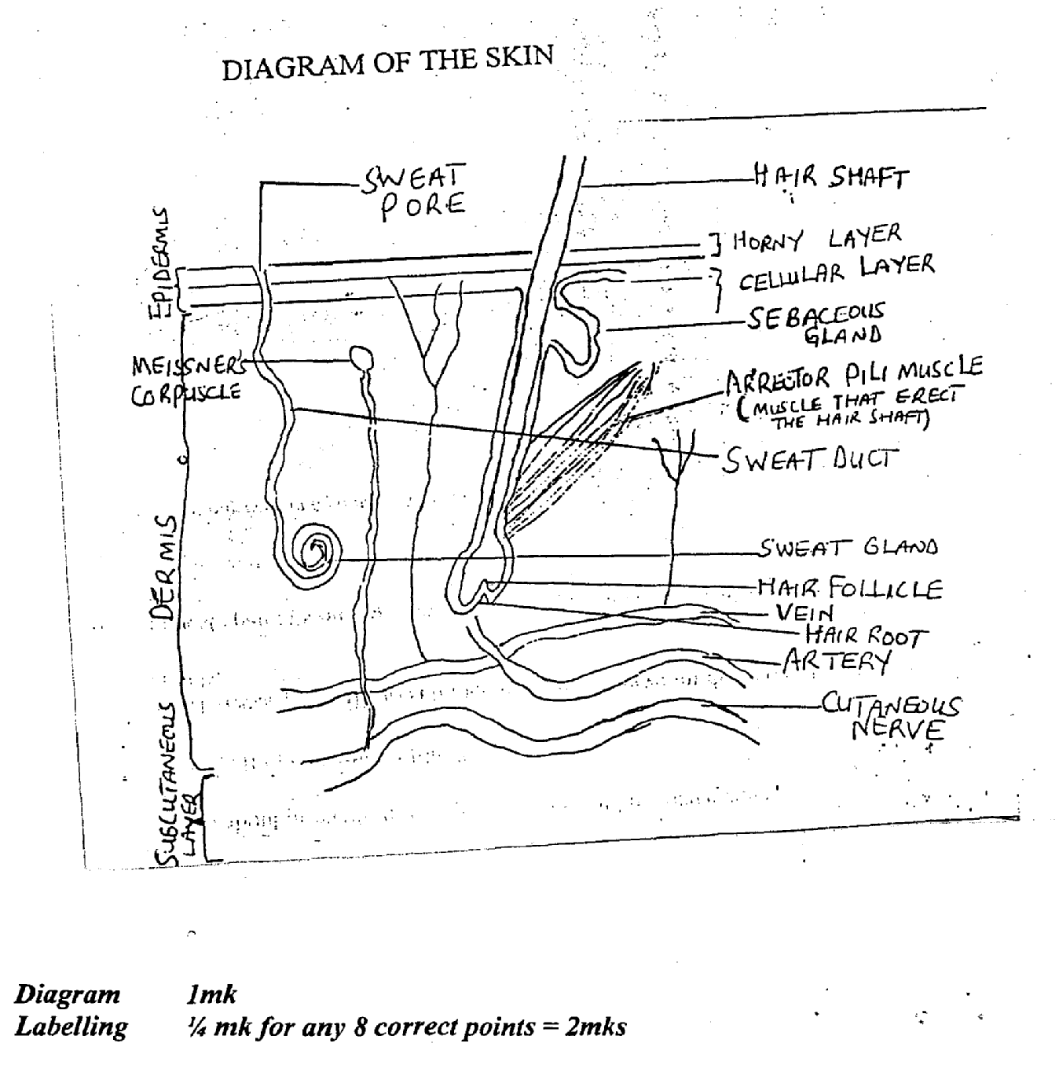

Description: The skin is the largest organ in the body. It has a surface area of about 1.5 to 2m2 in adult, it includes glands Hair and Nails.
There are two main layers.
-. Epidermis
- Dermis

Epidermis:- Epidermis is the most superficial layer of the skin.
- It is composed of stratified keratinized squamous epithelium which varies in thickness in different parts of the body.
- It is thickest on the palm of the hand and sole of the feet.
- There are no- blood vessel or nerve endings in the epidermis.
- It’s deeper layer are bathed in the interstitial fluid from the dennis, which provides oxygen and nutrients and drains away as lymph.
- The surface of the epidermis is ridged by projections of cells in the dermis called papillae. The pattern of ridges on the fingertips is unique to every individual.
- The hair secretions from the sebaceous glands and ducts of sweat glands pass through the epidermis to reach the surface.
- The melanin which gives the skin its colour is derived and secreted in the deep germinative layer of the epidermis.
¼ mk for any correct 4 points = Imk
Dermis
- A tough and elastic structure formed from connective tissue
- Matrix containing collagen fibers interlaced with elastic fibers.
- This is destroyed following overstretch leading to stretch marks seen in obesity and pregnancy.
- Effect of age on the collagen fibers produces wrinkles
- Structures in the dermis includes, blood and lymph vessels, Sensory nerve endings, sweat glands and their ducts, hairs, areola pill muscles, sebaceous gland
¼ mk for any correct 4points= link
FUNCTION OF THE SKIN
- Protection
- Regulation of body temperature
- Formation of vitamin D which is essential in the formation and maintenance of bone.
- It helps in the cutaneous sensation-touch, pressure, temperature and pain.
- Excretion
- Absorption
- Immune response.
- For identification
- Water fluid balance
¼ mark for any correct 4 point = lmk
[
b CAUSATIVE ORGANISM FOR LEPROSY
- Mycobacterium leprae or mycobacterium lepramatosus.
1 mark
c. CLINICAL FEATURES OF LEPROSY
Early Signs
- Hypo pigmented or erythematous patches on the skin,
- Diffuse thickening of the skin with a shiny appearance
- Loss of sweating or loss of hair over the skin lesion
- Loss of sensation to pain, touch and temperature in hand, and feet (anesthesia).
- Thickening of cutaneous nerves especially ulnar, lateral political
- Nodules in the skin especially of the nose chin and ears
- Thickening of earlobes
- Recurrent wounds and ulcer which do not heal
- Testicular atrophy
- Sterility
- Impotence
- Gynaecomagia
[
LATER DEFORMITIES (PRESENTATIONS)
- Depression of the bridge of the nose
- Wrinkling of the facial skin
- Loss of eyebrows
- Disfiguration of ear
- Stiffness of joints of fingers
½ mk for and correct 6 points= 3 mks

d. NURSING MANAGEMENT
Patient is usually treated as:
(a) Outpatient in the designated clinic
(b) Severe cases are always admitted for proper care.
- History taking
- Physical examination! complication
- Vital signs
- Care support
- Counseling
- Self esteem
- Coping mechanism
- Conduct Voluntary Muscle Test (VMT to check the range of movement)
- Sensory test: To test the loss of sensation of the skin lesion with cotton- wood whips.
- Prepare and assist other medical investigation e.g. slit skin smear.
- Give prescribes drugs.
- Give nourishing diet to replace worn out tissue.
- Encourage adequate rest to prevent further injury and conserve energy.
- Personal hygiene
- Conducive environment
- Cause/course of the disease
- Drug compliance
- Cough etiquette
- Protection and security
- Eye care — avoid excessive rubbing of the eye.
- It is the responsibility of the Nurse to trace the contacts of the client to ensure that the children and others are not infected.
- Rehabilitate patient depending on the level and form of deformity
- Wound dressing
- Bathing
- Avoid tight clothing (wear)
- Soak leg in soapy water (bar soap) to remove sloughs.
½ mk for any correct 8 points =4 mks
Medical Management
The medical management of leprosy is on the basis of classification and this is according to the W.H.O. Classification.
Leprosy as pauci bacillary or multi bacillary
It is the policy of the federal Ministry of health to treat leprosy client with multi drugs therapy (MDT) as recommended by the W. H. 0.
- Paucibacillary (PB) clients should receive one blister pack of P.B.M.D.T every 28 days for a period of 6 months (TOTAL 6 Blisters).
- The intake of drugs on every day of collection must be supervised. These 6 blisters should be completed within a maximum period of 9 months (Nine months)
- After completing 6 blisters the client should be released from treatment (R.F.T.)
- Multi bacillary (MB) clients should receive one blisters of MB MDT every 28 days for a period of 12 months.(TOTAL 12 doses) intake of drugs on every day of collection must be supervised.
- These 12 blisters should be completed within a maximum periods of 18 months.
- The drugs used in leprosy treatment are as follows.
• Rifampicin
• Caofaziamine
• Dapsone
- The treatment for leprosy is simple, available and free
- Drugs are supplied in special pack that contain the correct dose for one person for four weeks (28 days). All that is needed is to decide which course of treatment the patient needs and to make sure that they take it regularly.
Medical investigation
- Slit skin smear (SSS)
½ mark for any correct 4 point = 2mks

e. Prevention of Leprosy
- Public health education, information can be spread by the use of pamphlets on leprosy, Radio, Television etc.
- Information could be spread also by school children, churches mosque mothers etc.
- Avoidance of overcrowding e.g. rooms, Offices, public places etc.
- Environmental sanitation.
- Notification
- Case finding
- Prompt and adequate treatment
- Adequate facilities
- Efficient manpower
- Follow up to monitor drop-outs
- Universal/standard precaution should be maintained
- Adequate nutrition to improve immunity
- Drug compliance.
1 mk for any correct point discussed,
Total of 4 points for 4 mks

3a Ways Managers can creatç good human relations
i. Establishing rapport among employees in the organization.
ii. Maintaining clear line of communication in the organization to ensure that every member of staff is carried along.
iii. Understanding the personalities and expertise of subordinates and assigning responsibilities based on their strengths.
iv. Encourage teamwork among employees of the organization
v. Preventing and managing conflicts
vi. Rewarding good performance as quickly as possible.
vii. Addressing employee concerns and problems as they arise
viii. Dealing with innovations through continuous in-service training for staff.
ix. Equal treatment of all subordinates irrespective of relationship or affiliatioii.
x. Use of appropriate leadership style.
(1 mk each for any five correct points = 5mks)
b. Conflict management strategies
i. Avoidance/Avoiding/Withdrawal
ii. Compromise/Compromising
iii. Collaborating! Collaboration
iv. Competing/Forcing! Coercing! Dominance/ Dominating
v. Accommodating/Accommodation/Smoothing
Others are:
Negotiation
Mediation
Linking-pin
Buffering

i. Avoidance) Avoiding/Withdrawal
- This implies not paying attention to the conflict and not taking any action to resolve it.
- Those who actively avoid conflict frequently have low self esteem or hold a position of lower power.
- Avoidance can be used when stakes are not high or the issue is trivial, confrontation will hurt a working relationship, when there is little chance of satisfying ones wants or when gathering information is more important than an immediate decision.
(½ mkeach for any correct 4 points = 2 mks)

ii. Compromise /Compromislig
- Finding solution that will at least partially satisfy everyone involved or attempting to resolve a conflict by identifying a solution that is partially satisfactory to both parties.
- It typically calls for both sides of conflict to give up elements of their position in order to establish an agreeable solution.
- It is used frequently for temporary resolution of complex issues.
- It is used for parties with equal power and have strong interests in different solutions.
- Relationships are maintained but a less than ideal outcome may be created.
(½ mk each for any 4 correct points = 2 mks)

iii. Collaborating/Collaboration
- It is a mode used when one party works with another party to find a mutually satisfying resolution.
- Both sides get what they want and negative feelings are eliminated.
- It involves confronting differences and sharing ideas and information.
- It takes a great deal of time and effort.
(½ mk each for any 4 correct points = 2 mks)

iv. Competing/Forcing! Coercing/Dominating
- It means pursing ones needs, goals and concerns at the expense of those of others or imposing ones will on others.
- No consideration is given to the interests or concerns of others
- Frequently used by persons with highly assertive personalities.
- This may breed hostility and resentment toward the person using it.
- It is used when quick decisions are needed and when unpopular decisions need to be implemented.
(½ mk each for 4 correct points = 2 mks)

v. Accommodation/Accommodating/Smoothing
- It means to neglect ones needs, goals and concerns while trying to satisfy those of others. It involves self-sacrifice.
- It often occurs when one of the parties wishes to keep the peace or perceives the issue as minor.
- Accommodators frequently feel disappointed because they get nothing in return.
(½ mkeach for any 4 correct points = 2 mks

c. Sources of Conflict
i. Differences in professional values, socialization and philosophy
ii. Limited tirhe or resources
iii. Increase workload
iv. Poor human relations
v. Disparity in knowledge and power
vi. Cultural diversity among colleagues
vii. Ambiguity of roles and status
viii. Poor remuneration
ix. Poor working conditions
x. Change in organizational policies
xi. Communication breakdown
(1mk each for any 3 correct points = 3 mks)

d. Effects of Conflict
- Positive Effects
- Inspire creativity and innovation
- Production of a new rule
- Share and respect of opinions
- Identify new members
- Improve future communication
- Modification of goals
- Brings change

Negative Effects
- Decreased productivity
- Waste of time and resources
- Increase in staff turnover
- Violence or hostility
- Creates emotional stress (depression, frustration apathy) and organizational stress
- Sabotage
- Affects comthunication
- Absenteeism of staff
- Decreased customer satisfaction
- Damage to the reputation of the organization
- Decreased staff morale/motivation
(1 mk each for any 6 correct points = 6mks)

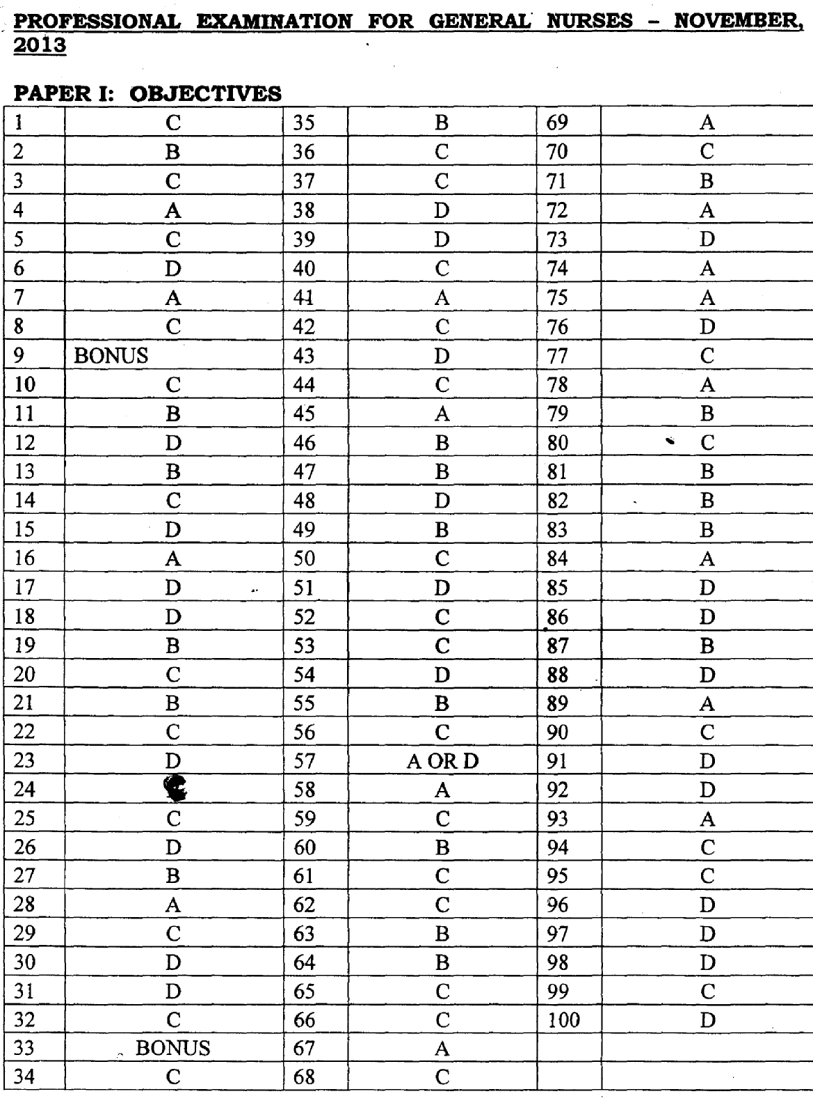

NOVEMBER 2013
MARKING SCHEME - PAPER II
la. Definition: This is the process of development/formation of red blood cells
(erythrocytes) ½mk
Site: Red bone marrow present in the ends of long bone, in flat and irregular bone ½mk
The regulatory hormones is erythropoietin secreted primarily by the kidneys
½mk
Stages: Erythropoietin stimulates pluripotent cells to produce proerythroblast
½mk
In the presence of vitamin B₁₂ and folic acid it changes into erythroblast/monoblast ½mk
The nornoblast loses the nucleus and chnges into recticulocytes ½mk.
The recticulocytes matures into erythrocytes ½mk, and is released into the blood stream.
Duration: 5—7 days ½mk
Key
Flow chart can be used for further illustration but no marks allocated to it.
Total =4mks
Pathophysiology of sickle cell anaemia
- Sickle cell anaemia is a recessively inherited blood disorder of HbS or SS gene.
½mk
- The normal life span of RBC is 120 days while that of a sickled RBC is 25—35 days ¼ mk
- Normal RBC shape is circular Biconcave non-nucleated disc while that of a sickle cell assume a. sickle or cresent shape when oxygen in the blood decreases ¼ mk
- There is displacement of valine (essential amino acid) substituted with glutamic acid (non essential amino acid) which causes the sickle or crescent shape ¼ mk
- The precipitated haemoglobin caused the RBC membrane to be more fragile and haemolye easily. ¼ mk
- This makes the cells clump together which leads to increase blood viscoscity resulting in sluggish circulation leading to occlusion of small blood vessels. ¼ mk
[
These causes infarction intravascular clothing and haemolytic anaemia ¼ mk
leading to susceptibility to the following:
i. Headache
ii. Fever
iii Ischaemia
iv. Pain
v. Loss of appetite
vi. Malaise/weakness/lethargy
vii. Joint pain
viii. Jaundice
ix. Concentrated Urine
x. Infection
xi. Swelling of limbs
xii. HypoxialAnoxia
xiii. Chronic organic damage
xiv. Growth and development impairment
(¼ mk each for any 8 correct points = 2mks)
Total =4mks

c. Nursing Management of a patient with sickle cell anaemia
- Admission/histoiy taking/assessmemt ½mk
- Ensure diagnostic investigations are carried out ½mk
- Initiate an maintain fluid replacement therapy/rehydration eg iv fluid/oral ½ mk
- Assess client level of pain using pain rating scale and manage appropriately ½mk
- Support and elevate acutely swollen joint until the swelling diminishes and provide physical care ½ mk
- Ongoing assessment for signs and symptoms of infection ½mk
- Encourage and improve client’s nutritional intake/status ½mk
- Serve/adminster prescribed medications eg Antibiotics, pain reliever (NSAID/opiates) haemiatinics and watch/observe for side effects or abnormalities ½mk
- Psychological care reassurance of clients, guide against being angry, avoid stress involvement of significant others. ½mk

Advice on discharge -
Health Education - Prevention of infections, avoidance of stressful situation, adequate nutritional status, awareness of anticipating complications e.g. priapsim ulcers etc.
- Coping strategies to minimize pain ½mk
- Need for genetic counseling ½mk
- Need for follow up visits ½ mk
Medical Management
- Investigation e.g PCV, FBC etc ½ mk
- Chemotherapy e.g NSAID, opiates, antibiotics, fiaemetinics, subcutaneous erythropoietin injection. ½mk
- Intravenous infusion ½ mk
- Blood transfusion — if indicated ½mk
- Oxygen theraphy if indicated. ½mk
9mks
d. Psychological Issues
- Fear of death from sudden crisis
- Anxiety of prognosis of crisis
- Stigmatization — social isolation at school or work
- Emotional strain from unpredictable bouts of pain and repeated episode of hospitalization.
- Exposure or likelihood of substance abuse (drug dependence)
- Burden of financial costs of treatment/management
- Depressionlsocial withdrawal
- Low self-esteem — due to physical defoniiities, growth retardation
- Coping capacity and social support
- Displaced aggression
- Guilt/Apathy
- Mood swing
- Sexual dysfunction
- Incompatibility in marriage
(½ mk each for any 6 correct points = 3mks)
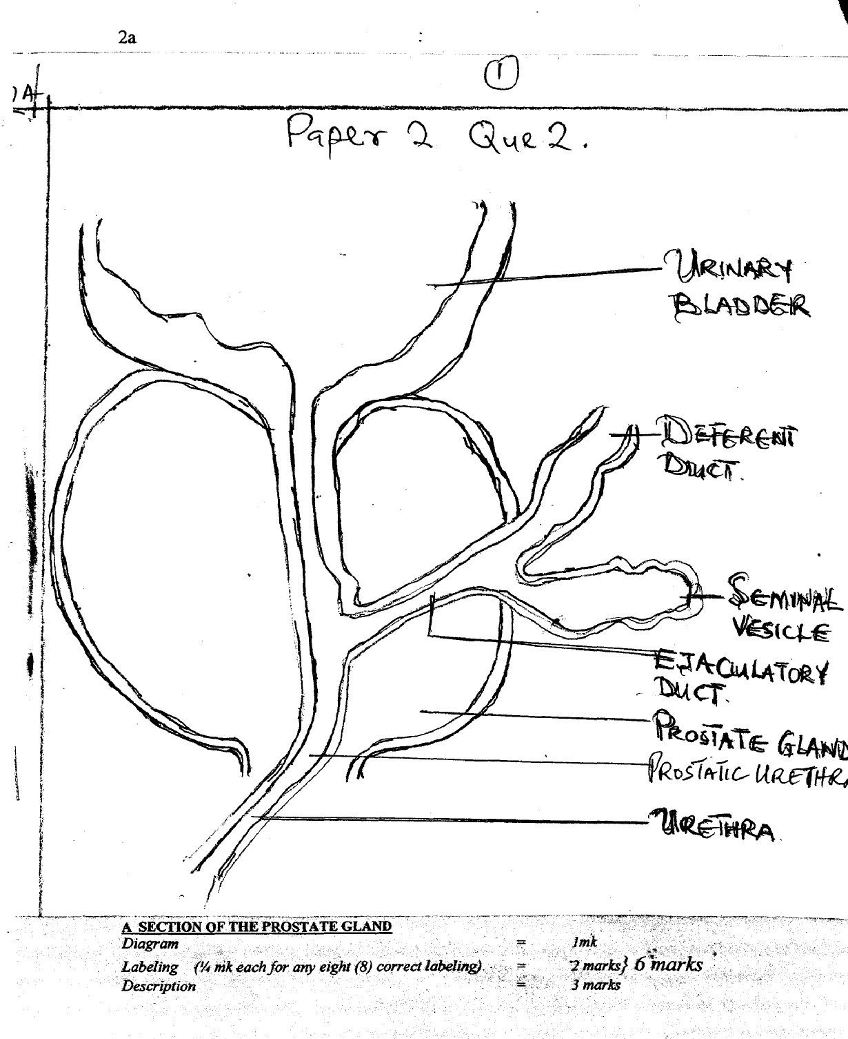

Defmition: The prostate gland is an acôessory organ of the male reproductive system. ½ mk
Location: It is located in the pelvic cavity in front of the rectum, behind the symphisis pubis at the base of the bladder encircling the prostatic urethral ½ mk
Shape: It is about the shape of a wall nut/chest nut ½mk
Size: Measures 4cm x 3cm x 2cm. ¼ mk
Structures: It is made of three layers:
- Outer fibrous tissue
- Middle layer of smooth muscle
- Glandular substance comprising of columnar epithelial cells. ¼ mk
Blood supply: It is supplied by inferior vessical, middle rectal and inferiorpudendal arteries which are branches of the internal iliac artery.
Venous return: This is by the corresponding veins. ¼ mk
Lymphatic drainage: It is by the vesico prostatic plexus draining into the internal iliac vein ¼ mk
Nerve supply: It is by the.sympathetic and parasympathetic nerve ¼ mk
Function/secretion: It secretes a thin milky fluid that makeup about 30% of the semen giving semen its milky appearance. ½ mk
b. Specific Diagnostic investigaticu
- Digital rectal examination
- Prostate — Specific Antigen test (PSA)
- Biopsy (Prostate)
- Urinary flow test
- Post void residual volume test
- Trans-rectal utra sound
- Serum acid phosphate test
- Prostate fluid analysis
- Urodynamic studies
- Neulogical examination
- Cystoscopy
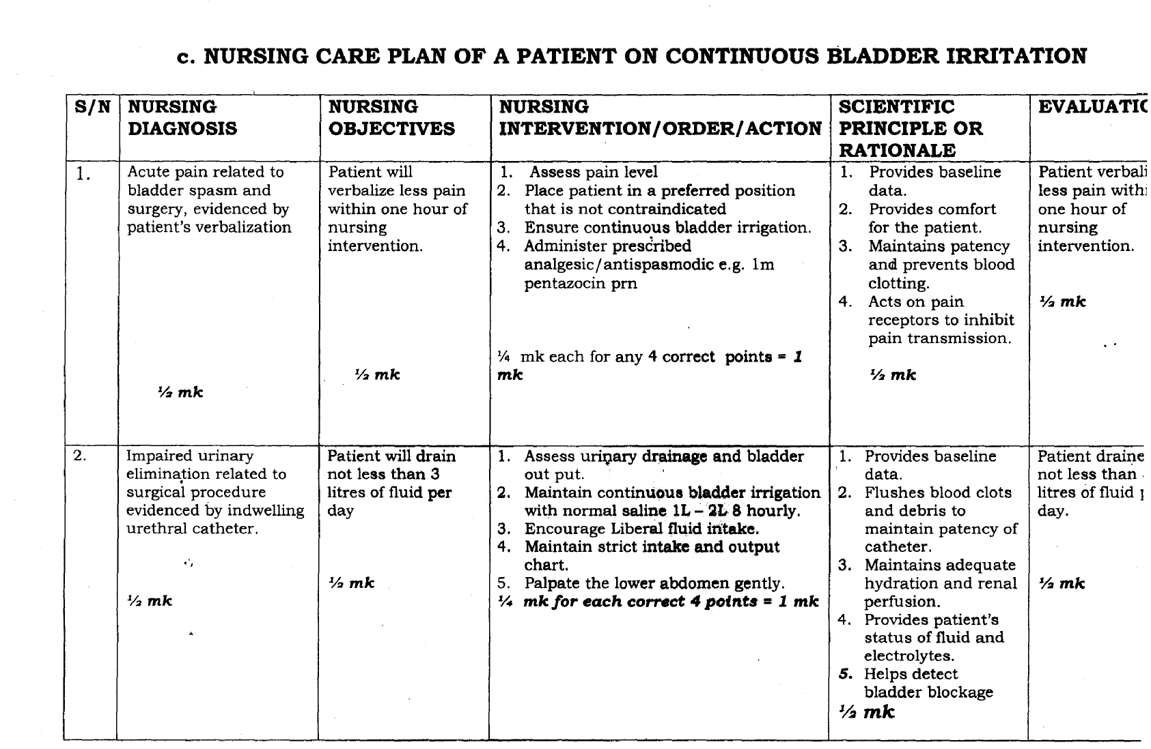
(¼ mk each for any 4 correct points = 1mk)
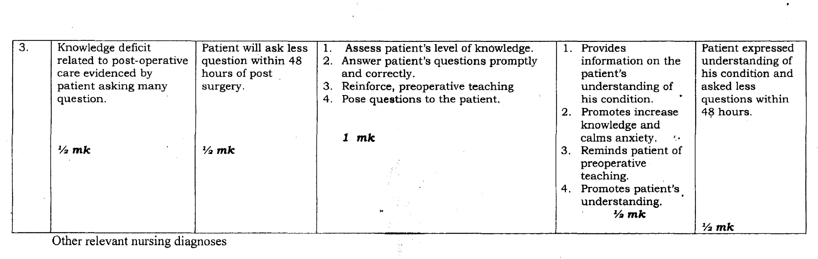
- Fluid volume deficit related to surgical intervention evidenced by blood loss.
- Risk for infectim related to indwelling catheter/bladder irrigation poor catheter care.
- Impaired physical mobility related to surgical intervention evidenced by confinement to bed.
- Self-care deficit (bath) related to surgical intervention evidenced by verbalization.

d. Advice on discharge
- Teach client/relations exercise (perineal and urinary stream interruption)
- Advise patient to avoid heavy lifting and strenuous exercise.
- Advice patient to avoid straining on stooling
- Avoid the use of NSAIDS e.g Aspirin
- Advice patient to eat nutritious/adequate diet to promote healing
- Encourage patient to stick to his drug regimen
- Advice patient to wear scrotal support
- Advice patient to visit for his follow up
- Advice patient and wife to abstain from sex for 3 months.
(½mk each for any 8 correct points = 4mk).
3a
Breast self-examination is advocated as a measure for early detection of breast cancer.
a. Explain the term breast self-examination
Breast self-examination is a procedure performed by an individual to palpate and visually examine self for any change in the breast and under arm areas of the body in order to detect possible lumps, skin changes, swelling and dimpling of the breast.
(½ mk each for any correct point = 2 mks)
[
b. Explain the prinêiples involved in breast examination
The principles involved in self-examination is grouped into three (3)
i. Standing in front of a mirror
ii. Lying down
iii. In the shower
Standing in front of a mirror
Standing in front of a mirror starts from age 20 years on a monthly basis after the menstrual period. And the following can be observed.
- Visual limp
- Swelling, redness and warmth
- Changes or retracted nipples
- The skin on the breast has the appearance of orange peel.
- Rashes, scaling or itching around the nipple.
- Abnormal discharge from the nipple such as blood like fluid or pus like fluid.
- The skin on the breast or nipples pulled inward.
(½mk each for any 4 correct points mentioned = 2mks)

Lying Down
- Lie down on the back with a pillow or folded towel under a shoulder
- Place right hand behind the head and with the left fingers pad flat, press the breast gently in small circular motions aound an imaginary clock face.
- Begin at the outer most point of the right breast for 12 o’clock and so on round the cycle back to 12 o’clock.
- Repeat the procedure on the left shoulder and the left hand behind the head
(½ mk for each correct point = 2 mks

In the Shower
- Examine the breast during a bath or shower hands glide more easily over wet skin.
- Place right hand behind the head and with the left fingers pad flat, press the breast gently in small circular motions around an imaginary clock face.
- Begin at the outer most point of the right breast for 12 o’clock, then move to one o’clock and so on round the cycle back to 12 o’clock.
- Repeat the procedure on the left breast.
(½ mk for each correct point =2 mks)
c. Mention four predisposing factors lot breast cancer
- Hereditary
- Obesity
- Age
- Radiation exposure
- Early menarche
- Late menopause
- Nuffiparity
- Hormonal therapy
- Female sex
- Dietary pattern
- Post-menopausal hormonal therapy
- Genetic mutation (BRCA I AND BRCA 2)
- Life style e.g alcohol, cigarette smoking etc
2mks

d. Outline the content of a health talk on breast self-examination to a group of women in O & G clinic using the following Preamble — Self introduction of the health provider to the clients and salutation.
i. Age to start — All girls who have attained the age of 20 years to the age of menopause should involve themselves in breast self- examination.
2mks

Ii Frequency — Breast self-examinatIon should be done every month after each menstruation.
2mks
iii Days in the month — For post-menopausal women, it should be first day of each month then from 3 — 7 days, after menstruation commences for pre-menopausal women.
2mks
iv Position! Situation
Position — Stianding, sitting and lying down Situation
i. When the women are under any hormonal drugs e.g.
Stilbesterol, Vitamin E or contraceptives
ii. During check-up
iii. When any abnormality is noticed on the breast.
2mks
v. Action to be taken if abnormality is found
- Consult a nurse or a doctor
- Compliance to advice given by the health provider
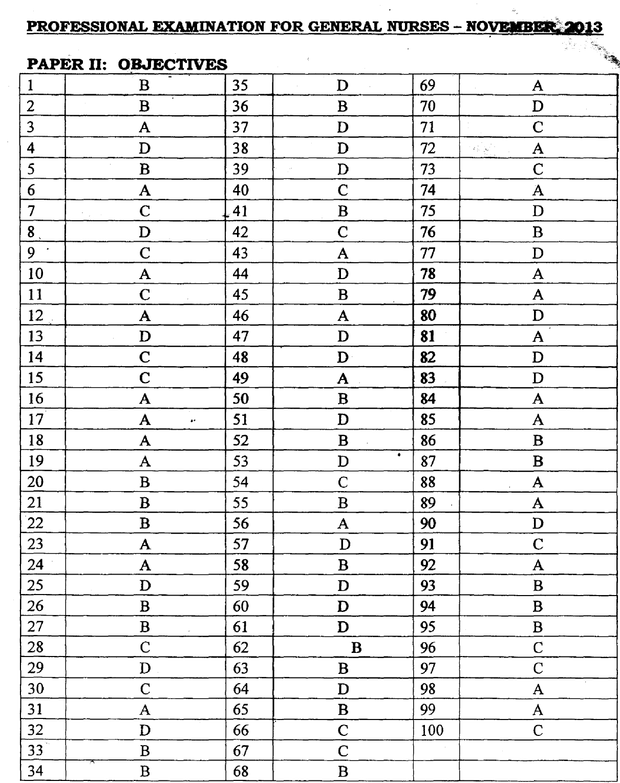

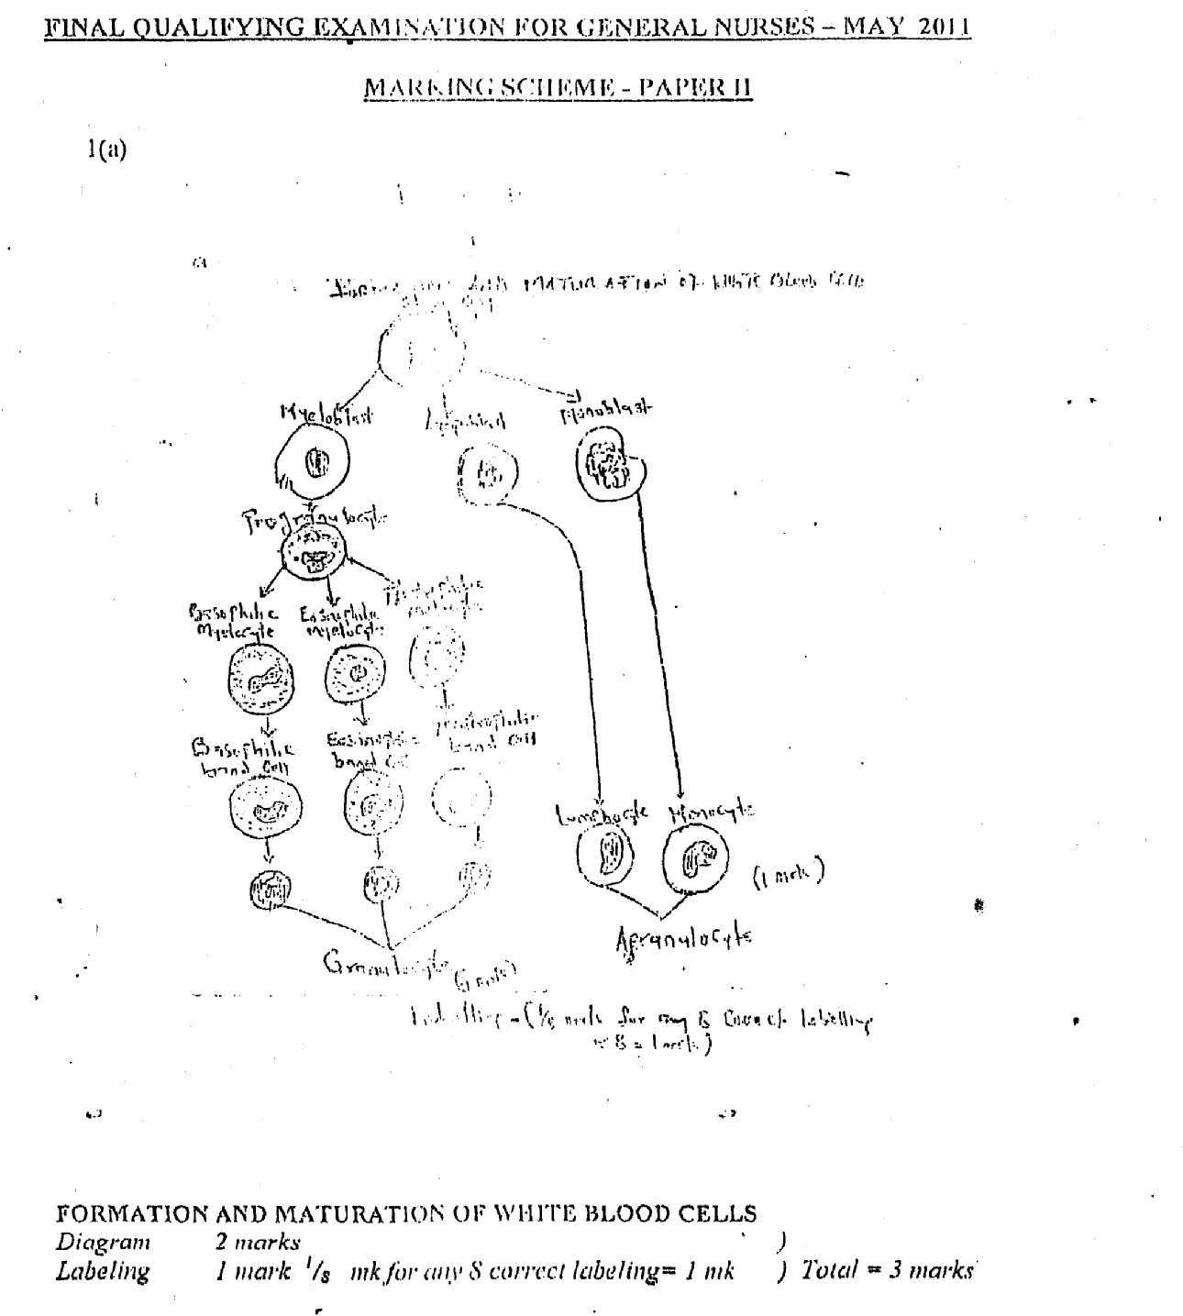

1. Formation and fmaturation of white blood cell
White blood cells are named according to their appearance and are spherical cell with a nucleus white in colour because it lacks heanioglobin. It is know leucocytes.
(½mk)
There arc two major of white blood cells, namely:—
A. GRANULOCYTES (POZYMORPHORLUCLEAR LEUKOCYTES
- Neutrophils
- Eosinophils
- Basoph (as gramlocytes) i.e. polymorphonuclear Ieukocytes
- Lymphocytes
- Monocytes (as granulocytes)
(½mk)
Lymphocytes are the smallest while blood cells. They develop from lymphoblasts which originate in the red bone marrow whose development is regulated and determined by different growth factors derived from the stem cell.
(¼mk)
They proliferate and produce more Iymhocytes as they migrate through the blood to the lymphatic tissue. Majority of the body’s total lymphocyte population is in the lymphatic tissues i.e. the lymph nodes, spleen, tonsils lymphatic nodules and thymus.
Maturation: The earliest recognizable cell is the myeloblast with a larg round to oval nucleus. There is immature chromatin and cytoplasm is basophilic without granules. The promyelocyte is slightly larger than a blast and its cytoplasm contains granules. At this stage, the cell becomes a myelocyte, it is smaller than promyelocyte.
Myelocytes have round oval nuclei and is followed by development of metamyelocytcs which are smaller than myelocytes. The life span of white blood cells is shorter than the red blood cells (0.5-9.0 days).
[ (½mk)
Function
1. Immunity
2. B cells produce antibodies for destruction of bacteria
3. T cells protect against viruses and other intracellular micro organism
(⅛ mark each for any correct 2 points = ¼mark)
b. Pathophysioloy
- The malignant cell ol acute lymphocytic leukaemia are lymphoid precursor cells (i.e. lymphoblasts) that are arrested in an early stage of development. (½mk)
- This arrest is caused by abnormal expression of genes, often as a result of chromosomal translocation. (½ mk)
- The lymphoblasts replace the normal marrow elements, resulting in a marked decrease in the production of normal white blood cells. (½ mk)
- Consequently, anaemia, thrombocytopenia, and neutropenia occur to varying degree. (½ mk)
- The lymphoblasts also proliferate in organs other than the marrow, (½mk)
- Particularly the liver, spleen and lymph nodes (½mk)
- As a result, leukocytes cannot perform its physiological ftinction as it is not mature, (½ mk)
- Thereby exposing the patient to risk of infection. (½ mk)
Total = 4 marks
C. Other types of Leukaemia
i. Chronic lymphocytic leukaemia
ii. Acutc myelogenous leukaemia
iii. Chronic rnyelogenous leukaemia
iv. Acute promyelocytic leukaemia
v. Hairy cell leukaemia
vi. Polymphocytic leukaemia
(½ mk each for any correct four points = 2 mks)

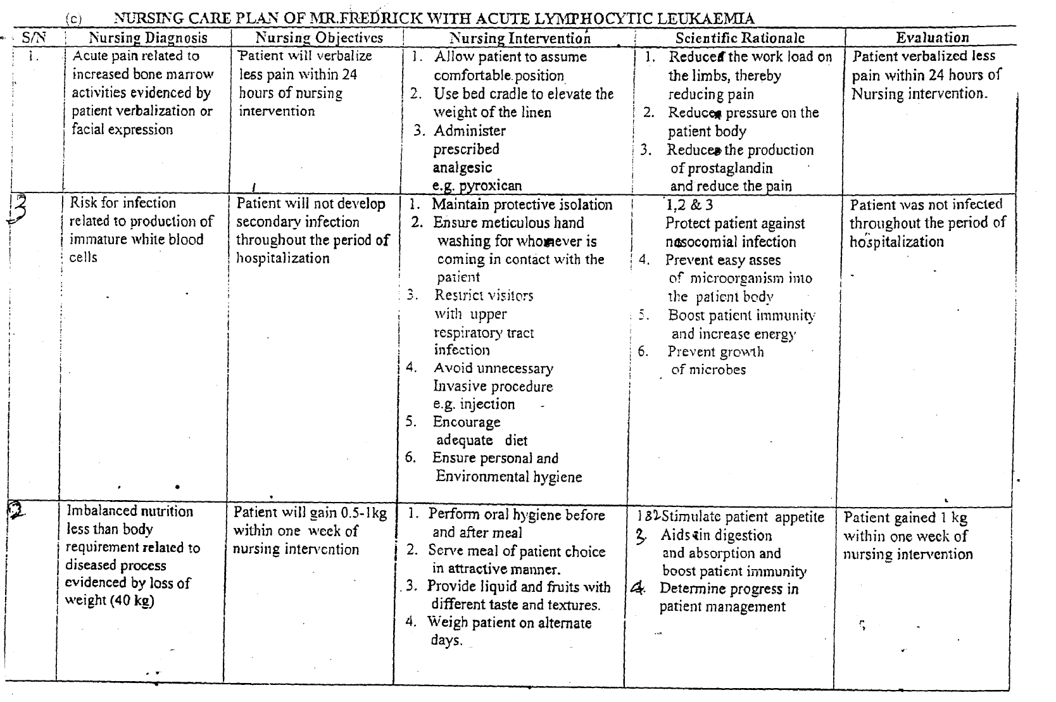
Other performing Nursing Diagnosis
- Bleecliiig Risk. For
- Deficient fluid volume (anaemia)
- Activity intolerance
Nsg Diagnosis - ½ mk
Nsg Objectives - ½ mk
Intervention- (¼ mk x 4) 1 mk
Scientific rationale - ½ mk
Evaluation - ½ rnk
Total = 3mks
2.
a. Is defined as a couples inability to achieve pregnancy) after 1 year of regular unprotected sexual intercourse (1 mk)
OR
WHO - definition based on 24 months of trying to get pregnant is recommended as useflul in clinical practice and research among different discipline.
b. Definition —The menstrual cycle is a series of physiological change that occurs within a woman of child bearing age and the cycle depends on individual woman. It vary in length, with average cycle taken to be 28 days. It commence at puberty and end at menopause except when pregnancy interupts. There are 3 main phases with each cycle, and they affect the tissue structure of the endometrium, controlled by the ovarian hormones.
The phases are menstrual, proliferative and secretory (1mk)
(i) The menstrual phase — this phase is characterized by vaginal bleeding, which last .For 3-5 days.
Hysiologically, this is the terminal phase of the menstrual cycle when the endometrium is shed down to the basal layer along with blood from the capillaries and with the unfertilized ovum (1 mk.)
(ii) Proliferative phase — this follows menstrual phase and last until ovulation. The first few days while the endometriurn is reforming is described as the regenerative phase. This phase is under the control of estrogen. It consists of the regrowth and thickening of the endometrium. At the completion of this phase the endometrium consist of 3 layers:- (½ mk.)
- Basal layer which never alters during menstrual cycle and contain all necessary rudimentary structures for building up new endometriurn.
(½ mk)
(b) Functional layer which contain tubular glands and changes according to the hormonal influence of the ovary. (½ mk)
(c) A layer of cuboidal ciliated epithelium which covers the functional layer and dips down to line the tutular gland (½ mk total = 2 marks)
(iii) Secretory phase — this follows ovulation and is under the influence of progesterone and oestrogen from the Corpus luteum.
The functional layer thickens to 3.5mm and becomes spongy in appearance because the glands are more tortuous (1mk)

Other performing Nursing Diagnosis
- Bleeding risk for of hypothalamus, pituitary, adrenals and thyroid glands
- Deficient fluid volume: mellitus, celiac disease, renal failure
- Activity tolerance disorder: Trauma, hydrocele, undescended testis, long distance lorry driver, varicocele, tight clothing, cancer, high temperature
- Nsg Diagnosis - ½ mk absence of semitual duets
- Impaired secretions- from prostate or seminal vesicles due to infection, metabolic disorders
- Intervention- vokrograde ejaculation
- Psychological of drug induced ejaculatory dysfunction
(½ mark each for any correct 3 points = 1½ marks)

Total = 3mks
- Endocrine disorders of hypothalamus, pituitary, adrenal and thyroid glands
- Systemic disease-i.e. diabetes mellitus, celiac disease, renal failure
- Physical disorder i.e. obesity, anorexia nervosa or strict dieting, excessive exercise
- Ovarian disorders i.e. ovarian eysts or tumours, ovarian endometriosis
- Psychosexual problem (vaginismus)
- Congenital anomalies
- Cervical trauma or surgery e.g. cone biopsy
- Hostile mucus
- Anti-sperm antibodies in mucus
- Defective implantation
½ mark each for any 3 correct points = 1½ marks
(3 points from male and 3 points from female)
Total = 3 marks
d. Primary infertility occurs when there is no previous pregnancy while Secondary infertility occurs when there had been one or more previous pregnancies irrespective of the outcome but a further pregnancy has proven impossible.
(½mk)
e. Investigations on infertility
- History taking to highlight health compromising factors like drug abuse.
- Occupational displacement
- Smoking habit
- Alcoholism
- Contraceptive use
½ mark each for any correct 2 answers = 1 mark

Diagnostic Tests
Male
- Semen Analysis — To estimate the volume (2 — 6mls). total sperm count = 40 x 10⁶ per ml, motility 60% and morphology 60%
- Testicular biopsy
- Hormonal analysis
- Chromosonal studies from blood or bucceal wnear
- Post coital test
- Ultra sound scan
½ mask each for any correct 3 answers = 1 ½ marks
Female
- Test to establish ovulation
- Cervical mucus examination
- Ultrasound scanning to detect ripening of graffian follicle, follicle tracking and thickening of the endometrium
- Luteinising hormonal (LH) Level can be measured with simple hormone test
- Hormonal assay to reveal fluctuations in circulatory oestrogen and progesterone FSH and LH.
- Endometrial biopsy
- Hysterosalpingograph
- Visual inspection by Laparoscopy and dye test or Hysteroscopy
½ mark each for any correct 3 answers 1½ marks
Total = 4 marks

f. Psycho-social implications
- Guilt
- Anger
- Anxiety
- Depression
- Aggression
- Grief
- Low self—esteem
- Feeling of worthlessness
- Inadequacy
- Failure
- Mental instability
Cuttural implications
- Social isolation
- Stigmatization
- Loss of inheritance
- Economic dcprivation
- Abandonment
- Discrimination
- Divorce
- Polygamy
(½ mark each for any correct ten (10) points from the two factors. Total = 5 marks).
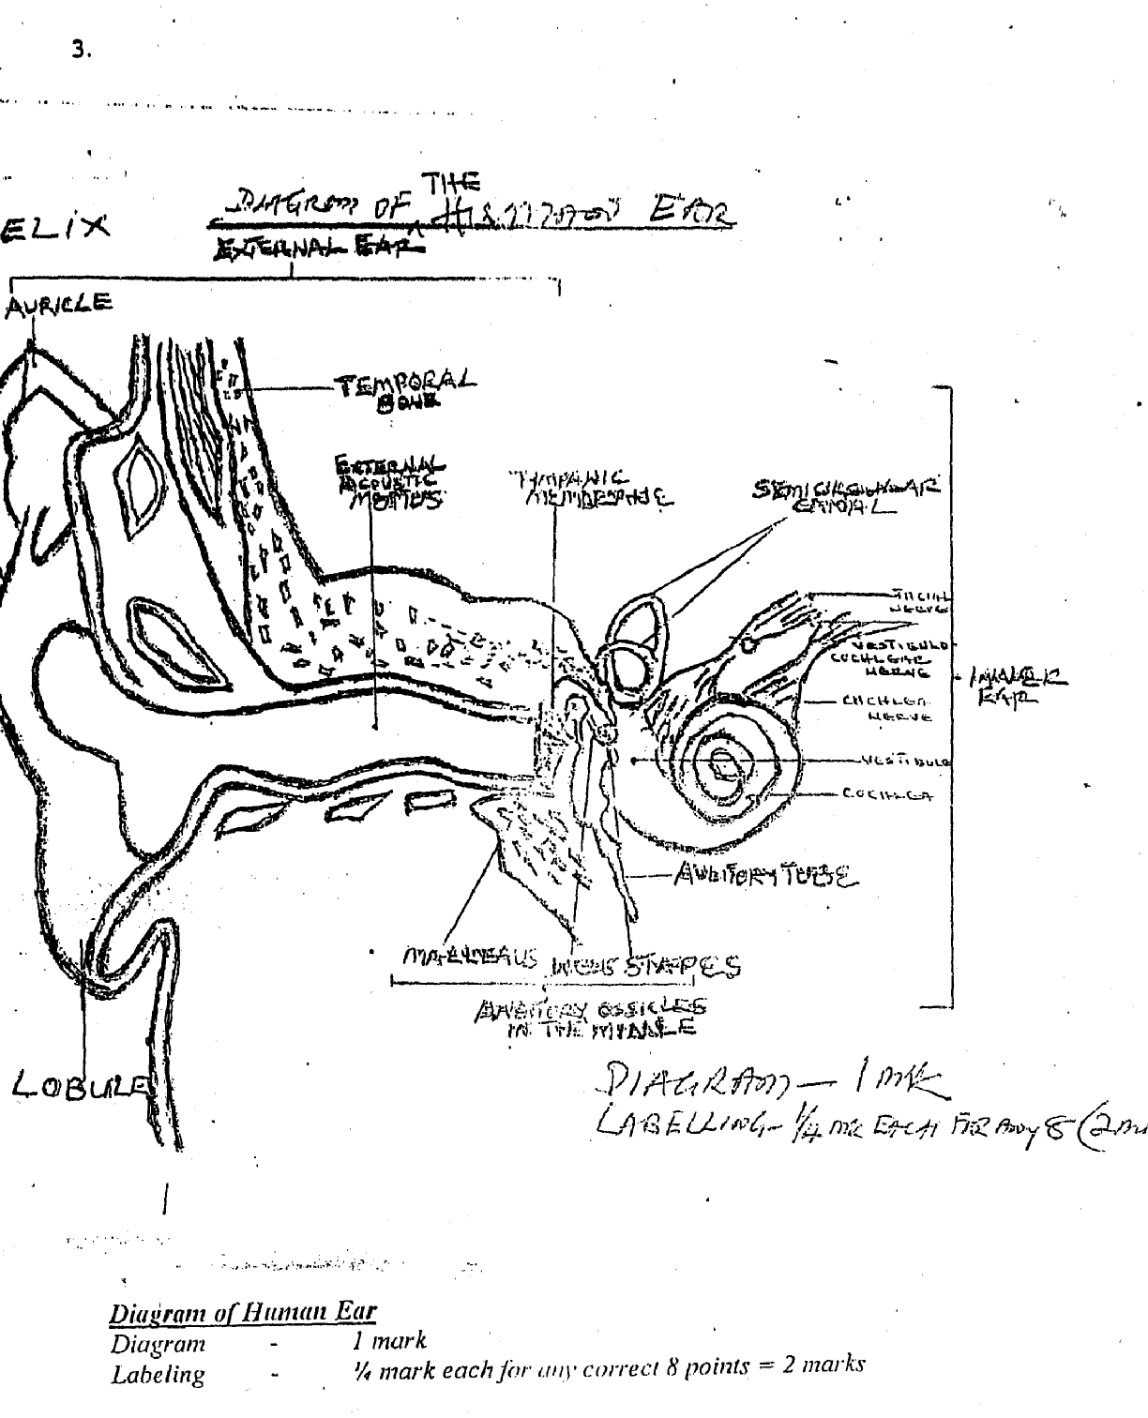
\

Description of the ear
Introduction: The ear is the organ of hearing, housed in the temporal bone, streteched out and attached to the sides of the head.
(¼ mk)
The ear is divided into three (3) parts.
- The external ear calleal the auricle which entrench and stands outside like fan
(¼ mk)
2. The middle ear is an irregularly shaped cavity filled with air. It comprises of three bones
namely from outside inwards
- Malleus (Mallet or harmer)
- Incus (Anvil)
- Stirrup (Stape)
(½ mk)
3. The inner car comprises of two different labyrinth:-
- Bon.y (Osseous) labyrinth- houses the vestibule, Semi-Circular canal and cochlea, it contains fluid calld peri-lymph.
- Membranous labyrinth comprises of the three semicircular canals and contains fluid called endolymph.
(1 mk,)

Opening of the ear
I. External auditory mealus from the outside continues to the car drum then to the middle ear.
II. The windows are two oval window and round window
III. The auditory or Eustachian tube
- Nerve supply — auditory or 8th Cranial Nerve
- Blood supply posterior auricular, ascending pharyngeal and superficial temporal maxillary arteries.
Functions —
1. Hearing
2. Balancing
3. Cosmestic make up
(¼ mark each for nay two correct points =½ mark)
Introduction - ¼ mark Openings - ¼ mark
Erternal car - ¼ mark Nerve supply - ¼ mark
Middle ear - ¼ mark Functions - ½ mark
Inner ear - 1mark Total - 3 mark
b. 6 Signs and Symptoms of Otitis media;
- Pain in the affected ear
- Fever (mild)
- Malaise
- Headache, sensation of fullness in the ear
- Tinnitus, nausea and vomiting
- On examination, the tympanic membrane bulges and becomes reddish (erythmatosus)
- Otorrhoea
- Nasal discharge as a result of associated rhinitis.
- Dizziness or vertigo
- Hearing loss of conduction type
- Irritation in the ears
- Mild restlessness and insomnia
(½ mark each for any 6 correct points 3 marks)

c. Surgical and Nursing Management of Master Chidi
Pr-Opcrative Management
- Admit the patient
- Explain the nature and essence of operation to the child and mother.
- Obtain informed consent
- Discus post operative communication strategies
- If ear is discharging, mop car prn
- Specimen is also taken for culture and sensitivity
- Patient should rest the affected part as much as possible
- Administer prescribed niitibiotics and analgesics
(½ mark each for any 3 correct points = 3 marks,)
Operative Care
- Assist the doctor during operation (myringotomy tympanotomy) post operative care
- Receive him into bed and make comfortable
- Place patient in recumbent position
- Monitor vital signs and record; report ahy abnormality
- Observe for any discharge from the ear noting odour, character and amount
- Administer prescribed antibiotics and analgesics
- Monitor side effects of prescribed drugs
-. Use psychotherapy to relieve pain and anxiety
- Do not remove inner dressing until ordered by the doctor.
- When inner dressing is removed then the dressing or pack should be changed every 24 hours or if soaked
- Notify the doctor if patient develops bleeding, fever, increased drainage, dizziness or decreased hearing.
- Assess for nausea and vomiting and administer anti emeties as ordered
- Assess for vertigo and dizziness especially with movement
- Ensure safety during ambulation
- Ensure optimal nutrition for the patient
- Avoid whispering and distant talking to the patient
- Health education should focus on standard personal hygiene, avoidance of people with cold, avoidance of picking the ear with local material example matches, finger, sticks, feathers, key etc.
- Avoid straining during bowel movement
- Avoid blowing the nose, coughing and sneezing (2-3 weeks).
- Avoid drinking through a straw
- Avoid rapid movement of the head, bouncing and bending over for 3 weeks.
- Avoid swimming, diving n travelling by air until allowed (2 — 3 weeks)
- Instruct patient to keep his head dry by not washing hair or showering for several days (1 week)
- Instruct patient to leave the mouth open, if coughing and sneezing
(¼. mk each for any 20 correct points = 5mks)
d. Complications
- Chronic oitis media
- Conductive hearing loss (deafness)
- Perforation of the cardrum
- Meningitis
- Otitis externa
- Labyrinthitis
- Sinusitis
- Mastoiditis
- Brain abscess
- Laryingitis/phiyngitis
(½ mark each for any 4 correct points =2rnks,)
4.
a) Dislocation
I) Definition:
- This is a temporary displacement of one or more bones in a joint in which the opposing bone surfaces loose contact entirely.
OR
- This can be defined as when the articulatiug surfaces of a joint are no longer in proximity.
OR
- This is a condition in which the articular surfaces of the bones forming the joint are no longer in anatomic contact.
(½ mark for any of the above definitions)
ii) Causes:
- Congenital and acquired disorders that cause muscular imbalance
- Traumatic/injuries e.g. in sports, falls
- Rheumatoid arthritis
- Pathologic factors due to disease of the articular or peri articular Structures
- Joint instability
(¼ mark for ally correct two (2) points = ½ mark)

iii) Clinical manifestations
- Jojnt pain
- Joint swelling
- Joint deformity
- Limitation of motion
- Deviation in length of the extremity
- Rotation of the extremity
(¼ mark each for any correct four (4) points= 1 mark)

lv) Treatment
- Reduction or close manipulation under anaesthesia
- Immobilisation of affected part
- Exercise to maintain normal range of movement
- Drygs lo relief pain e.g. Ibuprofen. Celebrese, Didofenac
- Elevation of extrmity to relieve pain and swelling
- Cold compress on the area to relief pain
(½ mark each for any correct four (4) points = 2 marks)

b) Ankylosis spondylitis
1) Definition
- This is chronic disorder characterized by inflainination, progressive restriction of movement of the spine and the sacro-iliac joints
OR
- This is a chronic inflammatory joint disease characterized by stiffening and fusion of the spine and the sacro-iliac joint
(½ mark for any of the above definitions)
ii) Causes
- Unknown
- Prcdisposing factors:
- Genetic/hereditary
- Bacterial
(¼ marks each for any correct two (2) points = ½ mark)

iii) Clinical Manifestations
- Low back pain
- Stiffness
- mild fever
- loss of appetite/anorexia
- weight loss
- change in gait
- difficulty in sitting up
- athralgia/tenderness over affected part
(¼ marks each for any correct four (4) points = 1mark)

iv) Treatment
- Physical therapy to maintain skeletal mobility and prevent natural progression of contractures
- Exercise are performed to maintain chest expansion, full extension of the spine
- Heat application
- Administer prescribed Drugs such as;
- Non steroidal anti inflammatory drugs (NSA1D) e.g. Diclofenac
- Diclofenac
- Indomethacin
- Ibubrofen
- Apirin
(½ mark each for any correct four (4) points = 2marks)

c) Paget disease
i) Definition
- This is a state of increased metabolic activity in the bone characterized by abnormal and excessive bone remodelling both resorption and formation.
OR
- This is a slowly progrssive metabolic bone disease characterized by an initial phase of excessive bone resorption followed by reactive phase of excessive abnormal bone formation especially affecting the skull, femur, tibia, pelvic and vertebral bones.
OR
- This is a chronic disorder that can result in enlargement and misshaping of bones which causes excessive production and formation of bone tissue to become weaken resulting in pain.
(½ mark for any correct definition)
ii) Causes
- Unknown
- Predisposing factors;

- Genetic/hereditary
- Viral infection
(¼ marks each for any correct two (2) point = ½ marks)
iii) Clinical Manifestations
- At early stage, it may be asymptomatic
- Severe persistent bone pain
- Impaired mobility
- Headache
- Deformity-Kyphosis
- Pathological fracture
- Enlargement of the bone e.g occiput
- Bowing of the long bones such as tibia and femur reducing client’s height
- Osteogenic sacrcoma
- Flush or warn skin and tenderness
- Apathy, lethargy, fatigue
- Gout
- Renal /kidney stone
(⅛ marks each for any correct eight (8) points -1 mark)

iv) Treatment
- Prevention: Surgery to reduce pathologic fractures, correct secondary deformity or relieve neurologic impairment OR Prevention of deformity or fracture
- Bed rest
- Care of pressure areas
- Pain: relieve with moderate exercise and NSAIDs
- Adninistration of precribed Calciluinu and cytoloxic —drugs lo slow excessive resorption
- Specialised foot and heel lift for cleforrmity
(½ mark for any correct four (4) points =2marks)
d) Osteomalacia
i) Definition
- This is a metabolic disease characterized by inadequate and delayed mineralisation of bone especially in mature compact and spongy bones.
OR
- This is a softening of the bones due to defect in bone mineralisation secondary to inadequate amount of available phosphates and calcium.
(½ mark for any of the above definitions)

NB: In children it is known as rickets

ii) Causes
- Vitamin D deficiency due to inadequate sunlight OR malabsorption of vitamin D
- Hypocalcalmia due to excessive urinary calcium excretion OR deficient dietary calcium foods OR pregnancy
- Decreased endogenous production of vitamin .D
- Renal tubular disease
- Anticonvulsant therapy
- Familial/hereditary metabolic error
- Liver disease which interfere with metabolism
(¼ marks for any correct two (2) points = ½ marks)
iii) Clinical Manifestations
- Bone pain and tenderness
- Muscle weakens and weight loss
- Immobility
- Softening and weakening of bone
- Bone fracture due to softening and weakening of bones
- Vertebral collapse with minimal trauma
- Unsteady gait/deformity
(¼ marks for any correct four (4) points = 1 mark)
iv) Treatment
- Dietary supplement of vitamin D
- Treatment of underlying disease that may cause the disease
- Administer prescribed calcium, phosphorous OR Vitamin D if serum level(s) are low e.g.calcium carbonate, calcium gluconate
- Prevention is very essential with diet rich in vitamin D such as milk, egg, fish, etc
(½ mark each for any four (4) correct points = 2 marks)
e) Fibromyalgia
i) Definition:
- This is a chronic muscular pain syndrome characterized by generalised muscle and skeletal pain
OR
- This is a chronic rheumatic disorder where the complaint arise from muscle, tendons and ligaments rather the joint.
OR
- This is a chronic musculo skeletal syndrome characterized by diffuse pain, fatigue and tender joints
OR
- A chronic pain syndrome not an inflammatory disease with pain and tenderness located at specific site in the back of the neck, upper chest, trunk, low back and extremities.
(½ mark for any correct definition)
ii) Causes:
- Unknown OR obscured
- Predisposing factors such as:
- Disturbances of deep sleep
- Emotional upsets
- Depression
- Trauma/ accident
- Rheumatoid arthritis
- Lack of growth hormone
- Lack of exercise/persistent strain/chronic fatigue
- Flu like viral illness
- HIV infections
- Lyme disease
(¼ mark each for any correct two (2) points = ½ mark)

iii) Clinical Manifestations
- Pain and tenderness over the site
- Generalised muscular swelling
- Tingling and numbness in the finger and toes
- Insomnia/ lack of sleep
- Headache
- GIT symptoms
- Pronounced fatigue/
- Memory Loss
- Symptoms of irritable bowel syndrome and excessive sensitivity to cold
(⅛ mark each for any correct eight (8) points = 2 marks)
iv) Treatment:
- Symptomatic treatnaenl
- Education and reassurance has been very important
- Anti inflammatory medication despite the fact there is no tissue inflammation
- Tricyclic antidepressant
- Immobilisation with splini or neck collar
- Instruct client to observe any drowsiness and not operate machinery if droway
- Instruct client to exercise regularly such as stretching and walking.
(½ mark each/br any correct four (4) points 2 marks)

A. Student playing football on the field is bitten by a snake
1. Remove the student from the source of danger
2. Keep the student quiet, calm arid still
3. Reassure the student
4. Kill the snake if possible
5. Apply constricting band above the bitten area
6. Gently wash the wound well with soap and water
7. Pat dry with clean cloth
8. Allow the bitten site to bleed freely.
9. Immobilize the affected part
10. Keep the affected part below the level of the heart
1 1. Prevent overcrowding for ventilation
12. Do not give any thing by mouth if the patient is unconscious or if the patient is vomiting
13. Transport student to the hospital immediately.
14. Take the dead snake along for identification
15. Observe patient while on the way to hospital e,g, bitten site
16. Send for the relatives
(½ mk each for any 10 correct points = 5 mks)
B. A young boy recovered from a river before drowning
1. Take the child to a safer place
2. Prevent over crowding
3. Ensure a patent airway
4. Hold the child upside down to cause water to drain out of the lungs
5. Press the stomach to allow drainage of swallowed water
6. Loosen tight clothing around the neck, chest and waist
7. Remove wet clothing
8. Treat for shock
9: Keep the body warm by covering the child’s body with available dry clothes
10. Reassure the child
1 1. Transport the child to the hospital inimediately
12. Send for the relatives
(½ mk for each any 10 correct points = 5 mks)

C. A young woman whose jealous boyfriend poured acid on her
I. Remove the woman from thu scene of the the incidence
2. Flood tho affected area slowly with running cold water for 20 minutes to wash off the acid
3. Gently remove the stained clothes
4. Reduce over crowding
5. Reassure the woman
6. Do not remove any formed blister
7. Cove tbe woman with clean clothes to provide privacy
8. Treat for any sign of shock
9. Transport the woman to the hospital immediately
1 0. Take remains of the acid to the hospital if available as evidence
11. While in the hospital, neutralize with sodium bicarbonate if available.
(½ mk each for nay 10 correct points = 5mks)
D. A girl frying plaintain and suddenly the hot oil poured on her two legs
1. Remove the girl from the source of the danger
2. Pour cold water on the on the affected leg to serve as cooling effect
3. Reduce the crowd
4. Avoid rubbing the site (minimal handling)
5. Reassure the girl
6. Gently remove cloth on affected legs
7. Do not apply ointment or oil
8. Keep the legs dry by applying a clean dressing
9. Treat for any sign of shock
10. Call emergency line where applicable
(½ mk each for any 10 correct points = 5mks)

