ABIODUN NJO CELEBRATES 2022 NURSES' WEEK IN GRANDSTYLE

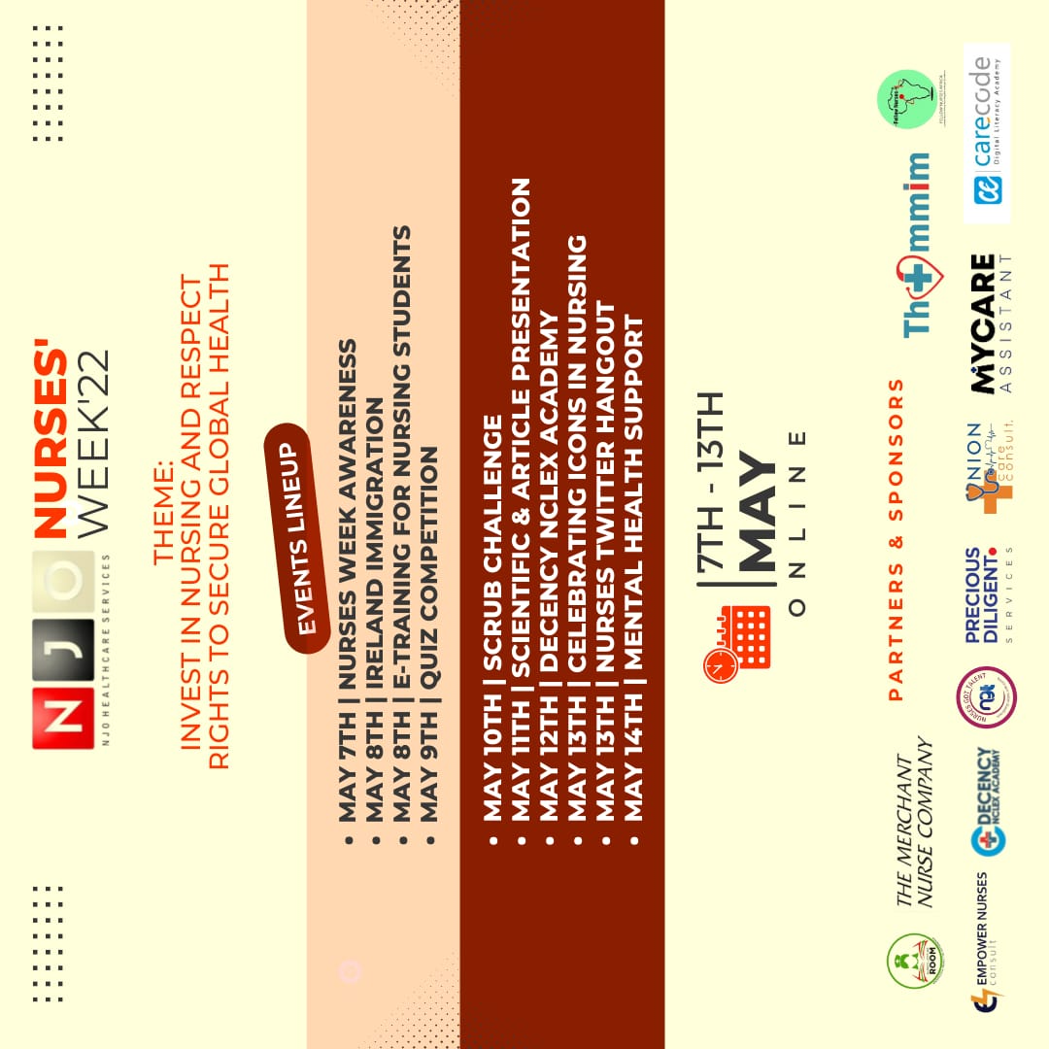
International Nurses' Week begins each year on the 6th of May and ends on the 12th of May around the world to commemorate the anniversary of Florence Nightingale’s birth.

Celebrating these modern-day heroes is one of many ways to encourage their acts of selfless service and bravery, especially in the event of a global pandemic. As a result, the theme for this year was 'Nurses: A Voice to Lead - Invest in Nursing and respect rights to secure global health’ as an opportunity to raise awareness about the need to invest in nursing profession, empower nurses, and respect their rights to further reinforce their efforts in nurturing a healthy world.

NJO led by Abiodun Oluwatobi, took the nurses’ week to a new dimension this year with a virtual nurses’ week celebration, which ran from the 7th to the 13th of May 2022, with a series of mind-blowing and breath-taking events on various social media platforms including Twitter and Zoom, facilitated by prominent nurse scholars, business leaders, and influencers with the active participation of over 4,500 nurses across the globe.

This is the first of its kind and can be described as epic and transformational because of its evident impact on the participants, the image of the nursing profession, and the world at large. It was equally sponsored by different agencies and notable organizations. The virtual event was greeted with great enthusiasm from nurses in Nigeria and across the globe and to ensure that a large number of nurses were engaged during the events, a massive awareness was created about two (2) weeks before the events using promotional content in the form of videos, write-ups, articles, and fliers across all social media platforms and websites.

The Nurses Week Virtual Celebration was packed with events that addressed various aspects of nursing and support for Nurses which are;

May 7th - #NursesWeekAwareness
May 8th - Ireland Immigration
May 8th - Training for Undergraduate Student Nurses
May 9th - Quiz Competition
May 10th - Scrub Challenge
May 11th - Scientific Presentation
May 12th - Icons in Nursing Celebration
May 13th - NCLEX, Nursing, and USA Migration
May 13th - Nurse's Twitter Hangout

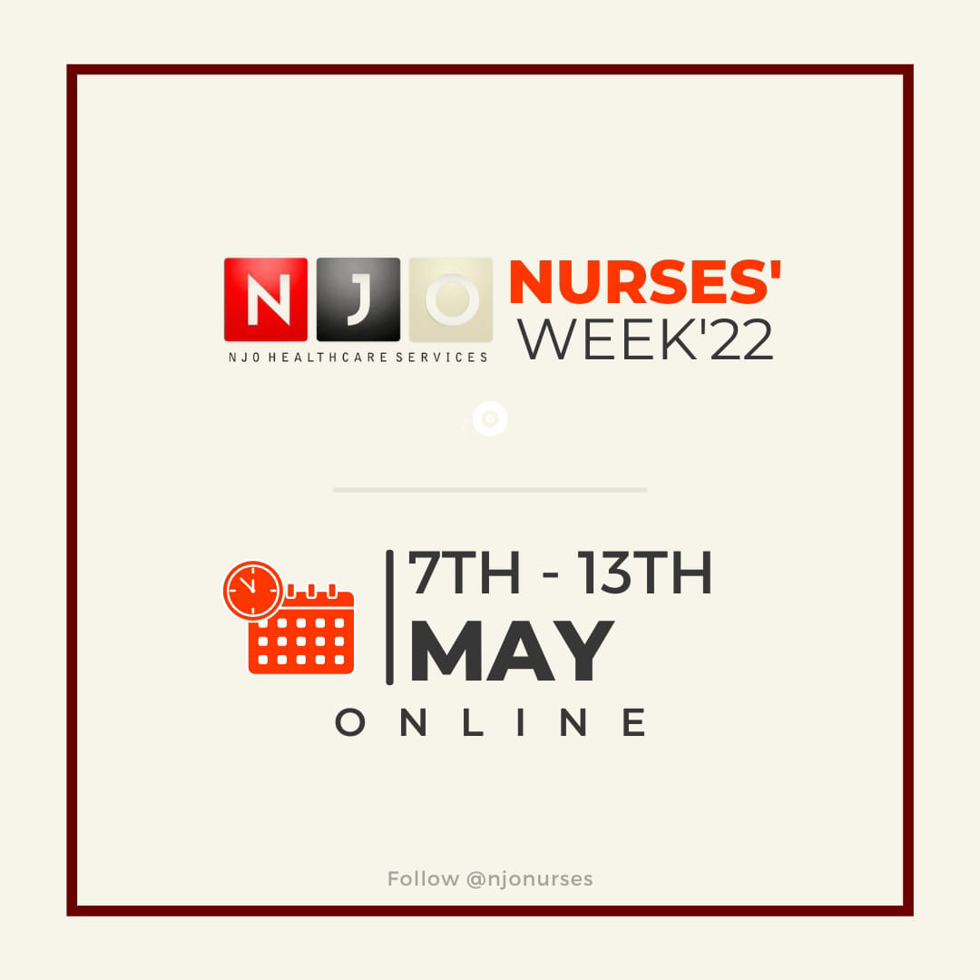

SUMMARY REPORT FOR EACH DAY

DAY 1
May 7th - #NursesWeekAwareness

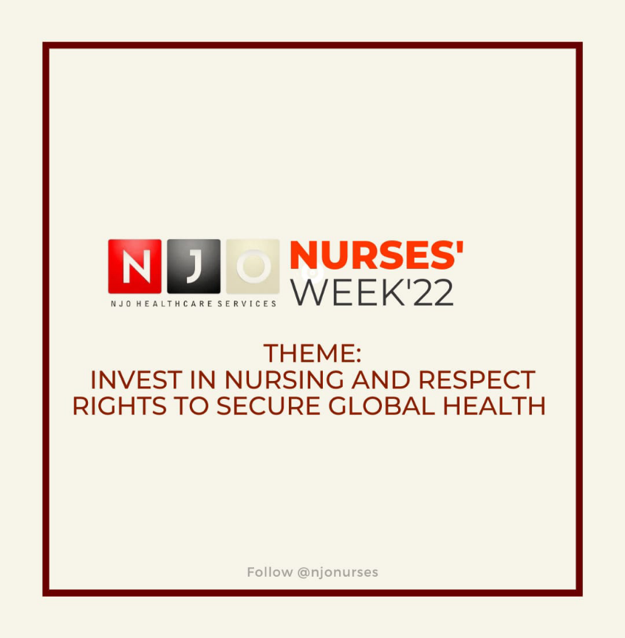
The Nurses Week Awareness was held virtually on the 7th of May in line with the given Nurses' Week theme for the year 2022 by the International Council of Nurses (ICN): "Nurses: A Voice to Lead-Invest in Nursing and respect rights to secure global health." Spotlights were thrown on the incredible roles’ nurses play in society, advocating for better remuneration, career development, and support for nurses, and this momentum was sustained till the end of the program.

The campaign was coordinated by Mayowa Racheal Popoola and the awareness was created using social media as a tool to reach a larger percentage of the population.

Watch HERE:
https://youtu.be/iPVpmpzjhH4

Day 2
May 8th - Ireland Immigration

Exploring international opportunities has a huge impact on the career advancement and personal development of nurses, and given this, the Ireland Immigration webinar hosted on the 8th of May, 2022, addressed some of the reasons nurses should consider migrating to Ireland, as well as the myths and facts to watch out for to make informed decisions about the migration process.

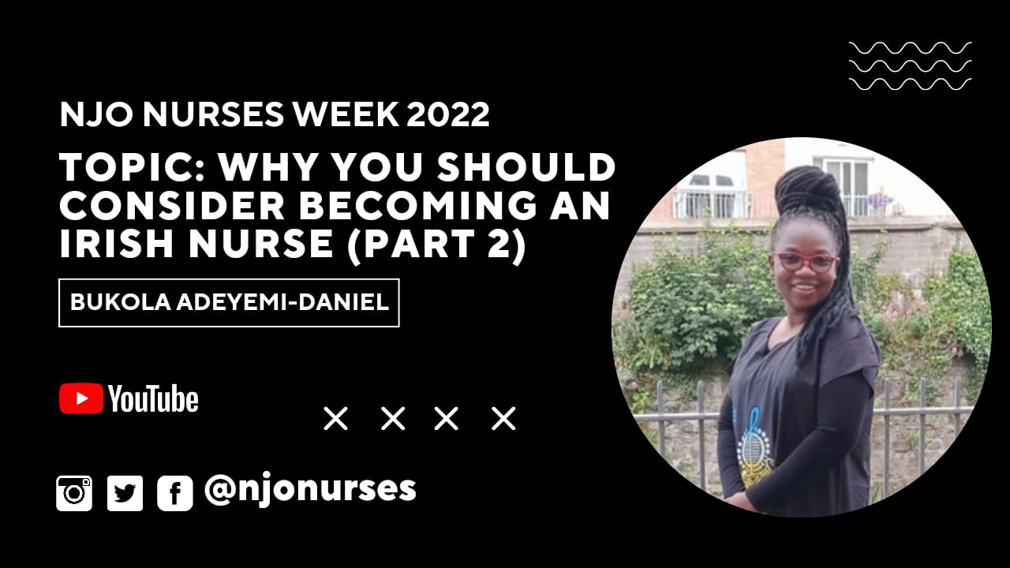

BUKOLA ADEYEMI-DANIEL is an enthusiastic and exceptionally dedicated nurse professional. Apart from her professional status as a Nigerian registered nurse, midwife, and public health nurse, she also holds a Bachelor of Nursing Science Degree (First Class Honours). Bukola is also an Irish RN passionate about career growth and supporting the quest of others on the same path.

Watch here NOW!
https://youtu.be/KRBEuDgLXjc
DAY 2
May 8th - Undergraduate Nursing Student

Student Nurses were not left out of the show in any way, as an E-Training titled "12 Things Student Nurses Should Know Before Graduation" was organised specifically for them, bringing great excitement and awareness of what they should focus on before graduation in preparation for accelerated career growth and a more fulfilling experience in the nursing profession.

Given the above, some of the areas addressed were the scope of practise and salary structure for nurses; the use of social media for building influence, impact, and income; licence as a tool for empowerment, and the power of the mindset in leading a self-fulfilling and career-fulfilling life.

Omowumi Fadairo hosted the event via Zoom, with over 100 student nurses in attendance.

Nr. OSEMEKA MERCY MARY is a United Kingdom Registered Nurse and a Licenced Nurse in Nigeria. She's the founder and CEO of Nurses Lecture Room, a platform created out of a passion for academics and teaching that started on WhatsApp and now has more than 20,000 followers on Facebook and over 120k subscribers on YouTube [@Nurses lecture room] for grooming student nurses for their NMCN professional examinations. A believer and motivational speaker passionate about corporate networking, developing new ideas, community development, and impacting lives through teaching.

Watch the replay here:
https://youtu.be/vXXxoaVLDnc

DAY 3
May 9th - Quiz Competition

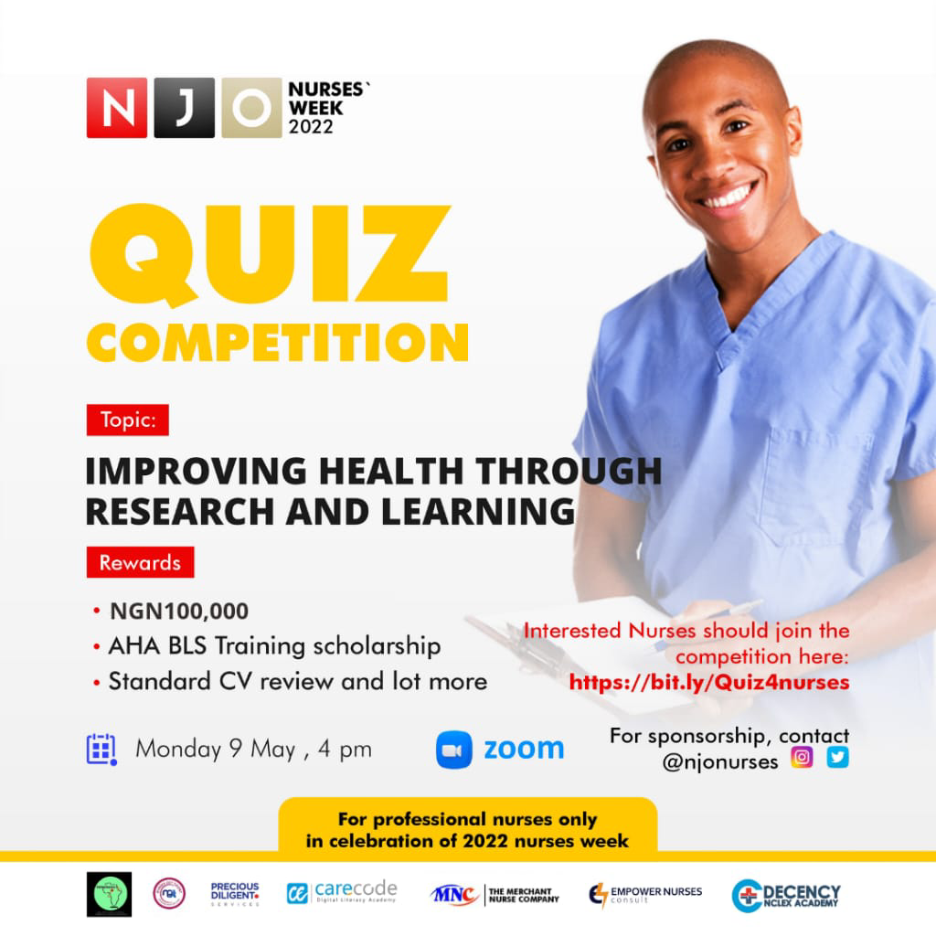
The virtual quiz contest was successfully held on the 8th and 9th of May on Zoom with over 46 participants recorded, moderated by two vibrant Nurses, and was in three stages; two pre-final stages, and the grand finalé.

The first pre-final stage took place on May 8th, where participants were asked two questions each covering anatomy, pharmacology, Medical-Surgical, and general nursing. The quiz competition proved again that Nurses are a set of super-intelligent professionals and it was also an avenue to bring back to memory what details might have been forgotten and as a challenge that studying and learning is a continuous process and must never stop.

Twenty-five participants made it to the second pre-final stage, which took place at 5 pm on May 9th, where each participant was asked one question, and upon failing any question was eliminated.

Twelve participants made it to the grand finalé, which lasted for close to three hours in three elimination phases. Only two contestants advanced to the final round, where they answered five questions but ended up tied.

A final round was conducted with questions on current affairs, where Nurse Alabi Oluwatoyin Matthew, an intern nurse, emerged as the winner after nearly eight consecutive rounds and took home the cash prize of NGN 100,000 while the first runner-up Nr. Chioma Uzodinma had a NGN30,000 cash prize. The facilitators and quiz masters were Nr. Mogbolu Max-Walter and Nr. Adewumi Oluwatobi.

Pre-final stage 1
https://youtu.be/-CZEZVEod8Y

Pre-final stage 2
https://www.youtube.com/watch?v=RXbffq6IcYo

Grande finale
https://youtu.be/_2mWuzHAU-s

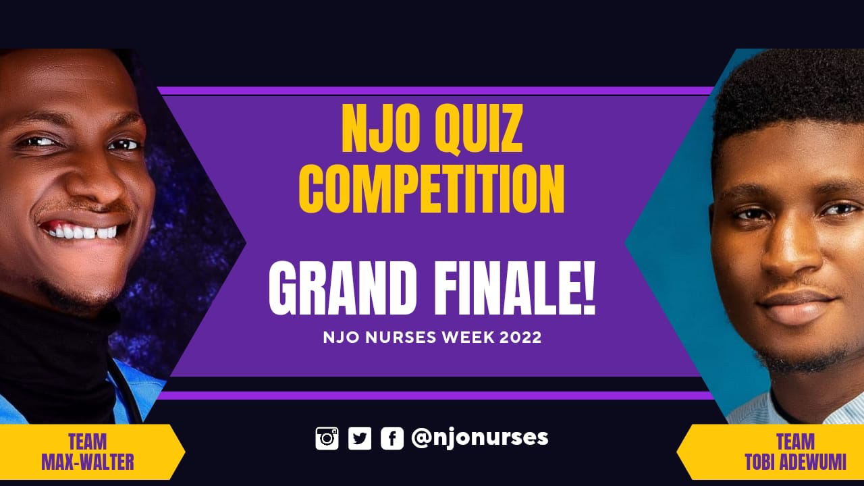
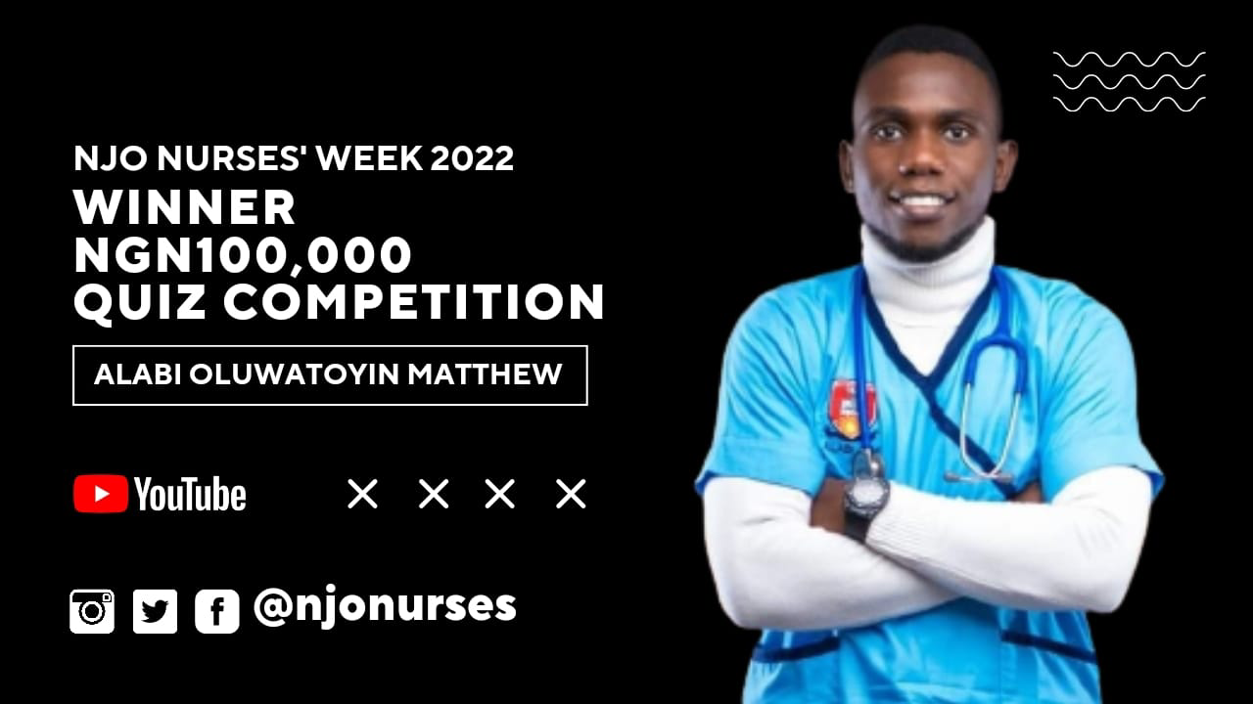

Alabi Oluwatoyin Matthew is an intern nurse who is passionate about nursing research and data analysis. He recently graduated from the University of Medical Sciences (UNIMED), Ondo State. He's the winner of the sum of NGN100,000 for the just concluded NJO Quiz Competition 2022 in celebration of 2022 Nurses Week.

Surprisingly, just as Faith (the first scrub challenge winner) saw the challenge on a friend's WhatsApp status, Alabi also saw the Quiz Competition on someone's status. He was keen on jumping on the Scrub Challenge, but his girlfriend motivated him to embark on the Quiz Competition instead. As regards the elimination phases of the competition, Alabi described them as tasking and almost gave up at some point during the stages.

He plans to use this cash prize to push his career into international space. We could not achieve all of these successes without the aid of our sponsors.

Watch Alabi reaction here:
https://youtu.be/wUa71Jejvzg
DAY 4
May 10th - Scrub Challenge

The Scrub challenge was virtually held on Instagram and it recorded about 200 Nurses who participated in the challenge. Participants were given a few days to get others to engage with their post given the criteria for selection, which was a higher number of likes and engagements on the selected winner's post organically.

Entries were carefully scrutinised and those with fake engagements or those that bought engagements were eliminated. The winner was selected by five members of the judges based on the criteria.

Olubode Irebami Faith, a final year nursing student at the prestigious Obafemi Awolowo University, emerged as the winner and went home with a whopping sum of NGN100,000. The first runner-up, Odusanya Toluwani, took home a sum of NGN 30,000 and the second runner-up, Marysandra Ozioma Ani, won the cash prize of NGN 20,000. Each of them was gifted standard scrubs in addition.
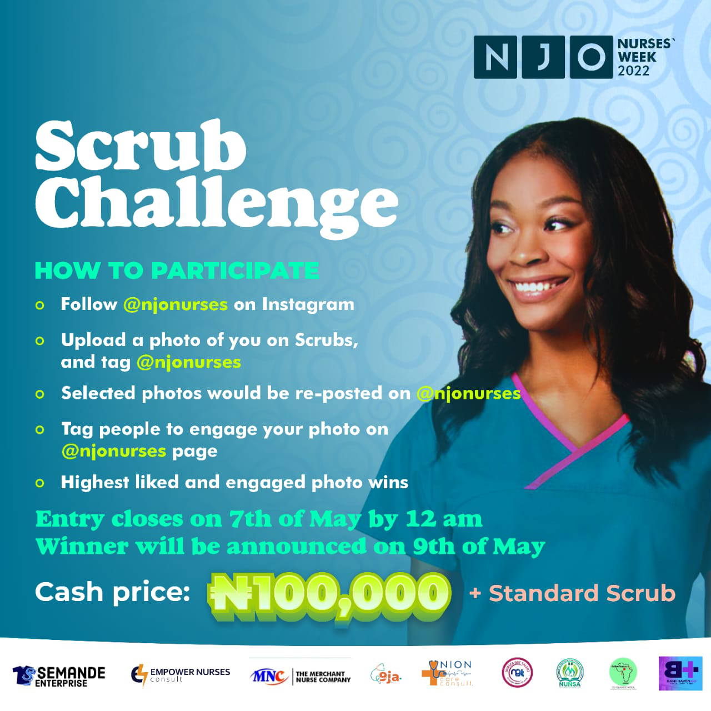

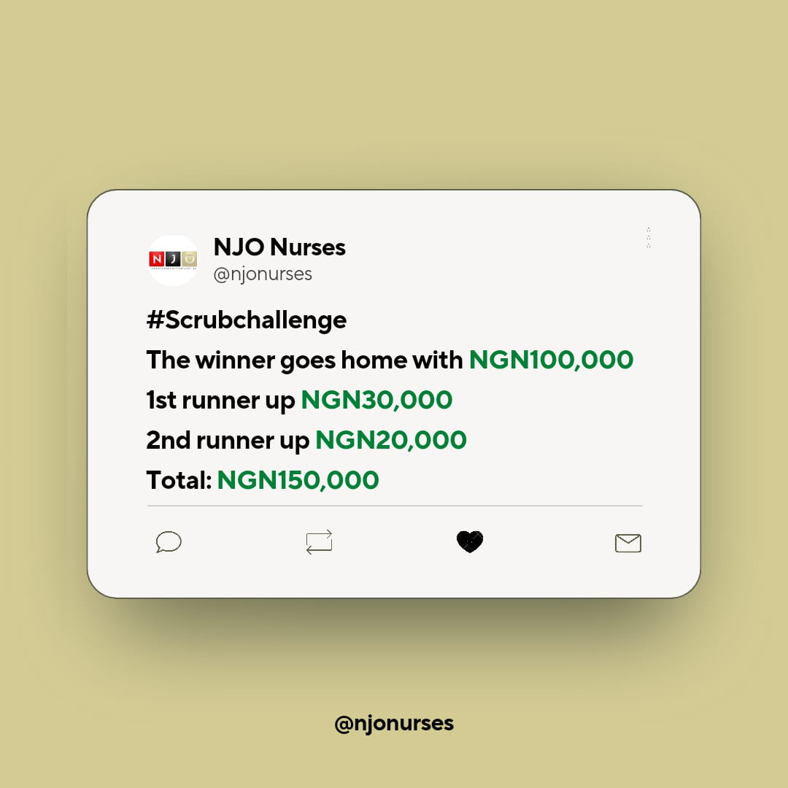

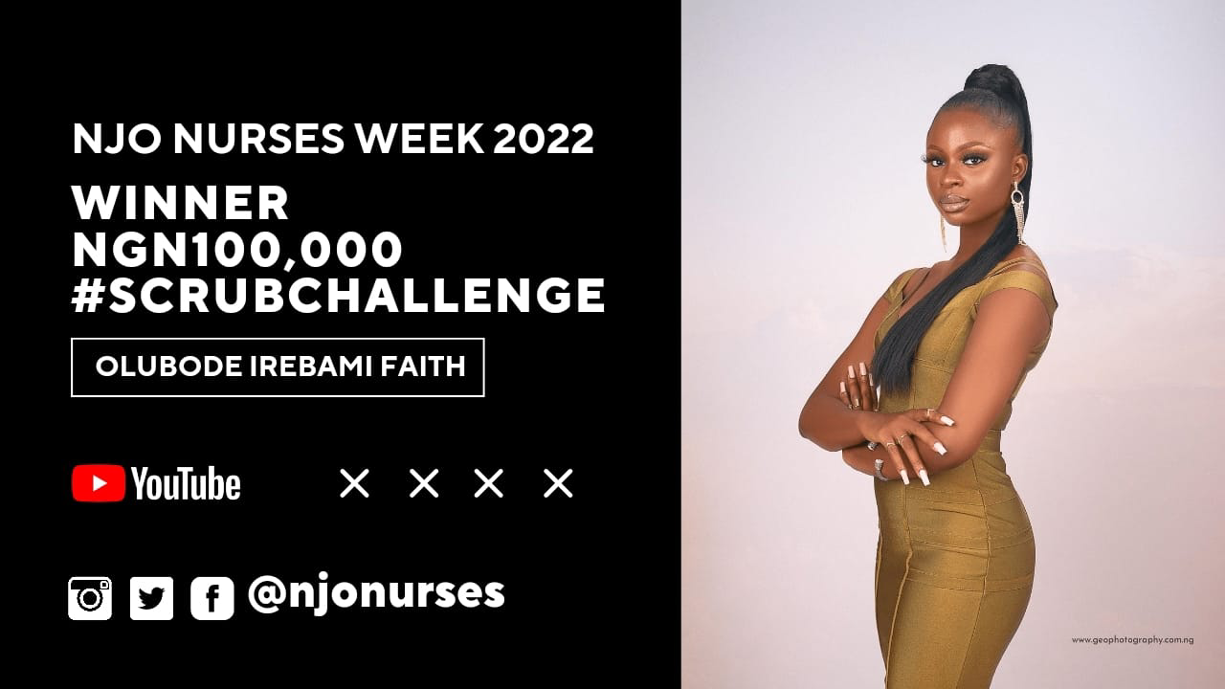

Olubode Irebami Faith is a final Nursing student from the prestigious Obafemi Awolowo University, Ile-ife. She's a young aspiring makeup artist who jumped on the Scrub Challenge organized by the NJO team as part of the celebration for 2022 Nurses Week. She saw the announcement about the scrub challenge on her colleague's WhatsApp status a few days into the contest. She didn't think she'd win because the contest only lasted a few days and had 170 nurses competing. However, in this brief interview, she told the team lead for NJO that the money (NGN100,000) will go a long way towards improving her side hustle (make-up business) to get more equipment as she's getting more clients since ASUU extended the most recent strike action for another 12 weeks.

Watch Faith’s reaction here:
https://youtu.be/ZAho1mdTNHE

DAY 5
May 11th - Scientific Presentation

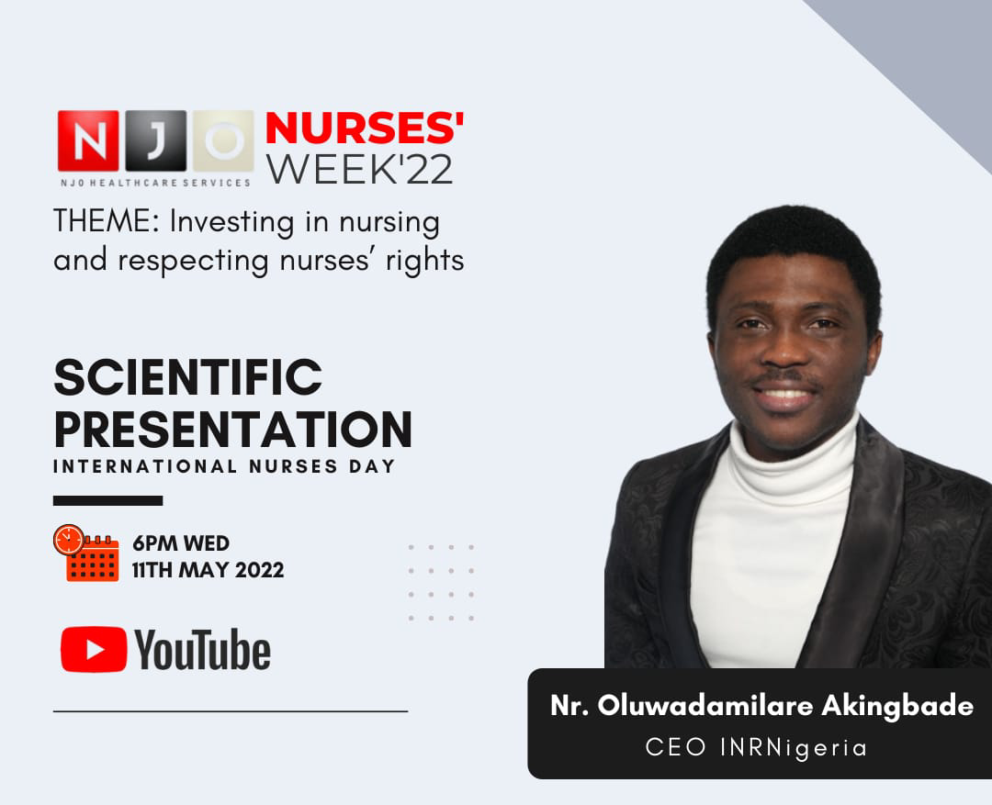
The virtual Scientific Presentation on the topic ’’Investing in Nursing and Respecting Nurses’ Rights’’ delivered by Oluwadamilare Akingbade, RN, Ph.D. (c), the CEO of the Institute of Nursing Research Nigeria was hosted on YouTube.

The presentation addressed some of the key challenges Nurses face, such as inadequate leadership representation, global shortages of Nurses, and the impact of the COVID-19 pandemic on the nursing workforce. He recommended solutions to these challenges by advocating for the relevant stakeholders such as the government, hospital authorities, NGOs, and others to invest in the welfare of Nurses, Nursing Education, Advanced Practice Nursing, Nursing Leadership, Nurse-led Projects, and Nursing Research. The recommendation was made as an outlook on the WHO declaration of the urgent need for funding the nursing profession.

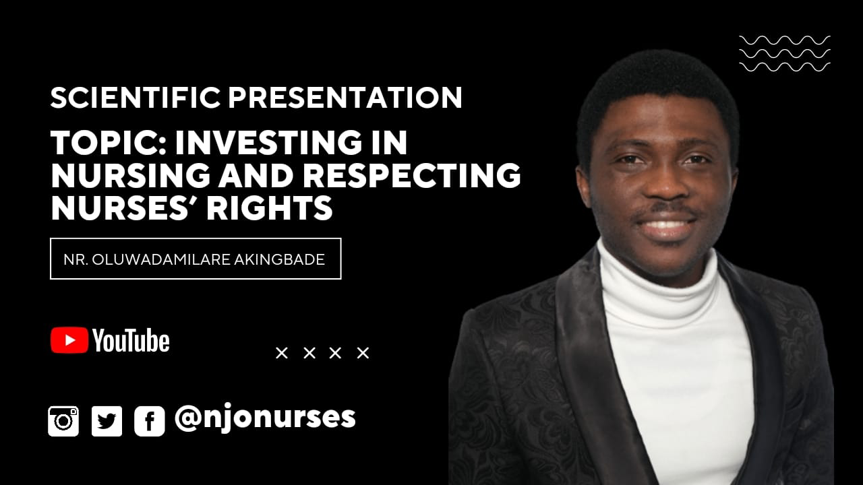

Nr. OLUWADAMILARE AKINGBADE is an award-winning nurse, named one of the top ten most inspiring male nurses in Nigeria in 2017 by Fellow Nurses Africa. He won the best oral presentation (student category) at the 7th Pan Pacific Conference organized by The Nethersole School of Nursing, The Chinese University of Hong Kong, in May 2021. He recently won the Research Doctoral Degree Academic Scholarship from the Oncology Nursing Foundation.

A nurse leader, Damilare is one of the 29 scholars attending the 2021 Global Nursing Leader Institute (GNLI), a strategic policy leadership program organized by the International Council of Nurses (ICN) for senior nurse leaders worldwide. He received a scholarship to be part of the 2021 cohort from August 2021 to June 2022.

Watch the presentation here:
https://youtu.be/gBYhexGsgp8

DAY 6
May 13th - NCLEX, Nursing and USA Migration

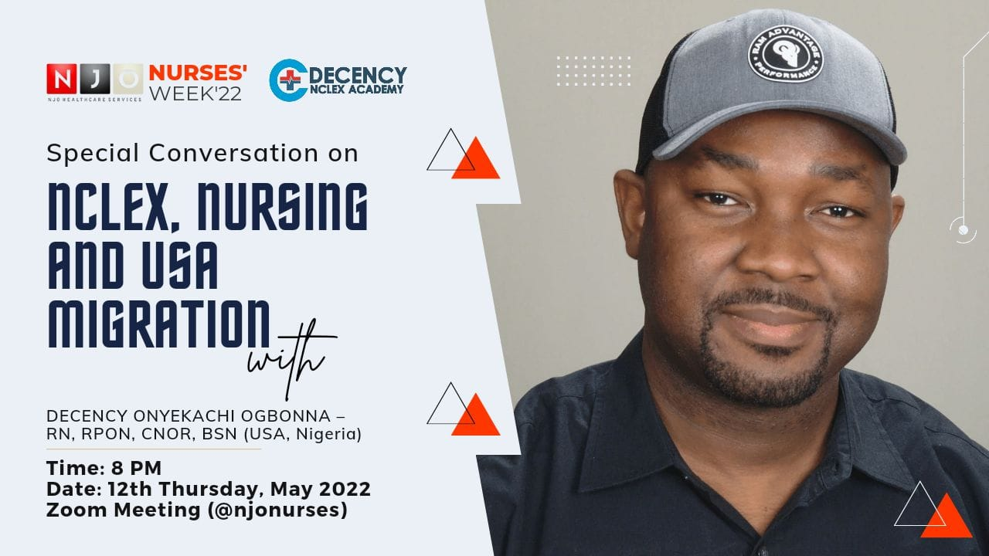

The virtual conversation on NCLEX, Nursing, and USA migration was held by Decency Onyekachi Ogbonna RN, RPON, CNOR, BSN, CEO of Decency Nclex Academy.

The atmosphere of celebration and the week’s excitement was heightened on Thursday, 12th of May when Mr. Decency Onyekachi simplified the migration process and pathway to becoming a Rregistered Nurse in the United States of America. The webinar was quite unusual as the guest speaker went beyond the topic to give other useful information on work and living in the USA, and the opportunities and challenges that may be encountered.

Resources to prepare for NCLEX were also shared and participants also had access to a study and US migration mentorship platform to guide their migration process. The webinar lasted for over two hours with more than 200 participants.

DECENCY ONYEKACHI is the Founder and CEO of DECENCY NCLEX ACADEMY, a platform for training and education that has helped many Nigerian Nurses achieve their American DREAM since 2016. Decency NCLEX Academy stands to support Nurses globally to overcome numerous constraints that have over time become a barrier to them achieving their career goals. We do this by constant motivation, mentoring, and unbeatable guidance as our candidates continue to embark on their journey.

You should watch the webinar:
https://youtu.be/t7Dy1Y-BIqY

DAY 7
May 13th - Nurse's Twitter Hangout

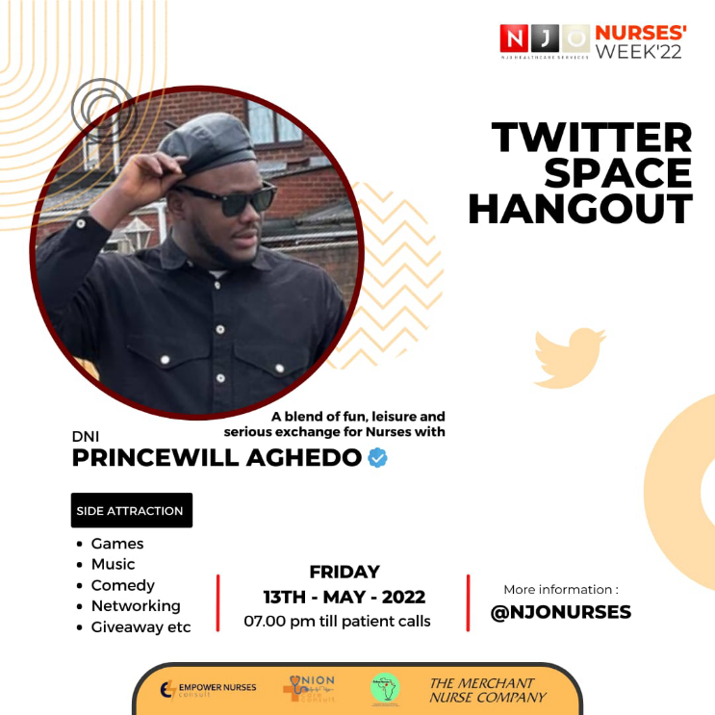

The Nurses Twitter Hangout, anchored by Princewill Aghedo DNI, Global Nurse Leader popularly referred to as the Descendant of Nightingale, has been streamed by over 2000 individuals. The 5-hour long hangout served as a virtual relaxation spot where the participants had fun with games, music, and discussions on a diverse range of topics, including self-development, professional development, career talks, career migration pathways, politics, and so on.
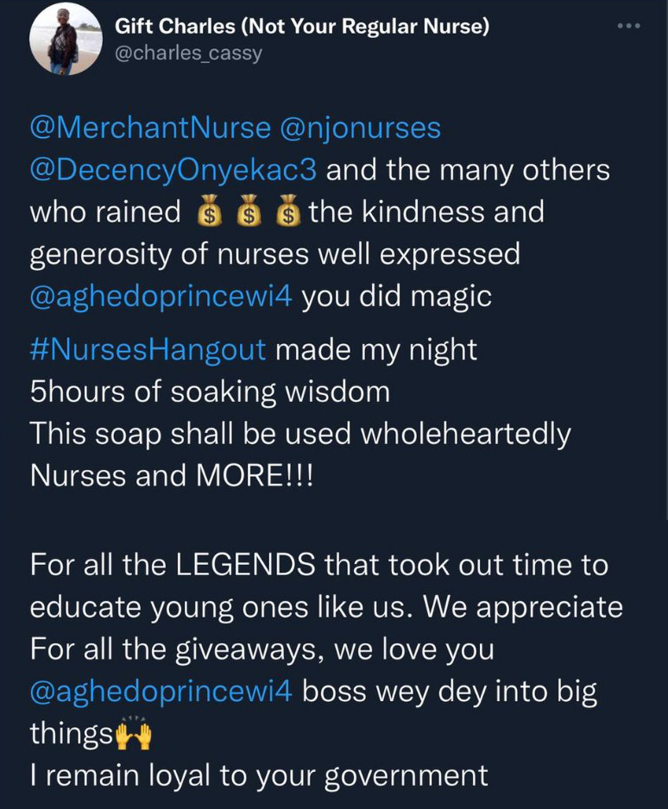

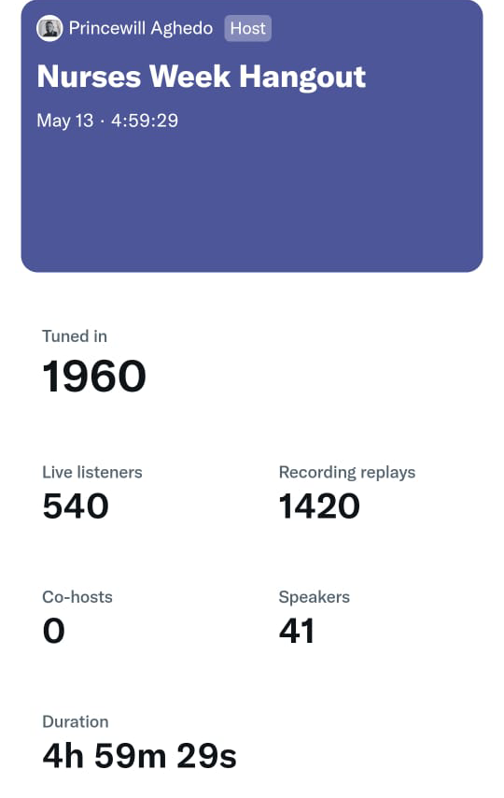

Held on the 13th of March, was the most attended of all the activities and seems to be the summit for many Nurses. This highly intellectual night of dialogue between many Nurses did not end without cash prizes and various giveaways. Each guest speaker discussed various topics like the history of Nurses Week Celebration, past events hosted to celebrate Nurses Week in Nigeria such as the Nightingale Challenge and the need for its revival, and how Nurses can cope with and manage burnout.

The virtual hangout, which lasted approximately five hours, had amazing sessions and conversations with notable dignitaries in the nursing profession, at home, and abroad. Several giveaways were conducted and participants received their prizes for international passports, IELTS enrolment, and CBT voucher purchases. The speakers also explored the reasons why the annual Florence Nightingale Speech Contest should be brought back to the nursing education system. The last winner of the contest, Adewumi Oluwatobi, was present and also shared his opinion and recommendation. The meeting ended some minutes after midnight with numerous positive comments.

Link to listen to the Twitter space:
https://twitter.com/i/spaces/1gqxvlnDgVeGB
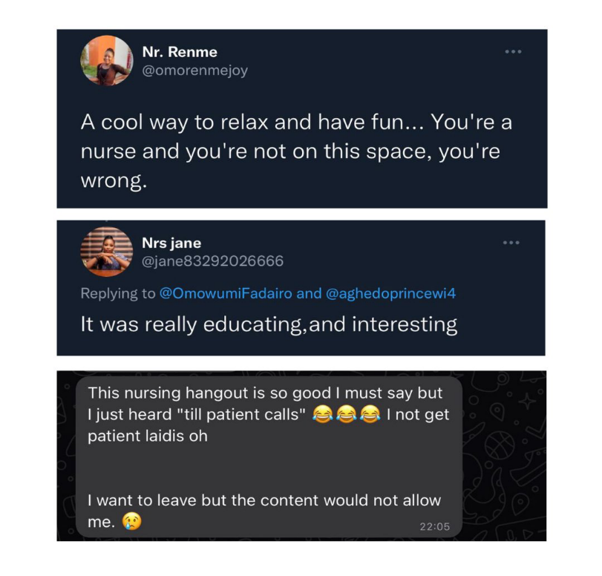
DAY 8
May 14th - Mental Health Support Program

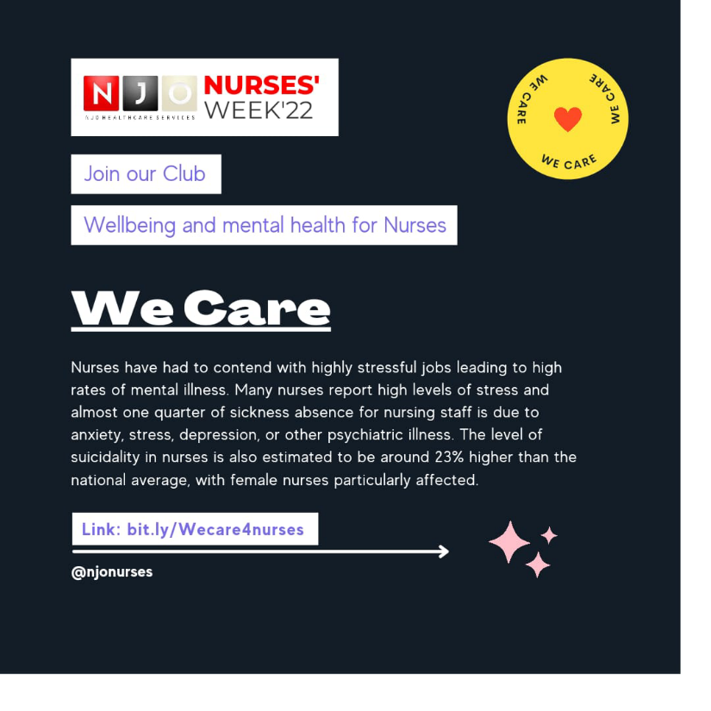
There have been recorded increased rates of anxiety, depression, and other psychiatric illnesses among nurses nowadays, which is sadly due to stressors like high patient-nurse ratios, poor remuneration, and unhealthy work environments, amongst others, which greatly impact the mental health of nurses.

The mental health programme held on the 15th of May provided mental health support to Nurses to cope with some of the challenges stated above. The conversation was led by Josiah Jackson Okesola, who shared his story with the audience and the key strategies Nurses can utilise to build their mental strength, followed by Tunde Rhema, who spoke on stress and its management.

The session took place for over three (3) hours with more than 90 nurses in attendance. The final event on mental health support was held on Zoom with Abiodun Oluwatobi, who spoke about the need to establish a support structure and a platform where conversations bearing on the mental health of nurses can be held. The nurses’ well-being club was formed and several nurses joined.

Club link: https://bit.ly/Wecare4nurses

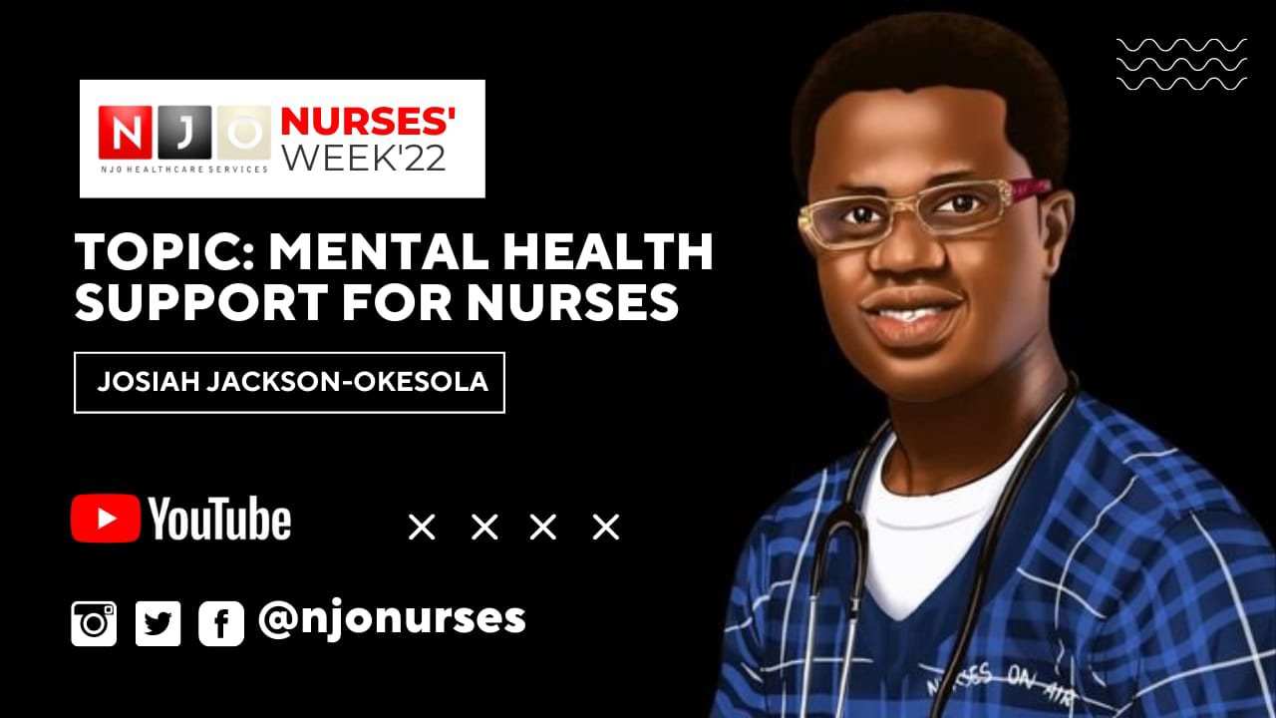

Josiah Jackson-Okesola is a licensed professional Nurse Clinician, multi-award-winning nurse innovator, extraordinary global nursing leader, media consultant, digital media broadcaster, mental health therapist, practicing psychotherapist, and public speaker.

Jayjay as he is fondly called by friends and colleagues holds the advanced qualification of Masters Practitioner in the field of Neuro-Linguistic Programing (MPNLP) and Psychotherapy; with expertise in Result Technologies, Hypnosis, and Neurological Repatterning for Addictive Habits.

Watch the meeting replay here:
https://youtu.be/ZMshGvWfbkY

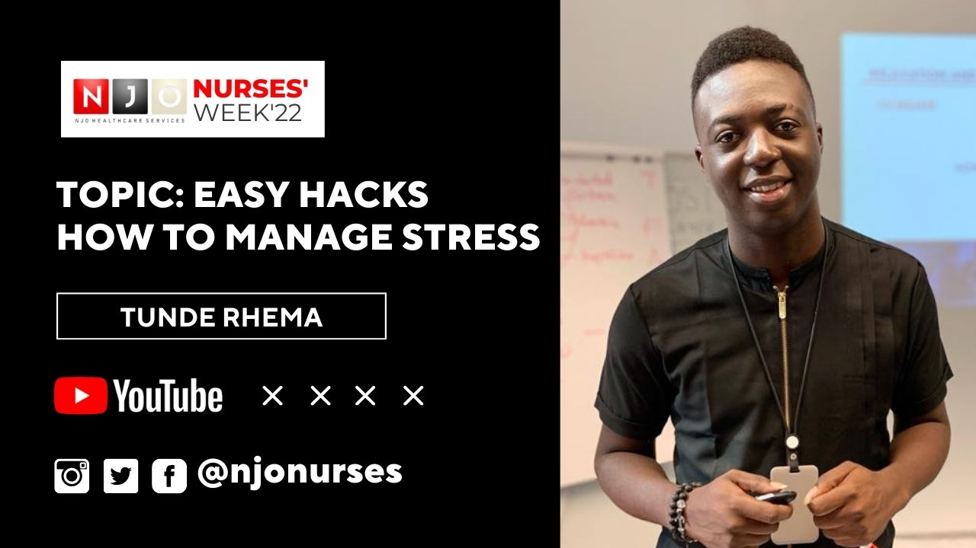

Tunde Rhema sheds light on a major paradigm that touches on Leadership, Mental Health, and Faith.

He is the founder of TR Leadership Hub [TRLH], which focuses on leadership, lifestyle, and technology. He is a renowned strategy support expert for SOBCA—Africa's foremost certifying academy for Anger Management, Emotional Intelligence, and solutions providers for Mental Health First Aid [SOBCA - MHW], Mental Health Wellness Initiative, Abuja [MHW], and Rehoboth Centre for Elderly Care, Abuja [RCEC].

He speaks at conferences and trains organisations on Leadership, Mental Health, Customer Relationship Management, and Business Leadership. He is the author of the books Don't Waste Your Waiting [DWYW] and Tranquil [The Mental Health Dimension].

Watch the video replay here:
https://youtu.be/ViQq9kUwrfc

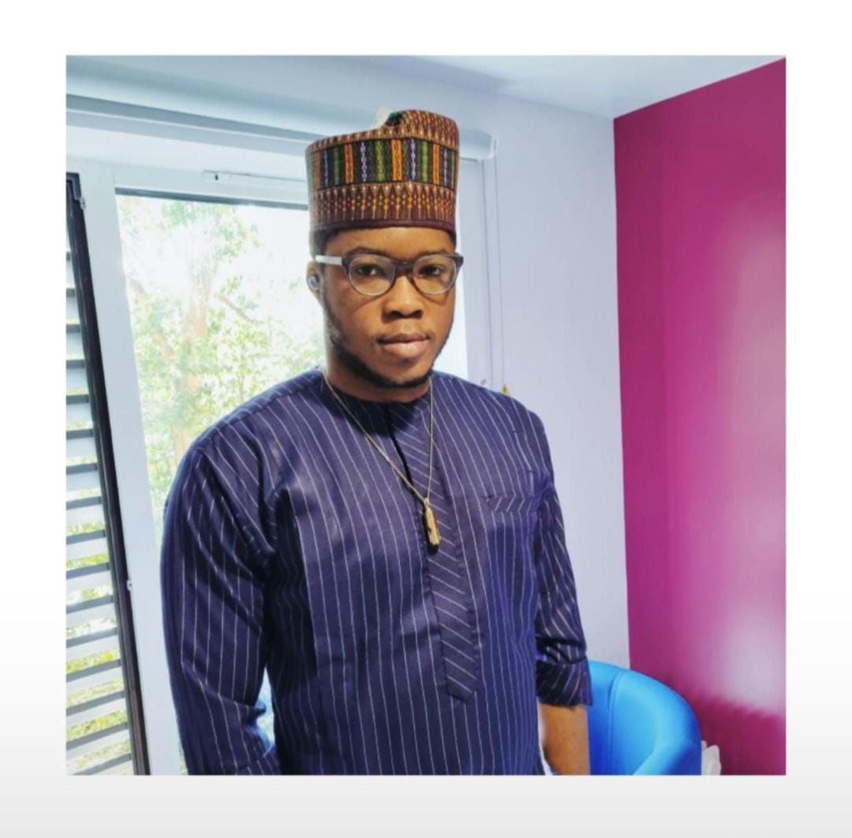
MEET THE BRAIN BOX

Abiodun Oluwatobi, founder of NJO, is the brain behind the NJO NURSES WEEK VIRTUAL CELEBRATION.

A trained emergency nurse based in the UK, American Heart Association Instructor, IADT (UK) Level 3 Trainer, trainer, and digital media enthusiast.

He's the admin for @njonurses, an online platform that shares resourceful content and various opportunities with over 50,000 Nigerian Nurses across all social networking platforms. Biodun is the author of 3 remarkable books, with the recently launched book titled "Big Dreams", which catalogued the step-by-step immigration paths to different countries for Nurses downloadable for free here [https://selar.co/p8ra] and his focus has always been to empower young Nurses to be globally impactful.

Email:abiodunhezekiah30@yahoo.com

PROJECT TEAM

Team Lead: Abiodun Oluwatobi Hezekiah

Team Members
- Max Walter
- Adewumi Oluwatobi Theophilus
- Omowumi Fadairo
- Oluwatunmise Ogedengbe
- Hallimattu Abdullahi
- Hope C Ukomadu
- Mayowa Racheal Popoola
- Faith Ajayi
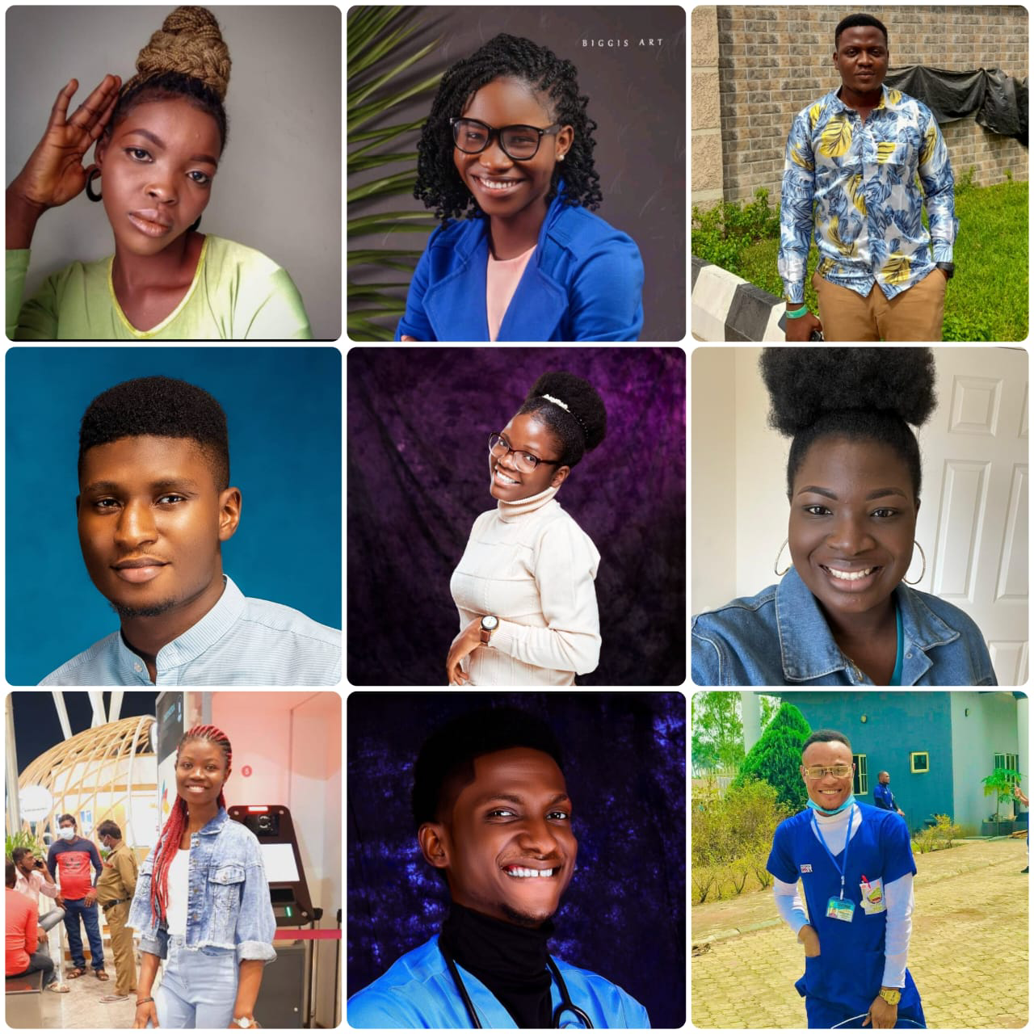
- Nelson Adeyeye
NJONURSES

NJO is an online media platform founded by Abiodun Oluwatobi where vacancy, training, webinars, opportunities, and updated news for professional healthcare workers, particularly Nigerian Nurses are shared. Founded on the 4th of December 2016 and has grown rapidly into a community of over 50,000 members and followers across different cadres of nursing.

Be a part of our community

Facebook Page:
https://www.facebook.com/Nursesjobsandopportunities/

Instagram:
https://www.instagram.com/invites/contact/?i=v151c01o5i6r&utm_content=8pty43s

Twitter:
https://twitter.com/njonurses?s=08

Linkedin:
https://www.linkedin.com/company/njo-healthcare-services/

Website:
https://njonurses.disha.page

YouTube:
https://youtube.com/channel/UCo3TIOXcgc_PUk_-MOrIwdw

Telegram:
https://t.me/+QPMzzSKP2Tqw7vyJ

Opportunities everywhere….
PARTNERS & SPONSORS

The Merchant Nurse
https://merchantnurse.com/

Nurses Got Talent Foundation
@nursesgottalentfoundation

Empower Nurses Consult
@EmpowerNursez

ThummimNG
https://thummimng.com/

Decency NCLEX Academy
https://decencynclexacademy.org/

Carecode
https://carecityonline.com

FellowNurses
https://fellownurses.com/

Decency Nclex Academy
https://decencynclexacademy.org/

Precious Diligent
@rwcp_pd
@preciousdiligent

Nurses Lecture Room @nurses_lecture_room

Union Care Consult
Fruit Clinic
@fruitclinic_ng

NursesRevolutio
@nurses_revolutio

Asquare Flourish Homes
@asquareflourishhomes

My Care Assistant
https://mycareassistant.ng/

Akab Homecare
https://akabhomecare.com/

9ja Nurses
https://9janurses.com/

NUNSA
https://nunsa.org.ng/

Nurses & Relationship Group
Demande Enterprise
Bami Haven. Co

